Thursday 4th June
Remember – Keep playing Spelling Shed!
Hive Games tomorrow.
1st code at 9:45am for a 10am game.
2nd code at 11:45am for a 12pm game.

Reading Activity
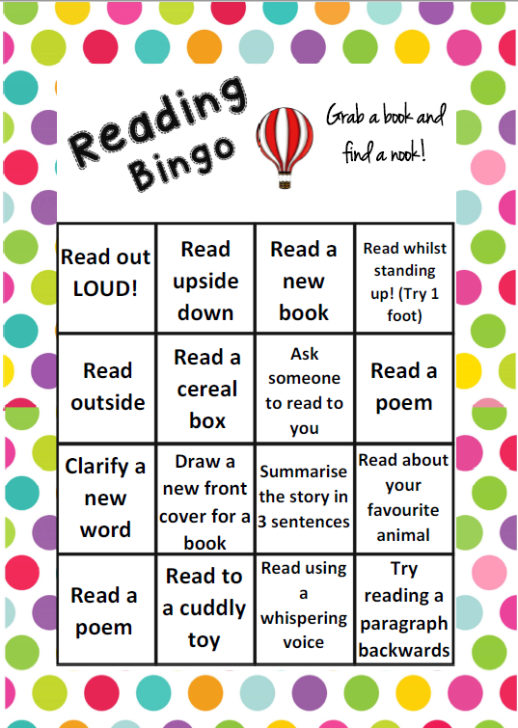
Continue with your Reading Bingo card!

PE
Today, we would usually have PE. Continue with your own workouts or you might like to try one of these dance videos.
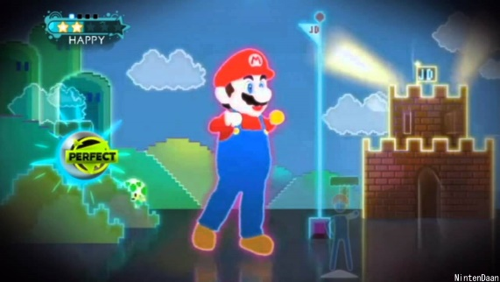
Mario Kart:
https://www.youtube.com/watch?v=39L-M5nhx6Y

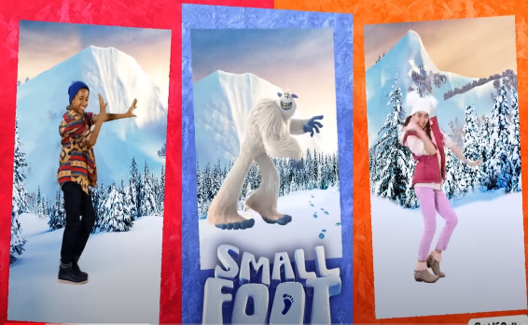

Do the Yeti dance: https://www.youtube.com/watch?v=T9T5fJDy_ig

Music
We would usually have a music lesson today. As a school, we have links with the Bromley Youth Music Trust (BYMT) who have created music lessons through video.
The video is on Google Classroom, please watch week 5.

Afternoon Activities
Year 3 were supposed to visit the Tower of London on 9th June so we have some activities for you to complete instead.
Please access the Tower of London website:
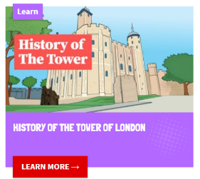
https://www.funkidslive.com/learn/tower/
Once you are on this website, please choose ‘History of the Tower’ which is a page with lots of facts and interesting information!

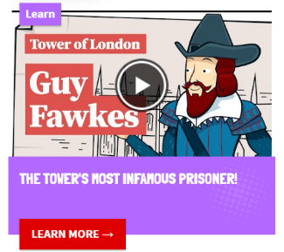
Afterwards, please choose ‘The Tower’s Most Infamous Prisoner’, which is a video.

We’ll carry on with this learning next week.

Afternoon Activities – Spanish
Please continue with Spanish on Language Nut. This week, we have set a ‘Where I Live’ activity which is all about your house. Please contact your class teacher for usernames and passwords.

Joke for the day
Why do we never tell jokes about pizza?

They are too cheesy!


