Wednesday 3rd June

Remember – Keep playing Spelling Shed!

Reading Activity
Read this short poem. This could be one of your Bingo squares!
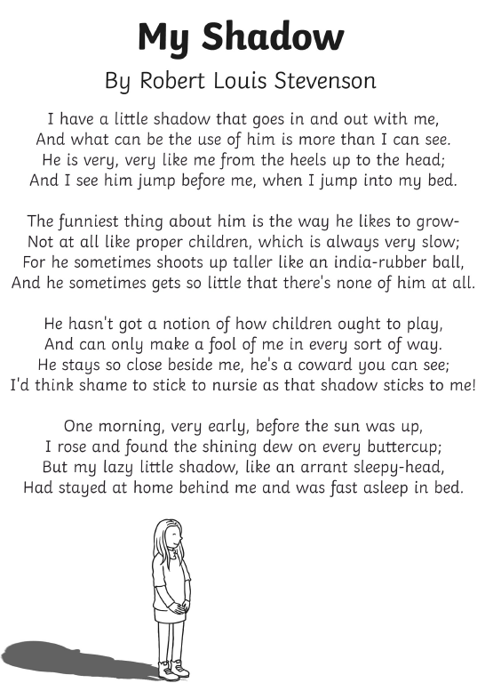

Questions
- Who is ‘he’ in the poem?
- How many rhyming couplets are there in the poem?
- Clarify the word ‘coward’
- Clarify the word ‘arrant’
- At the end of the poem, why had the shadow ‘stayed at home’?
- Do you think this is an old or modern (up to date) poem? Why?

Writing Activity
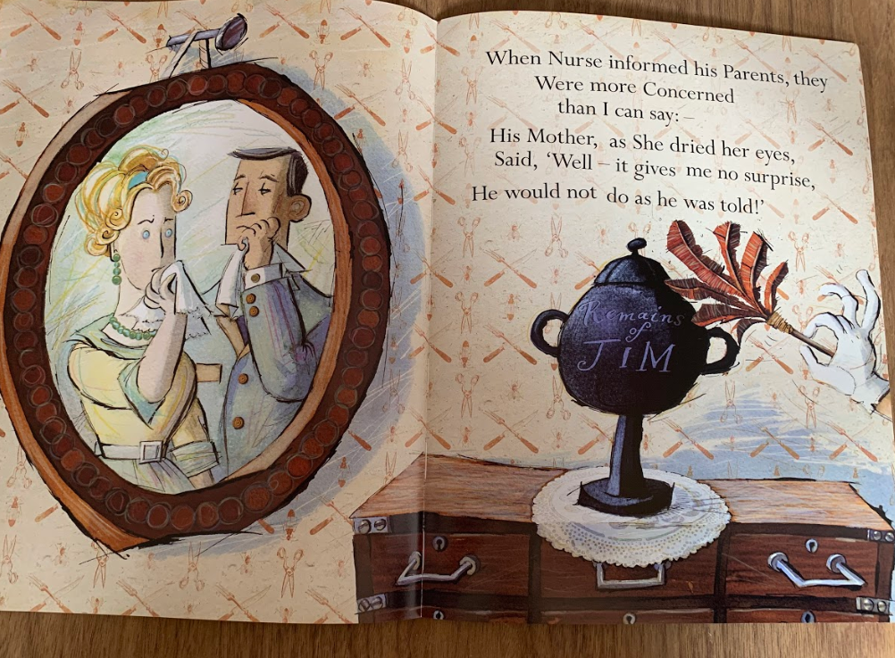
Read the final pages of Jim.

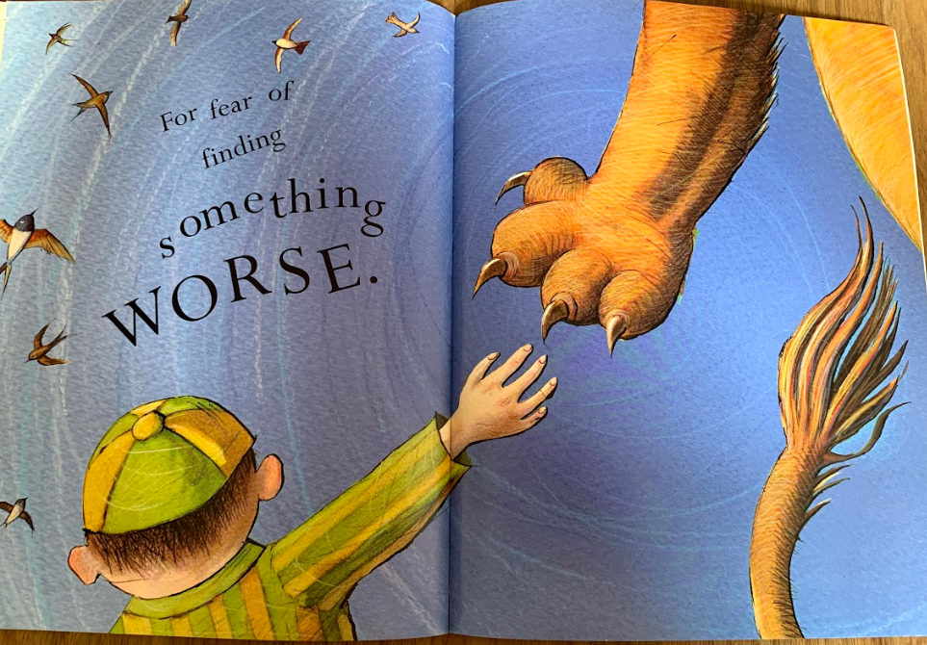
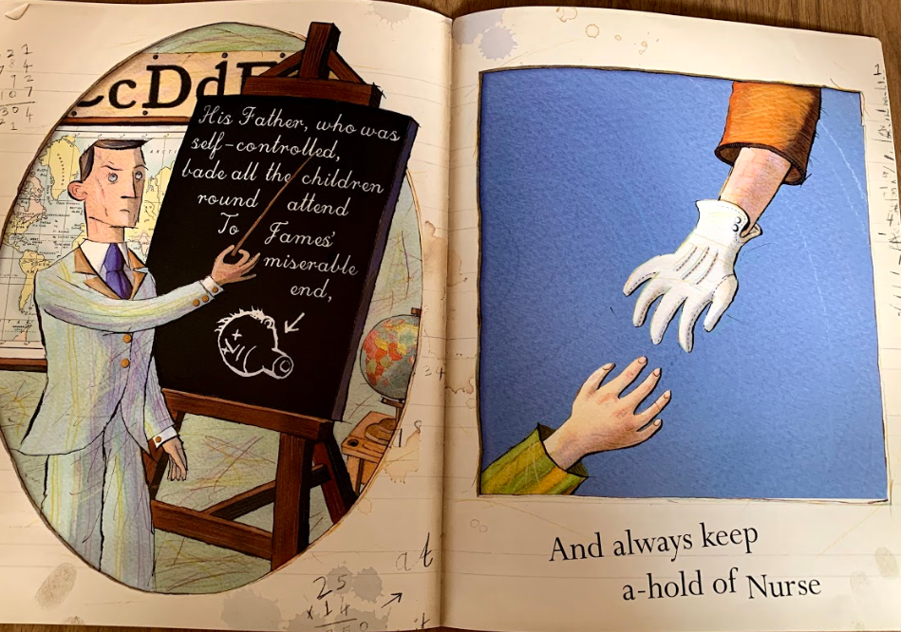

Today, you are going to perform the tale of Jim. Below is the story, you may want to spend some time clapping each line to ensure you understand the rhymes and syllables.
The tale is long so you may choose a coloured section to perform (you might just choose the green paragraph or the red paragraph) or you may perform the whole poem, it is your choice.
Perform the poem to a teddy, a pet or a member of your household.
We would also love to hear your poem so if you’d like to, please follow the steps on the next page so we can hear your performances too!
There was a Boy whose name was Jim; His friends were very good to him.
They gave him Tea, and Cakes, and Jam, and slices of delicious Ham, And Chocolate with pink inside, And little Tricycles to ride,
And read him stories through and through, And even took him to the zoo.
But there it was the dreadful fate befell him, which I now relate.
You know – at least you ought to know, for I have often told you so that children never are allowed to leave their Nurses in a Crowd;
Now this was Jim’s especial Foible, He ran away when he was able, and on this inauspicious day He slipped his hand and ran away!
He hadn’t gone a yard when – Bang! With open jaws a Lion sprang, and hungrily began to eat The Boy: beginning at his feet.
Now just imagine how it feels when first your toes and then your heels, And then by gradual degrees, Your shins and ankles, calves and knees, Are slowly eaten, bit by bit. No wonder Jim detested it!
No wonder that he shouted “HI! ‟ the honest keeper heard his cry, though very fat he almost ran to help the little gentleman.
“Ponto!” he ordered as he came (For Ponto was the Lion’s name), “Ponto!” he cried, with angry Frown. “Let go, Sir! Down, Sir! Put it down!” The Lion made a sudden Stop, He let the Dainty Morsel drop, and slunk reluctant to his cage, snarling with Disappointed Rage.
But when he bent him over Jim the Honest Keeper’s Eyes were dim. The Lion having reached his head, The Miserable Boy was dead.
When Nurse informed his parents, they were more concerned than I can say: His Mother, as she dried her eyes, Said, “Well- it gives me no surprise, He would not do as he was told!”
His Father, who was self-controlled, bade all the children round attend to James’ miserable end,
And always keep a hold of Nurse For fear of finding something worse.

Recording your poem
On Purple Mash, we have set you a 2Do. Please open this.
Choose ‘My Adventure Story’
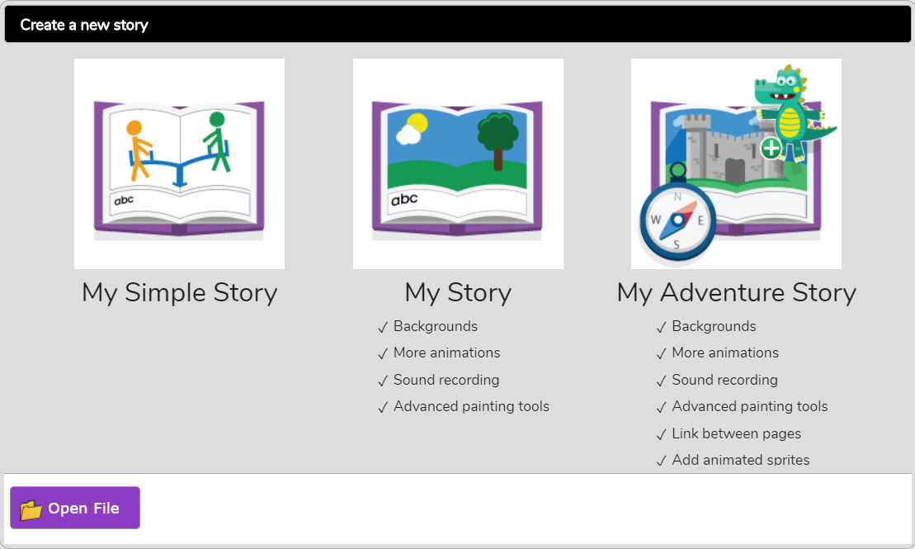

You might want to copy and paste the section you are performing.
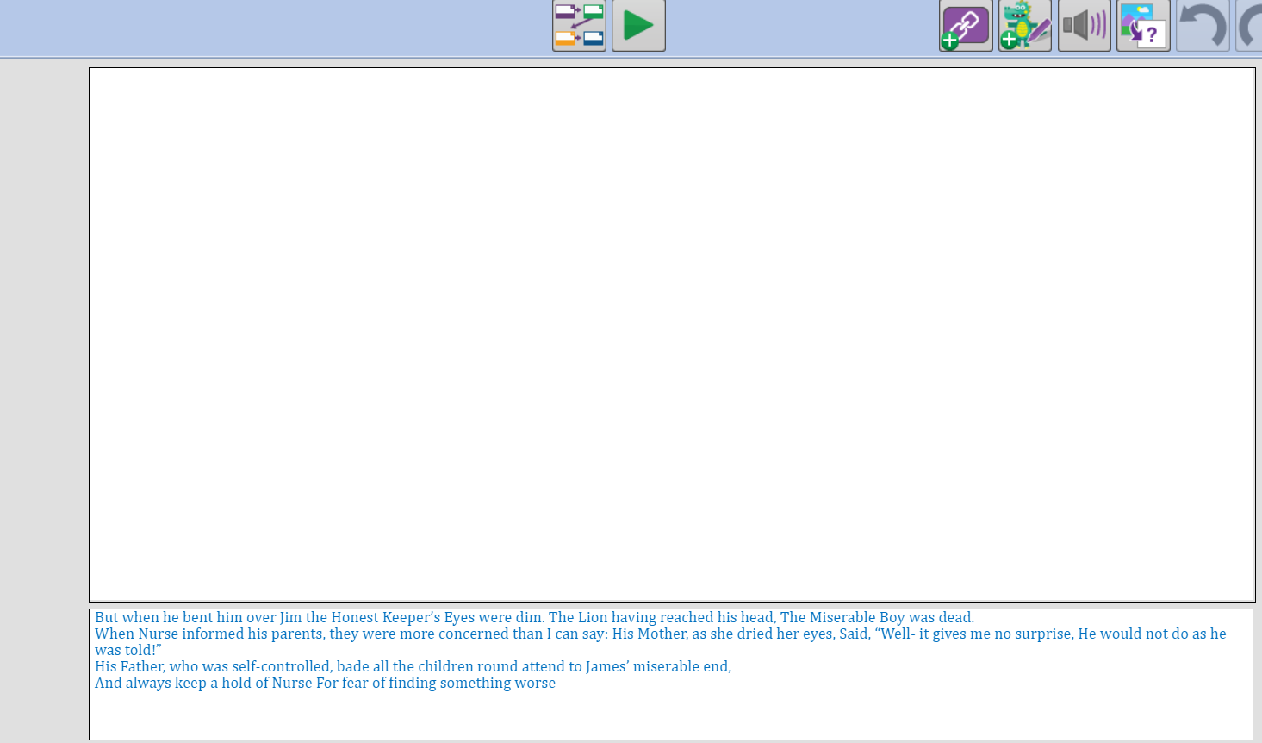

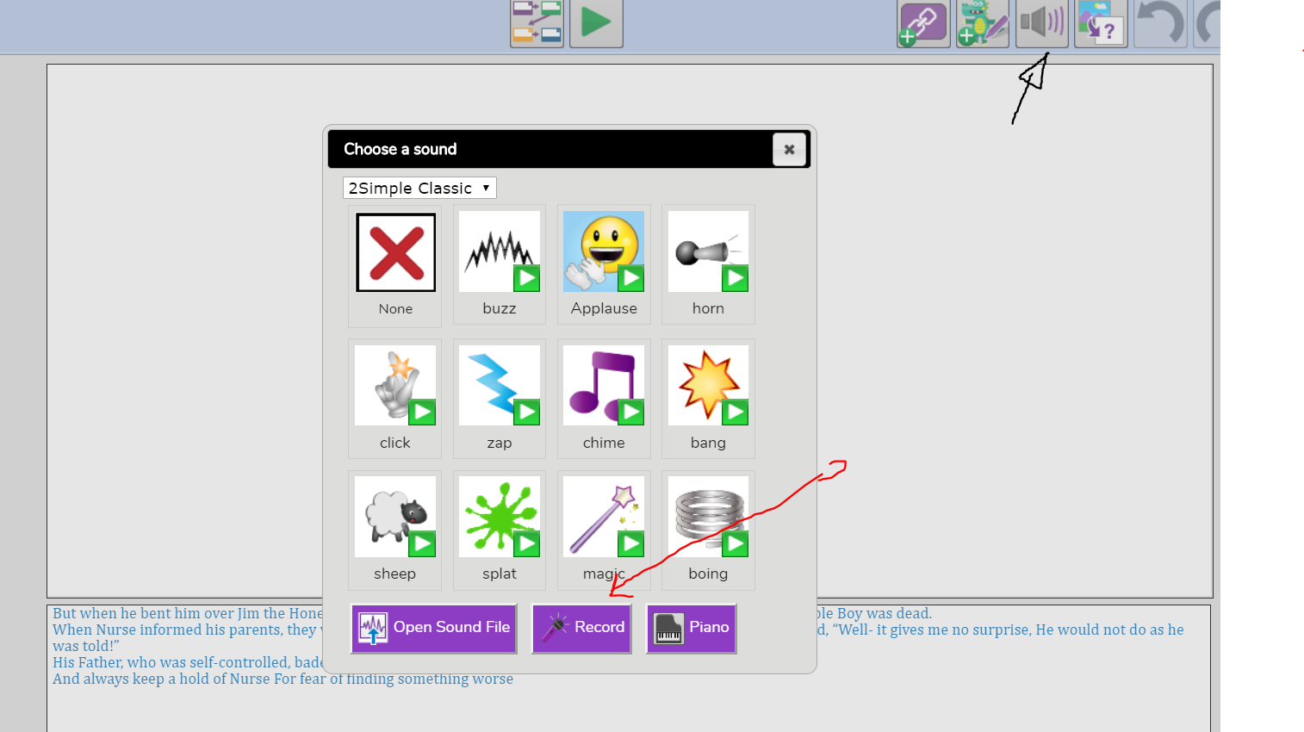
Choose the ‘sound’ button at the top right corner and click ‘record’
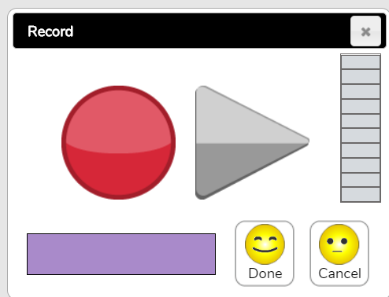

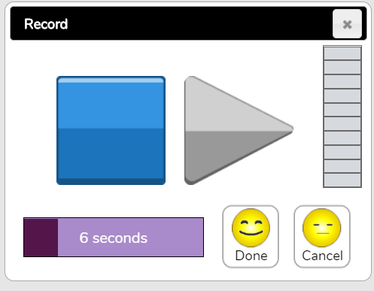
Press the big red button (record) when you are ready to speak.

You will know when it starts recording as the red button will turn into a blue square. Once you are done, click the blue button. Click ‘done’ and it will go into your story. Save your story for us to hear it!
You can only record for 30 seconds!

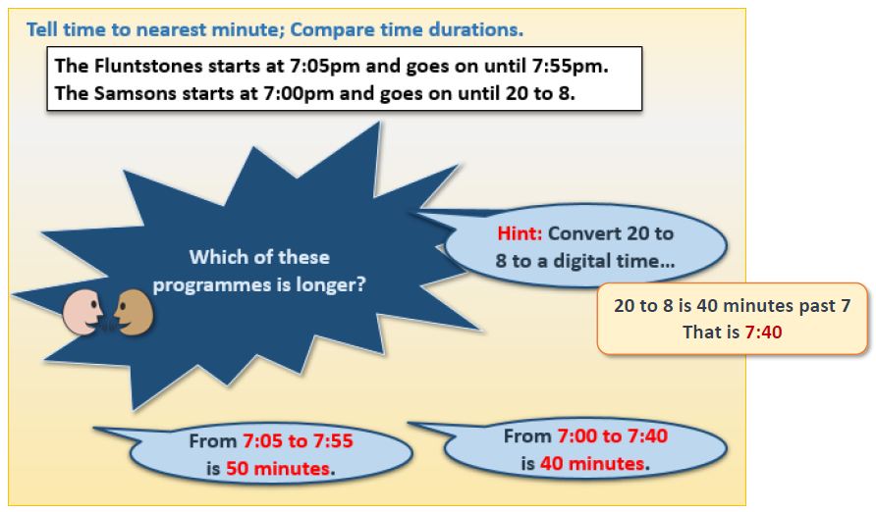
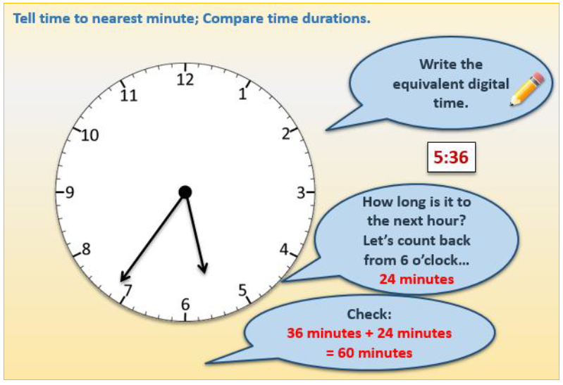
Maths Activity

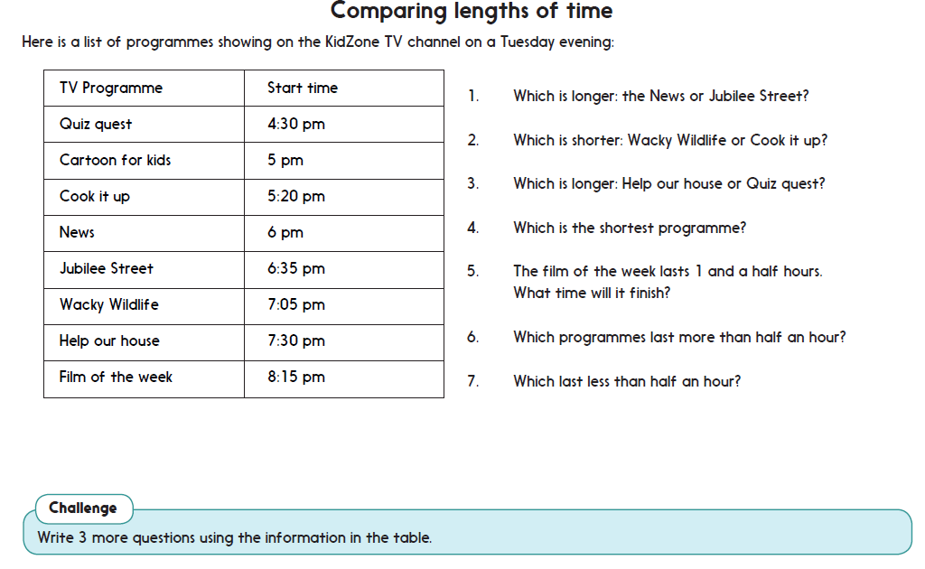

Afternoon Activity- SpaceX
We hope you all watched the SpaceX rocket launch to the International Space Station. If not, you can watch it here: https://www.bbc.co.uk/newsround/52526849
If you did watch it, did you manage to spot it in the sky? It was seen around 10:15pm near the moon!
The two astronauts flying are Robert Behnken and Douglas Hurley, they are two of Nasa’s most experienced astronauts. They have both been to space before and are even married to other astronauts!
About 10 minutes after launching, viewers spotted a dragon cuddly toy floating in the space craft! It is thought that it was being used to tell the astronauts whether they had zero gravity. As we know, gravity pulls us towards the core of the Earth so when the dragon floats, they know they have zero gravity.
This afternoon, we’d like you to complete an activity based around space! Here are some ideas but there are lots online too if you’d like to try something else.

Space Activity Ideas

Under the KS2 section on BusyThings, there are lots of Space activities.

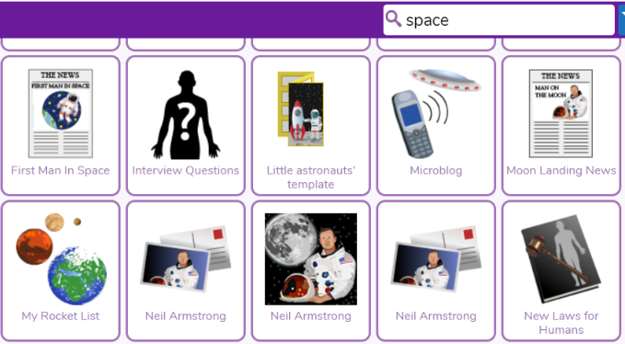

Type in ‘space’ on Purple Mash to find lots of activities.

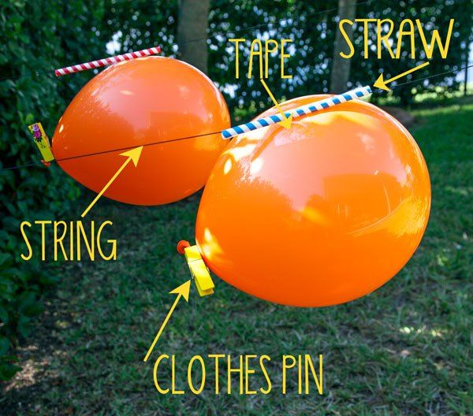

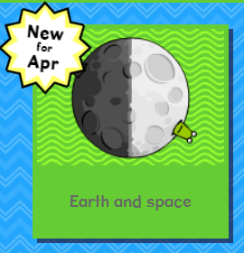


You could create a balloon rocket!



Or build a rocket out of a kitchen roll tube!

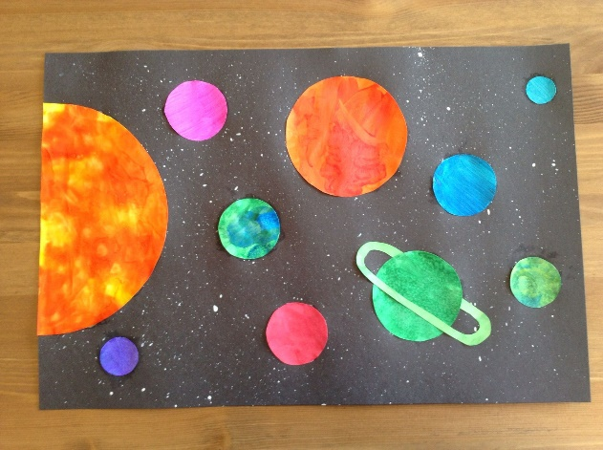

You could draw or paint a space picture.

Afternoon Activity- Human Bones

Watch this video from our favourite character – Dr Binocs. He will tell you all about the bones in our bodies.

https://www.youtube.com/watch?v=ywDOiNEdJVc

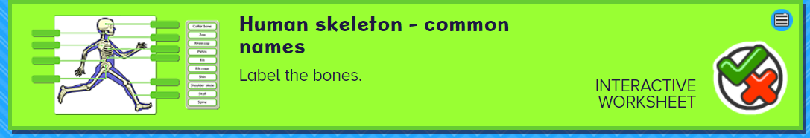
Once you have watched the video, try this interactive worksheet on BusyThings to label all the bones in our body.
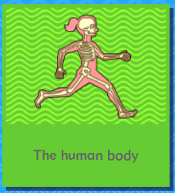

You can also try this CBBC quiz to help Doctober Xands pick the right bones!
https://www.bbc.co.uk/cbbc/quizzes/operation-ouch-doctor-xands-bone-picker

Joke for the day

What do you call a bear with no teeth?


A gummy bear!

