Tuesday 2nd June
Keep playing spelling shed!
Reading Activity
Continue with your Reading Bingo card, remember you may quiz on home books - just like we do at school!
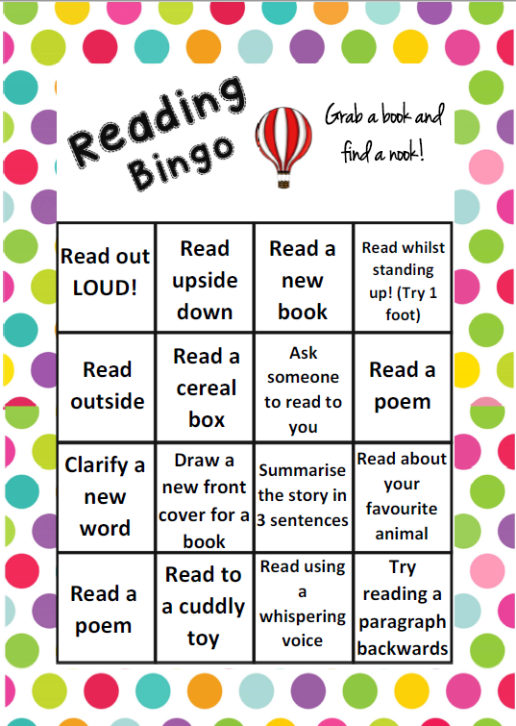
https://ukhosted65.renlearn.co.uk/2240525/

Writing Activity
Let’s look at some of the tricky words from the first part of our story – Jim: A Cautionary Tale. We will clarify these for you:
‘But there it was the dreadful fate befell him, which I now relate.’
- Fate- a power beyond one's control that is believed to decide what happens
- Befell – to happen to
‘That children never are allowed to leave their nurses in a crowd’
- Nurse – an old word for a ‘nanny’ or ‘babysitter’, someone who looks after your child.
‘Now this was Jim’s especial foible’
- Foible – a weakness in someone’s character
‘And on this inauspicious day, he slipped his hand and ran away’
- Inauspicious – similar to unlucky or unsuccessful.

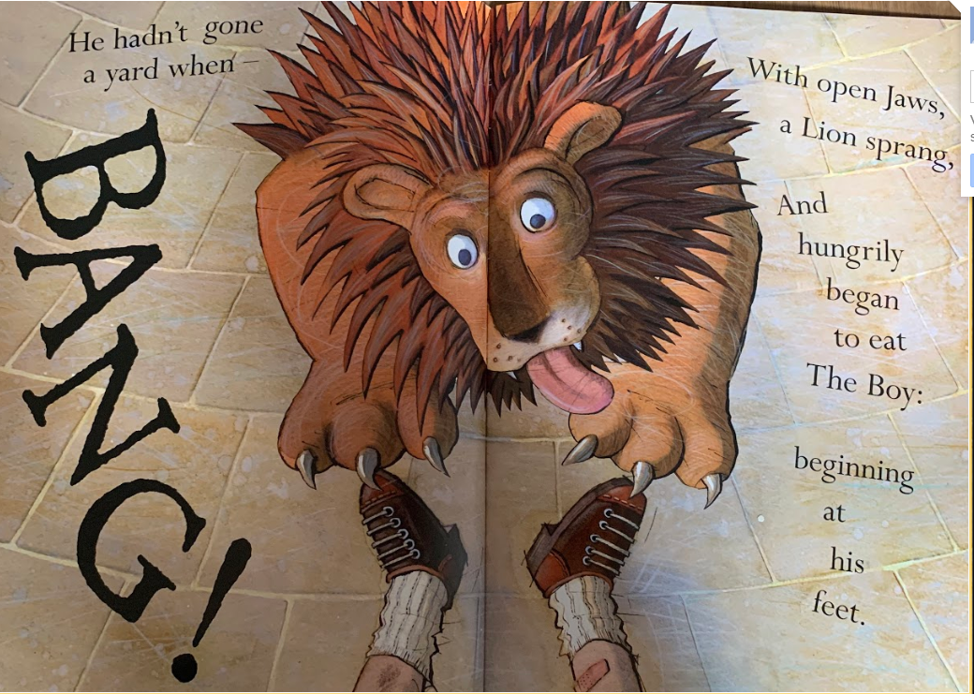
Finish reading the story.

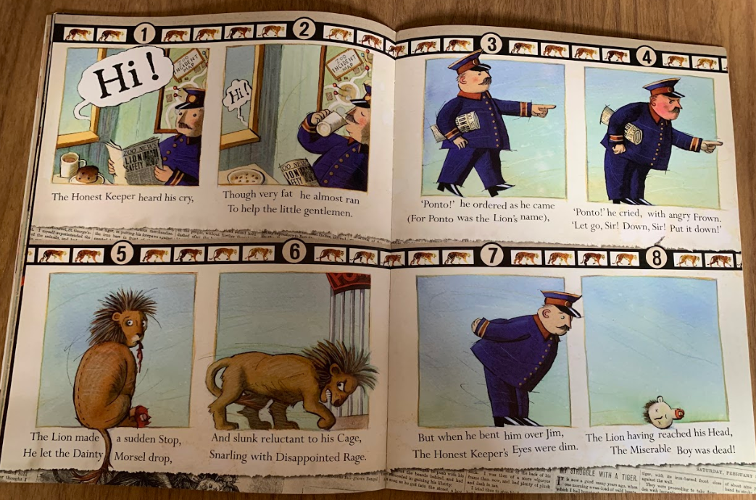
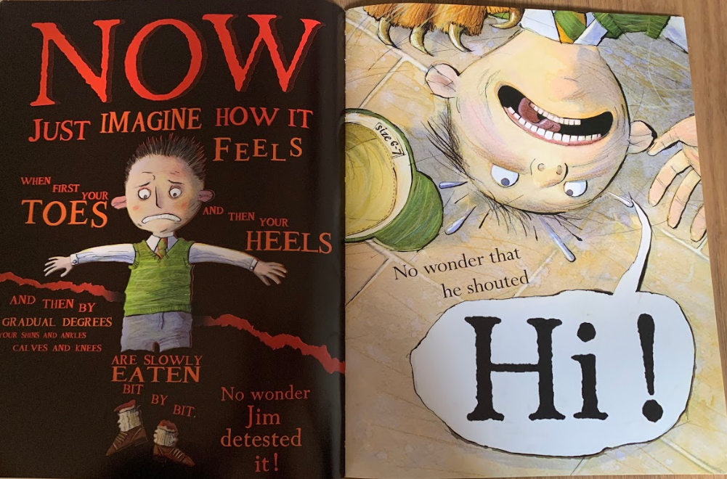

We will give you some lines from the tale, one rhyming couplet will be missing. Your task is to choose which word fits into the couplet best. We have created a quiz on Google Classroom for this task but the sentences are also below if you are writing on paper.

There was a boy called Jim;
His friends were very good to… (Tim or him)

They gave him tea, and cakes, and jam,
And slices of delicious… (ham or lamb)

That children never are allowed
To leave their Nurses in a… (proud or crowd)

And on this inauspicious day
He slipped his hand and ran… (away or to play)

‘Ponto!’ he cried, with angry frown.
‘Let go, Sir! Down, Sir! Put it… (crown or down)

His Mother, as she dried her eyes,
Said, ‘Well – it gives me no… (lies or surprise)

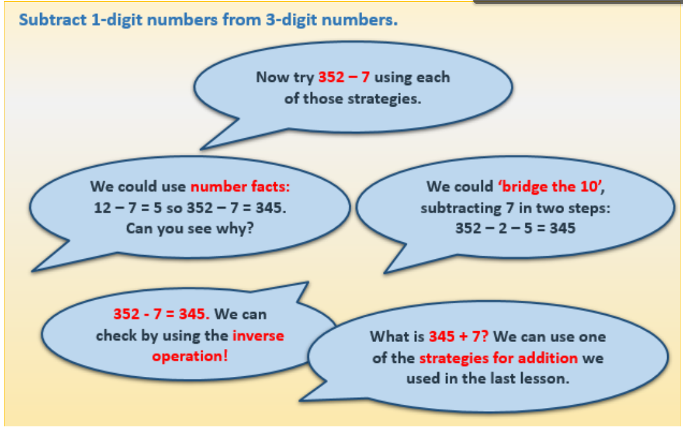
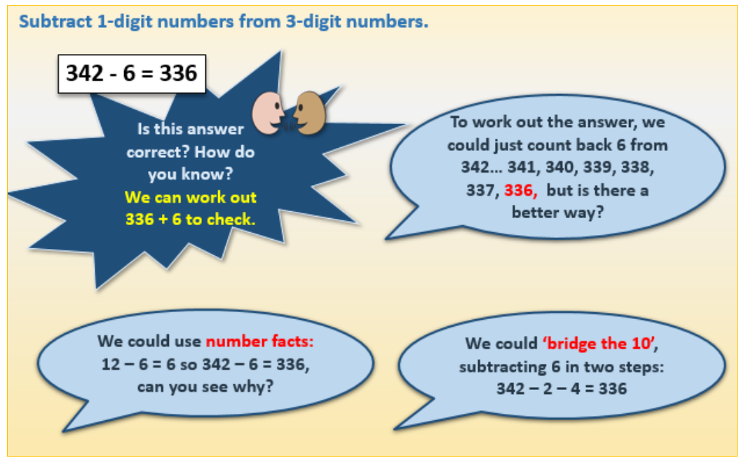
Maths Activity
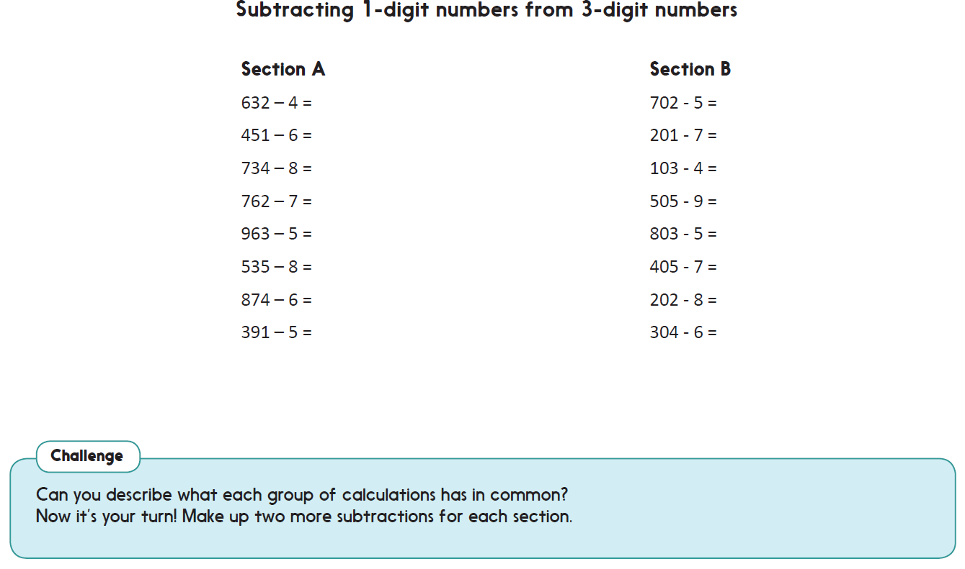
Afternoon Activities
A micro:bit is a piece of hardware which we have at school, unfortunately we did not have the time to play and experiment with them. However, micro:bit have a website where you can code virtually. Continue with your coding on the micro:bit, move onto ‘Name Tag’. If you’ve already done this one, try another!
https://makecode.microbit.org/#
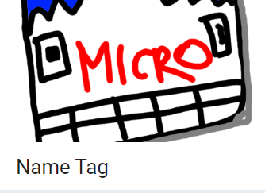
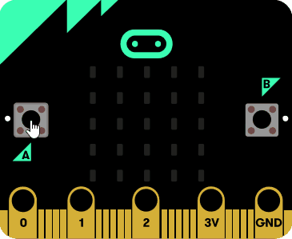

Joke for the day
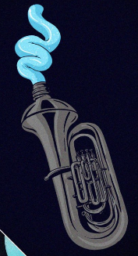
What instrument can be found in the bathroom?

A tuba toothpaste!

