Monday 1st June
Spellings for the Week – On Spelling Shed
(Linked to our new book)
- accidentally
- caught
- experience
- learn
- mention
- naughty
- tale
- caution
- dangerous
- warning
Reading Activity
We have made you a Reading Bingo card! There are 16 squares so if you complete 1 square a day, there should be enough to last you for the next two weeks. We have put ‘Read a poem’ on twice as we will still post a poem on Wednesday like normal. Please send us photos of you completing activities!
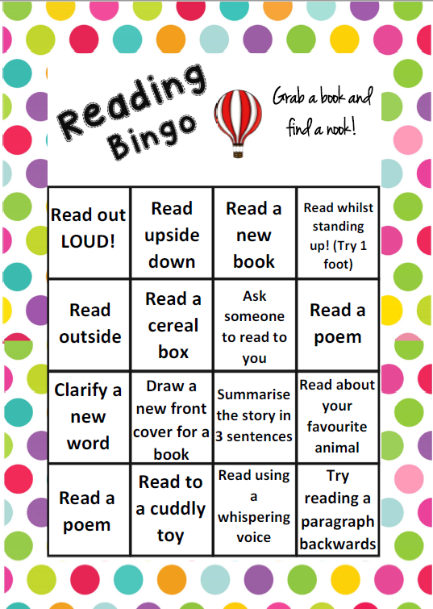

Writing Activity
We are reading a new book for the next two weeks, called ‘Jim: A Cautionary Tale’. This is a fiction book, because it is an imaginary story.
Today, we are focusing on the word consequence. A consequence is a result or effect which is usually negative or unpleasant. Actions have consequences, we are going to explore cautionary tales which have these.
Think/talk about:
- What do you think will happen if you tell too many lies?
- What do you think will happen if you run away from the person looking after you?
Finish these sentences with what you think the consequence will be:
- If you tell too many lies, then…
- If you run away from the person looking after you, then…
- If you eat too many sweets, then…
- If you don’t share your toys, then…
- If you don’t do your homework, then…
- If you steal something, then…
- If you are unkind to someone, then…
Extra – You might like to create a Warning! poster to warn people of the dangers of eating sweets/not doing your homework etc.
Once you have completed the writing activity, you may start reading the first pages of our new book.
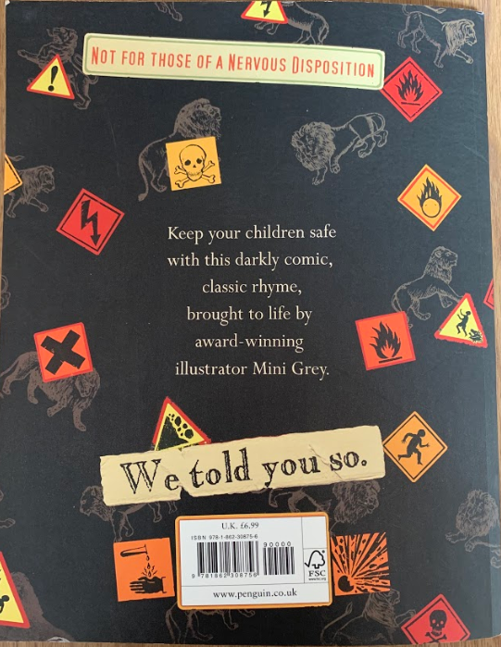
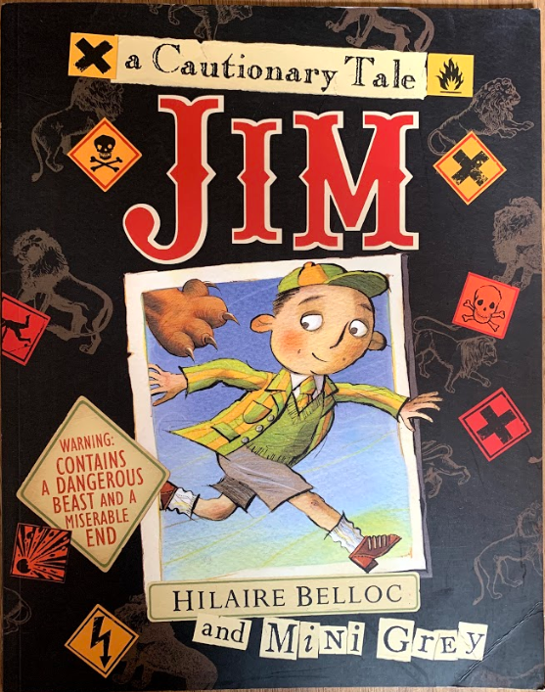

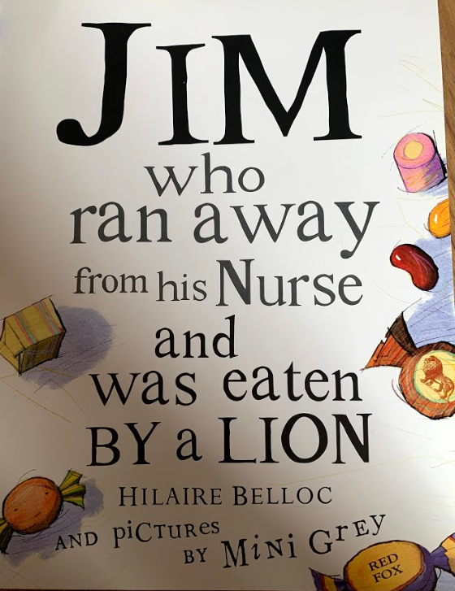
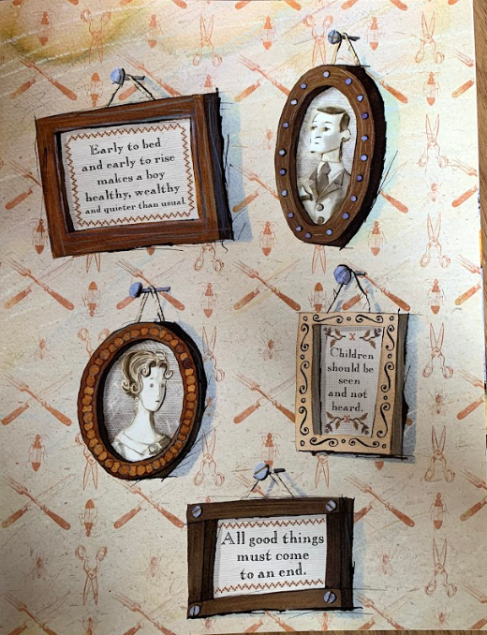

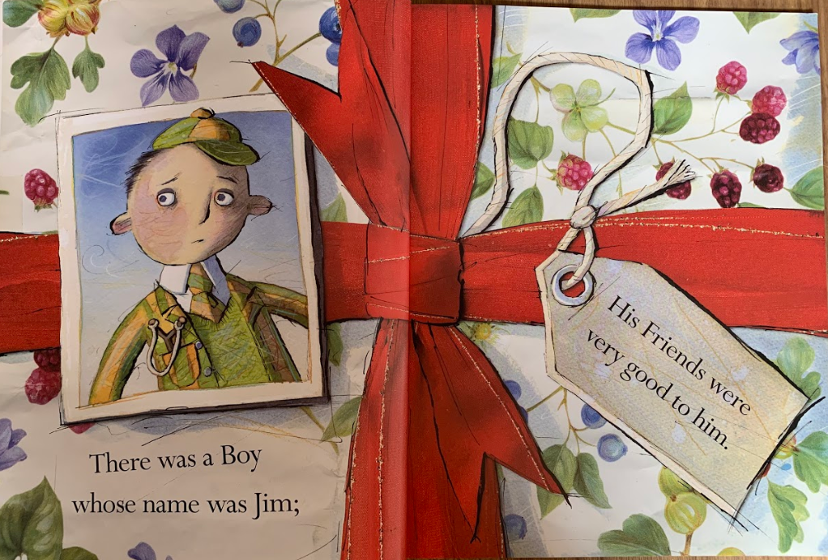

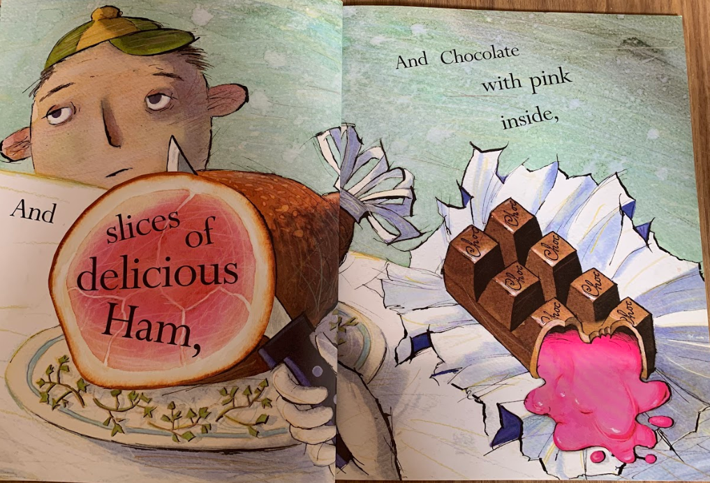
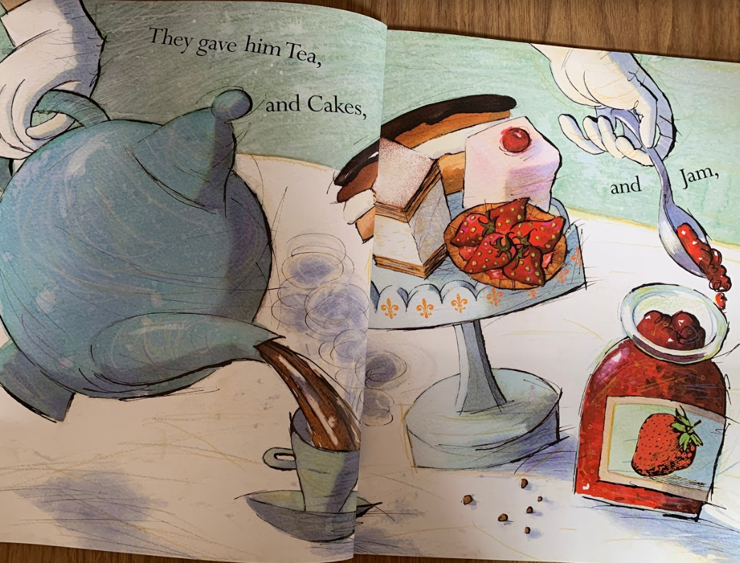

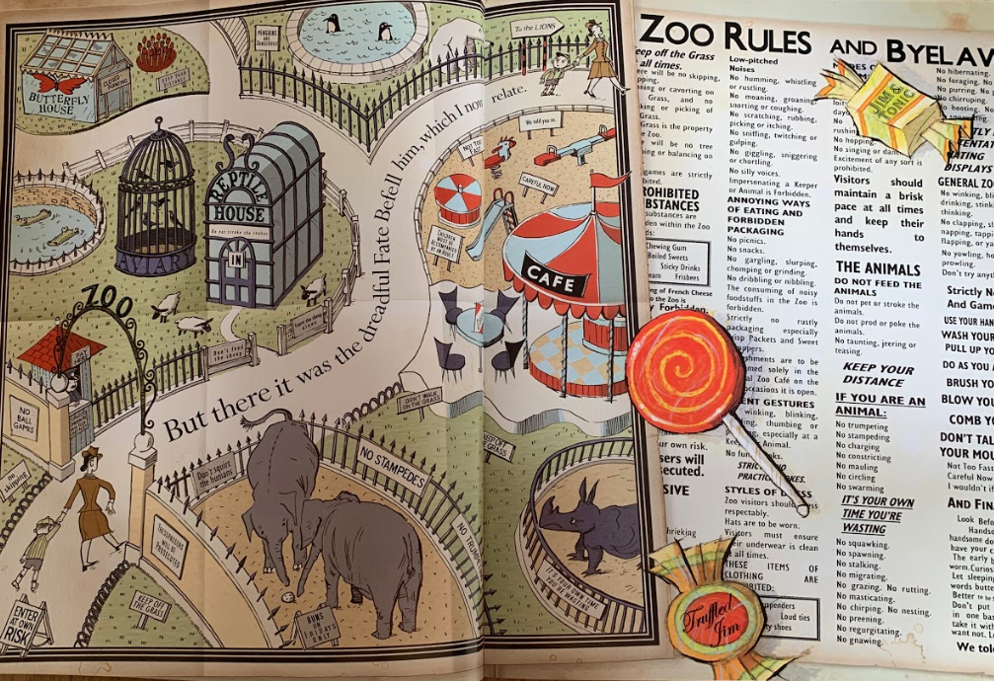
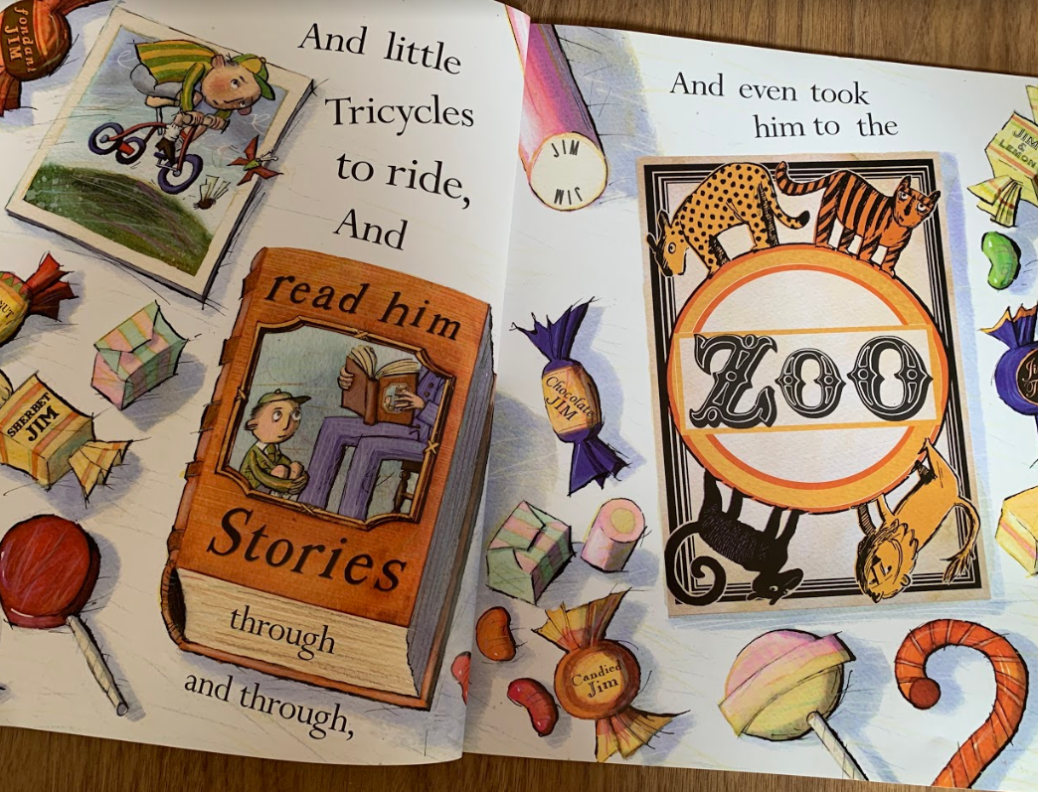
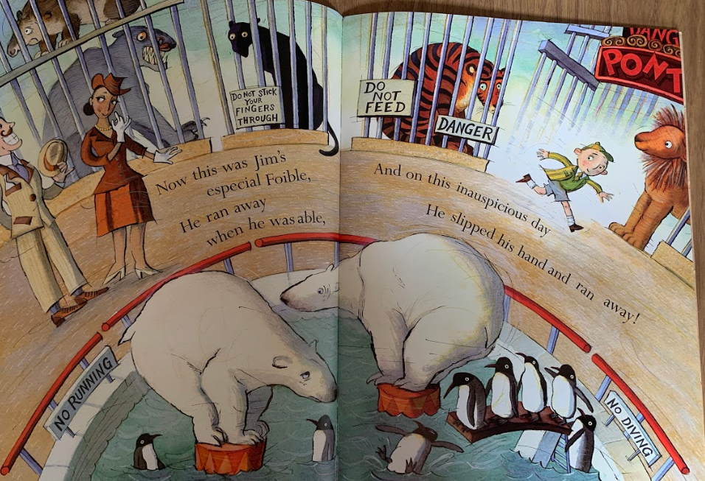
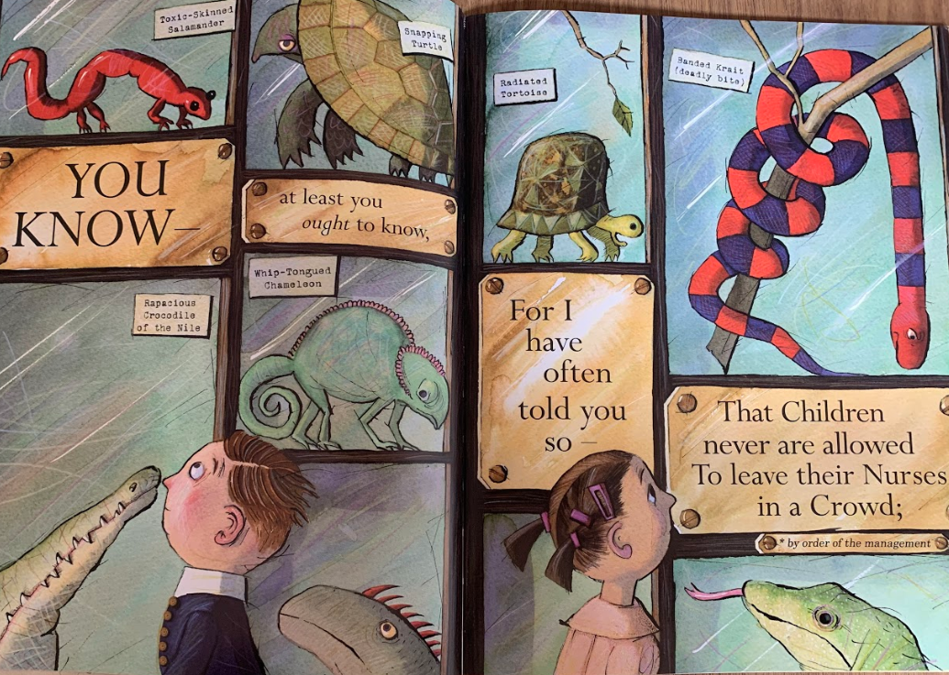

Jim slipped his hand and ran away! What do you think will happen to Jim? Look at the photos as there is a clue. We will find out tomorrow.

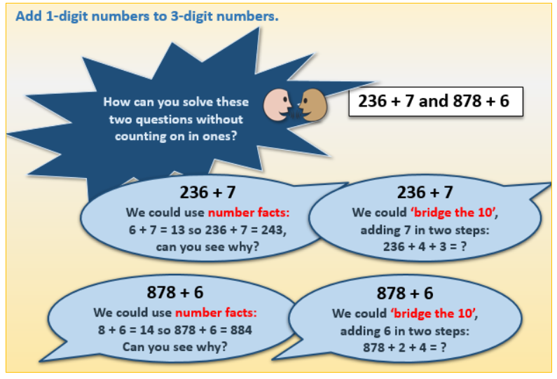
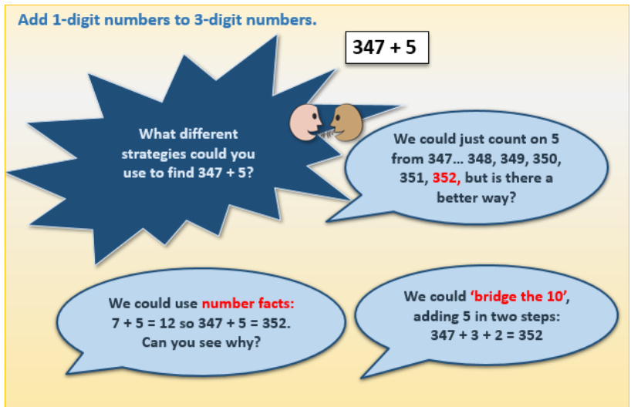
Maths Activity

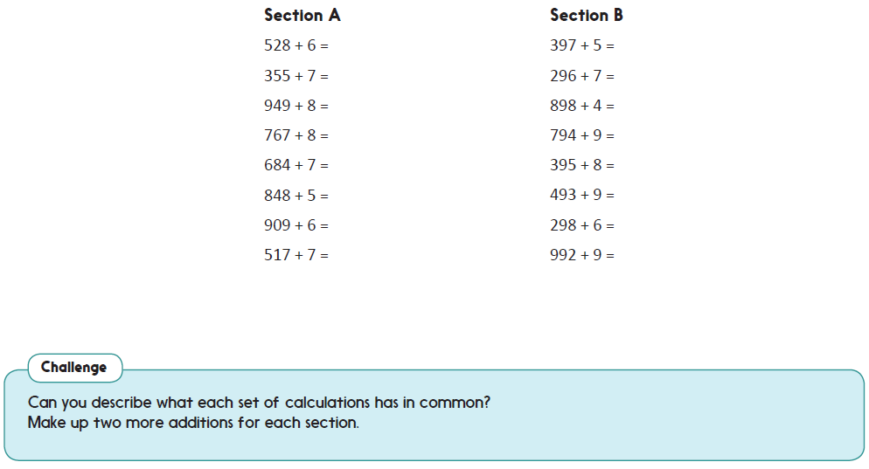

Afternoon Activities
We are moving on from our Artist topic, to a new topic called ‘Crime and Punishment’. We have looked through the activities and lessons which we would have taught at school and adapted them for home learning.

For our first week, we are going to research and sketch historic criminals. A criminal is someone who has broken the law. These criminals are from a long time ago so they would be treated differently if this happened today. Choose 1 criminal, write 5 facts about them and sketch them. You may do this on the 2Do on Purple Mash or on paper.

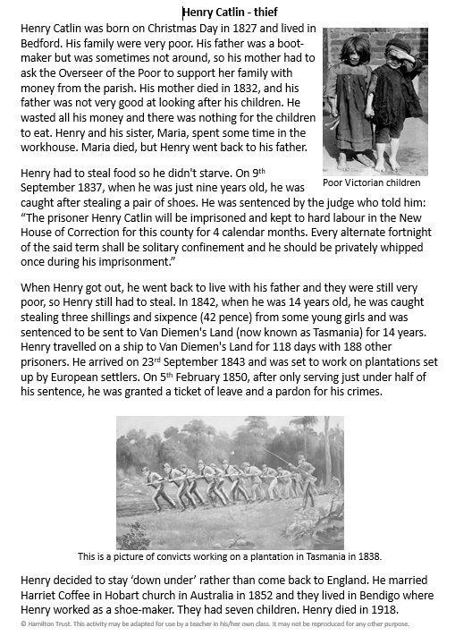
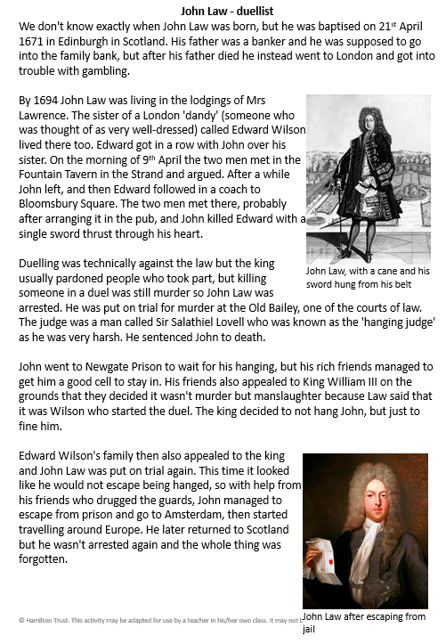
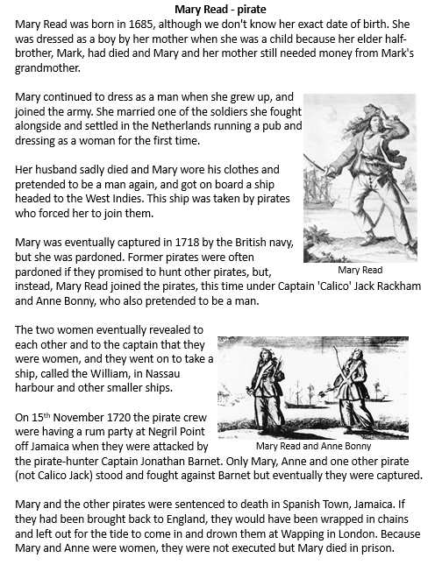
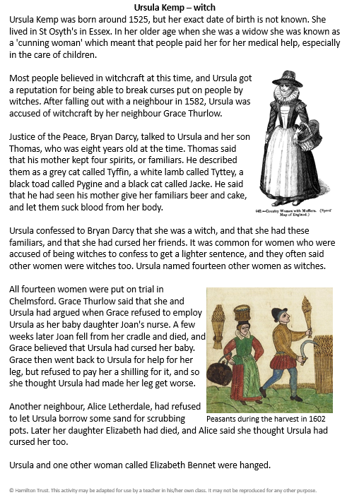
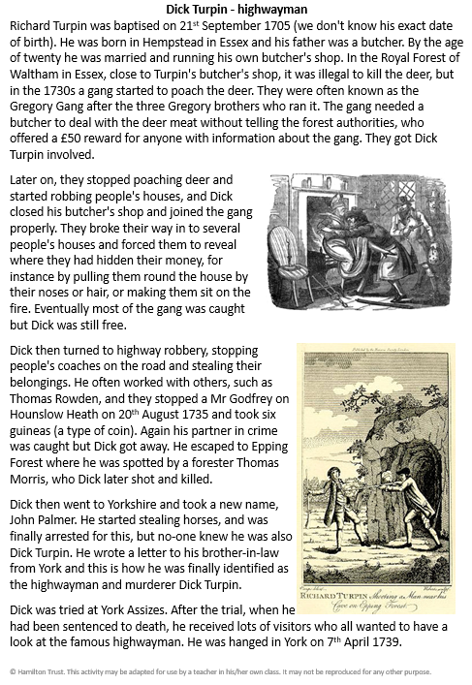

Joke for the day

Why did the dinosaur cross the road?

The chicken wasn’t born yet!


