Friday 22nd May
Hope you all have a lovely half term next week!
Remember – We are going to attempt a Hive game today for our spellings on Spelling Shed.
1st code posted at 9:45am for a 10am start.
2nd code posted at 11:45am for a 12pm start.
Both games will have the same spellings.

Reading Activity
Read this information about Piet Mondrain.
Piet Mondrain is a Dutch artist best known for his abstract paintings. Art that is abstract does not show things that are recognisable such as people, objects or landscapes. Instead artists use colours, shapes and textures to achieve their effect.
As well as abstract art Mondrian was also passionate about dancing! Apparently he didn't like slow traditional dances like waltzes or tango, but enjoyed high energy, fast dancing styles! He even called one of his abstract paintings Broadway Boogie Woogie after a popular dance of the time.
When Mondrian made his paintings, he would always mix his own colours, never using the paint directly out of a tube. He often used primary colours – red yellow and blue – as in this painting.
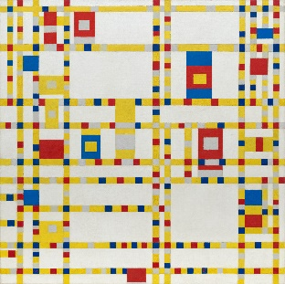
Explore Piet Mondrain further on the Tate website: https://www.tate.org.uk/kids/explore/who-is/who-piet-mondrian
Listen to ‘Boogie Woogie’ here!
https://www.youtube.com/watch?v=76dJIRh4BU0
If you would like to, you may complete this activity on Purple Mash which is all about Piet Mondrain.

Writing Activity
Here is a link to a sweet video of a child explaining the story, watch it and see if you thought the same as him.
https://www.youtube.com/watch?v=rxmSpQqKUU0&feature=youtu.be
Flotsam Poem
We are going to write an acrostic poem using the letters from Flotsam.
You could describe the creatures, the boy’s feelings or the beach.
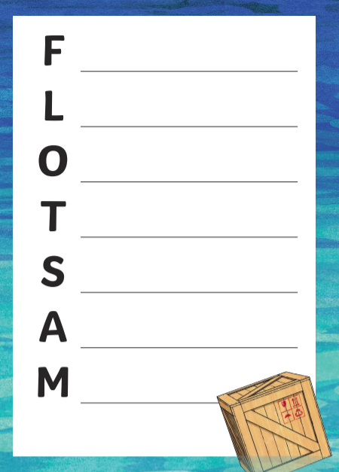

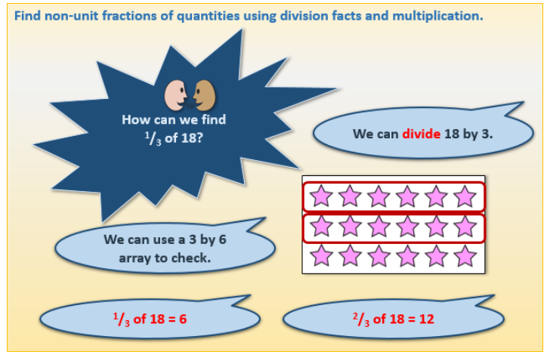
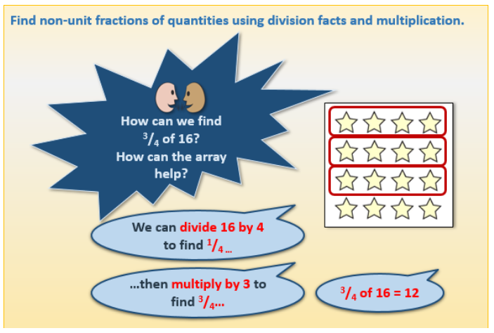
Maths Activities

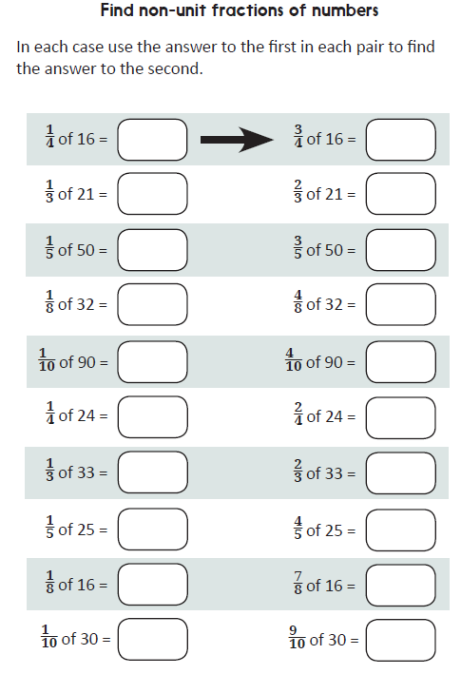

Afternoon Activities
Mental Health Week – Be Inspired
Happy Friday! For our last day of Mental Health Week, we are focusing on being inspired.
It is fair to say that we have both been incredibly inspired by all of you over the past months. You have all been so strong and amazing at adapting to this new way of life. We have had good days and down days but we pull ourselves back by remembering that this will not last forever and we will see each other soon. Today is about loving being YOU!
Activities:
- Sing and dance along to Firework by Katy Perry or This is Me! From The Greatest Showman.
https://www.youtube.com/watch?v=QGJuMBdaqIw
https://www.youtube.com/watch?v=CjxugyZCfuw

- Complete the ‘I Love Being Me’ activity on Purple Mash to tell us why you love being you!

Afternoon Activities – Piet Mondrain
Try to imitate a piece of artwork by Piet Mondrain. This piece of art is called
Composition with Yellow, Blue and Red 1937–42
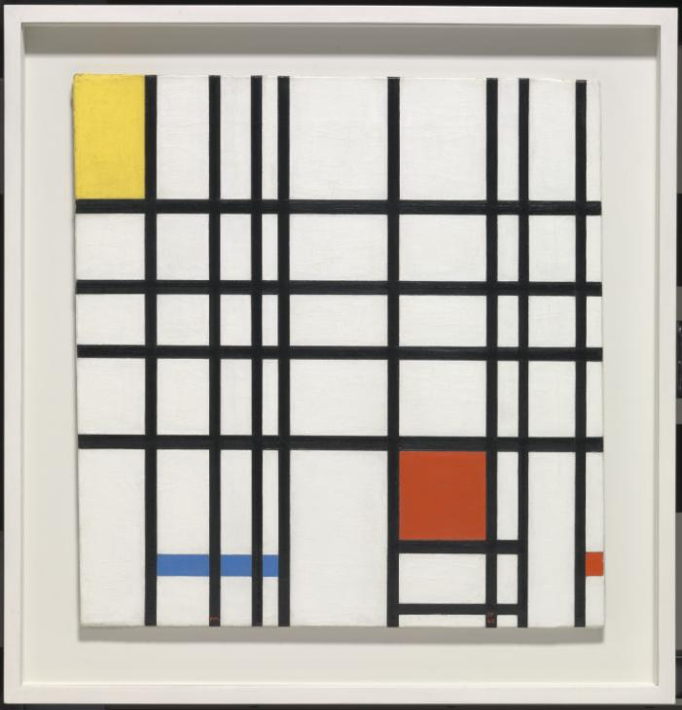

Afternoon Activities – Eid
Eid in Arabic means “feast, festival, holiday.” Eid is a worldwide festival and celebration for Muslims. During the calendar year there are two Eid's that are celebrated by Muslims. Eid ul Fitr, which means “festival to break the fast”, is at the end of the holy month of Ramadan in which Muslims fast for a whole month.

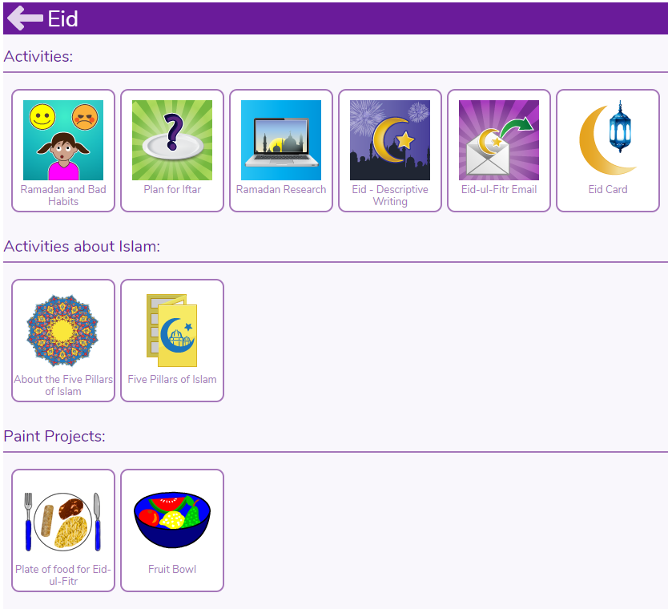

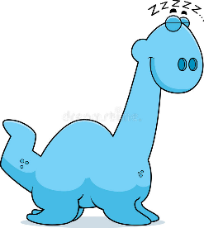
Joke for the day
What do you call a dinosaur who is already asleep?
A Dino-snore!
Thank you for the joke Becky!

