Thursday 21st May
Remember – Keep playing Spelling Shed!
Hive Games tomorrow.
1st code at 9:45am for a 10am game.
2nd code at 11:45am for a 12pm game.

Reading Activity

Read your own book at home, this might be a story book, magazine, recipe book or even the back of a cereal box!
PurpleMash have some great online stories, which are split into chapters. Each chapter has a quiz and accompanying activity on PurpleMash. To find this, click on ‘Serial Mash’ on the home page.

PE
Today, we would usually have PE.
You could carry on with the Joe Wicks workouts. Can you create your own workout too? Think about the different techniques Mr Duffin has taught you to ensure you are using all your muscles, you could even post your workout on Class Dojo. Try to use different moves from last week so we can see something different!
https://www.youtube.com/watch?v=TUp2_VAHIrI
Jake has sent me photos of his workouts! Check out this on below.
Burpees Lunges Long jump Tuck jump
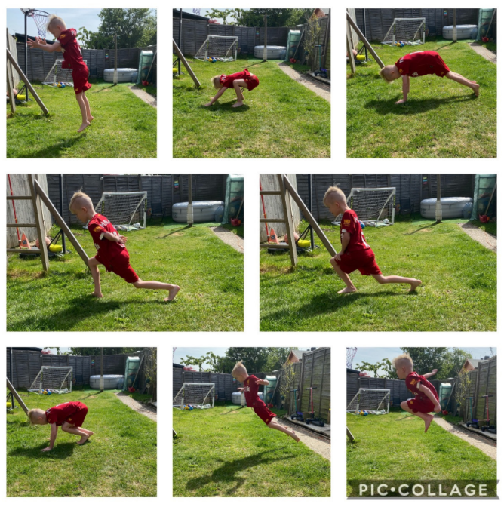

Or you could carry on with your dancing! Try this Trolls workout to ‘Can’t Stop the Feeling’, it’s only 3 minutes long!

https://www.youtube.com/watch?v=KhfkYzUwYFk


Music
We would usually have a music lesson today. As a school, we have links with the Bromley Youth Music Trust (BYMT) who have created music lessons through video.
The video is on Google Classroom, please watch week 4.

Afternoon Activities
Mental Health Week – Keep Learning
Today, we are focusing on the theme ‘keep learning’.
Learning new skills can improve your mental wellbeing by: boosting self-confidence and raising self-esteem, helping you to build a sense of purpose and helping you to connect with others.
Activities:
- Draw with Rob! In Year 3, we love drawing with Rob. If you haven’t done so already, try today’s creation. http://www.robbiddulph.com/draw-with-rob

- Try creating some towel art Follow this YouTube video with step by step instructions. https://www.youtube.com/watch?v=w4sb6OAnvAY

- Using the numbers 25, 50, 2, 7, 5 and 8. Can you make the number 309? You may use +, -, x or ÷

Afternoon Activities – Spanish
Please continue with Spanish on Language Nut. This week, we have set a ‘Where I Live’ activity. Please contact your class teacher for usernames and passwords.

Joke for the day

Why do bicycles fall over?
They are two – tired!



