Wednesday 20th May

Remember – Keep playing Spelling Shed!

Reading Activity
Read this short poem by Carol Ann Duffy.

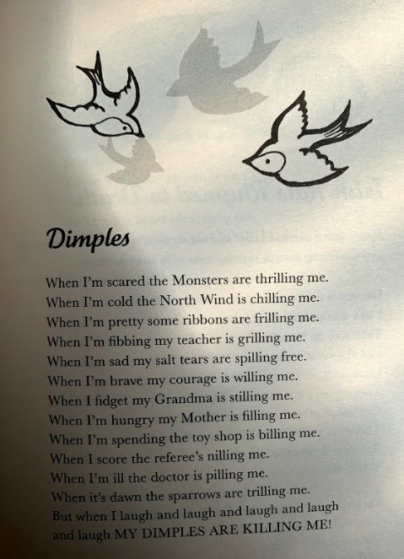

Questions
- Why is the poem called ‘Dimples’?
- What do the words ‘thrilling, chilling frilling’ have in common?
- Clarify the word ‘trilling’.
- What happens when the character is fidgeting?
- What happens when the character is scared?
- Does the poem end positively or negatively?
- Why does the author use all CAPITAL LETTERS at the end of the poem?

Writing Activity

The story is called ‘Flotsam’ which is the wreckage of a ship or its cargo found floating on or washed up by the sea.
The sequel (which you are completing today) is going to be called ‘Jetsam’, which is unwanted material or goods that have been thrown overboard from a ship and washed ashore
The difference between flotsam and jetsam is that flotsam is made up of objects which were overboard accidentally but jetsam is made up of objects which were thrown overboard on purpose to lighten the ship or because it wasn’t needed anymore.
Yesterday, you planned the sequel, called Jetsam, using the bare bones planning frame. Today, you are going to write/draw the sequel. There are two options for this, choose the one which you are happiest with.

Writing
You can simply write the story on a blank Google Classroom document.
Story board
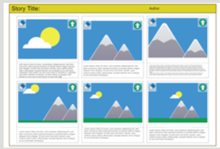
You can use the storyboard template on PurpleMash to draw and write your story.

Maths Activity
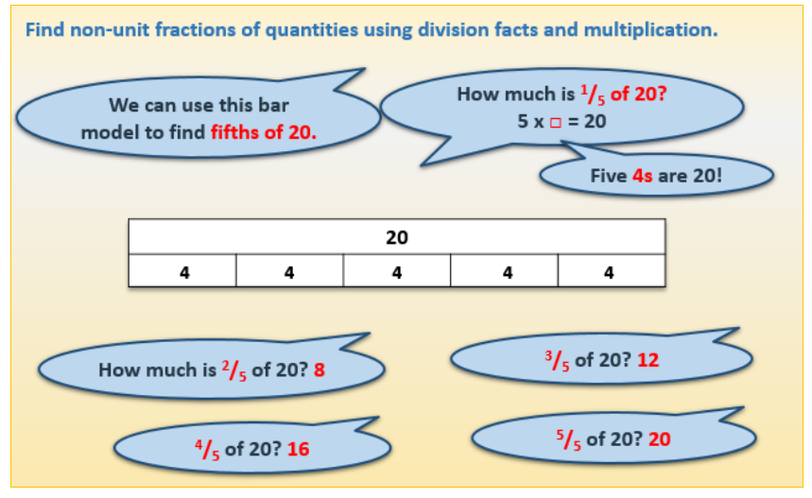
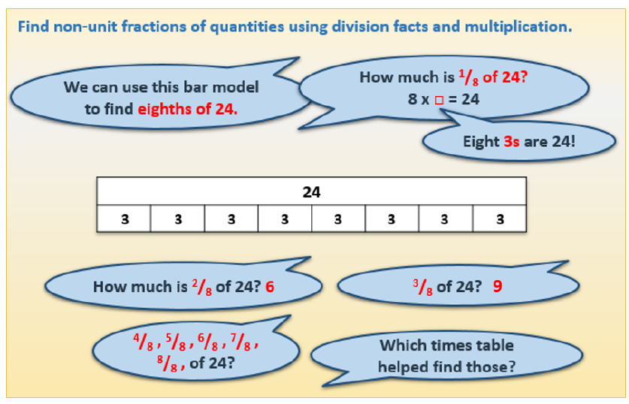

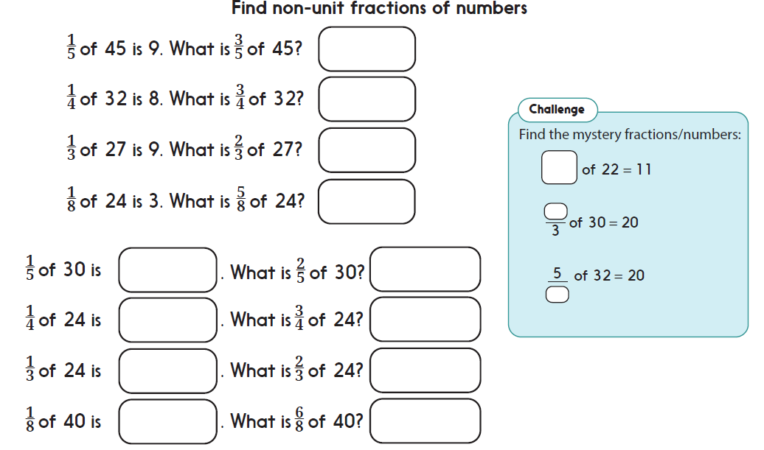

Afternoon Activities
Mental Health Week – Be Mindful
We are halfway through Mental Health Week and today we are focusing on being mindful.
Mindfulness is an approach that helps people to manage their thoughts and feelings and mental health. It is about paying more attention to the present moment – to your own thoughts and feeling, and to the world around you.
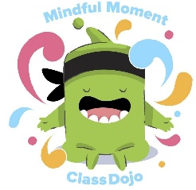
Activities:
- Take part in a Class Dojo Mindfulness activity with Mojo. https://www.youtube.com/watch?v=7KKqcH3EMBI

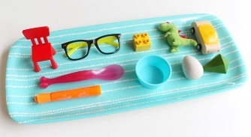
- Play a memory game Gather 10 objects from around your home and lay them on the floor. Cover your eyes and ask someone to take an object away. Can you spot what is missing? To make it trickier, you could take away 2 or 3 objects!

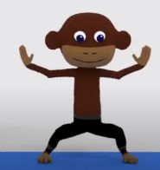
- Try Yoga! Watch this YouTube video and concentrate on each of the animal moves. https://www.youtube.com/watch?v=75m2xWoFBaA

Joke for the day

What did the traffic light say to the car?

Don’t look, I’m changing!
Thank you for the joke Karim!


