Tuesday 19th May
Remember to keep playing Spelling Shed.
Reading Activity
Please log onto Read Theory and complete 3 activities or visit the Collins BigCat website (https://connect.collins.co.uk/school/Portal.aspx) and log in using this username and password to access hundreds of eBooks. There are also worksheets which can be used alongside the books, which can be found here: https://collins.co.uk/pages/big-cat-ebooks
Go to https://connect.collins.co.uk/school/Portal.aspx and click on the Teacher portal and enter:
Username: parents@harpercollins.co.uk
Password: Parents20!
Click Login.

Writing Activity
Look at the final pages of the story to find out the ending.
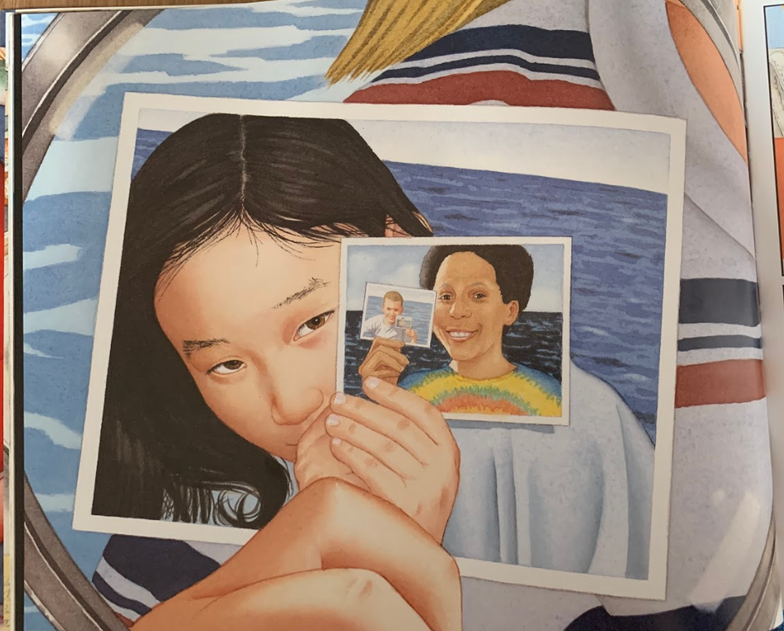

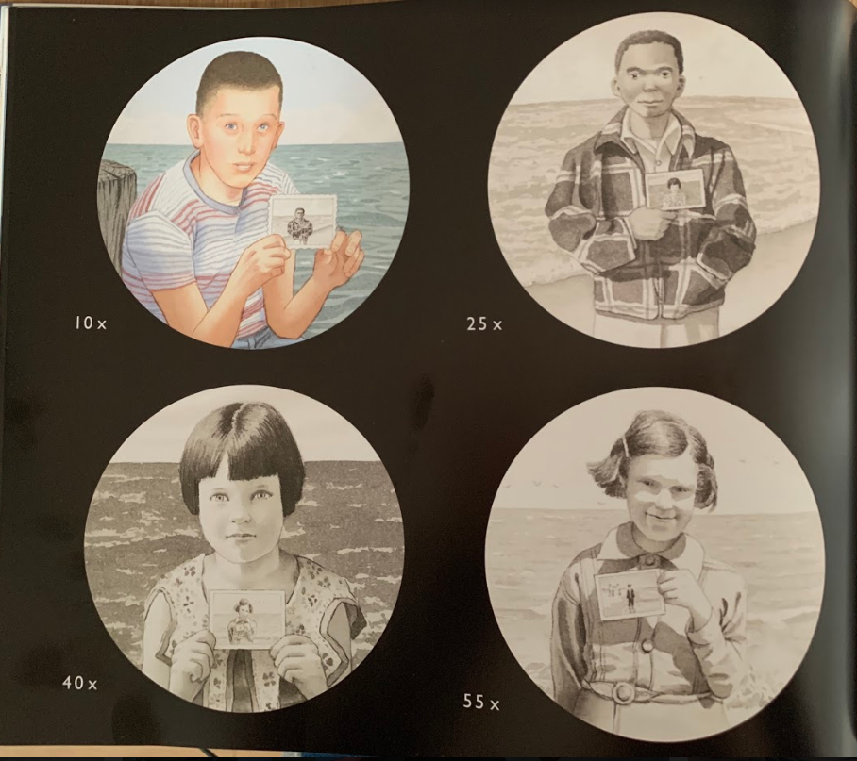
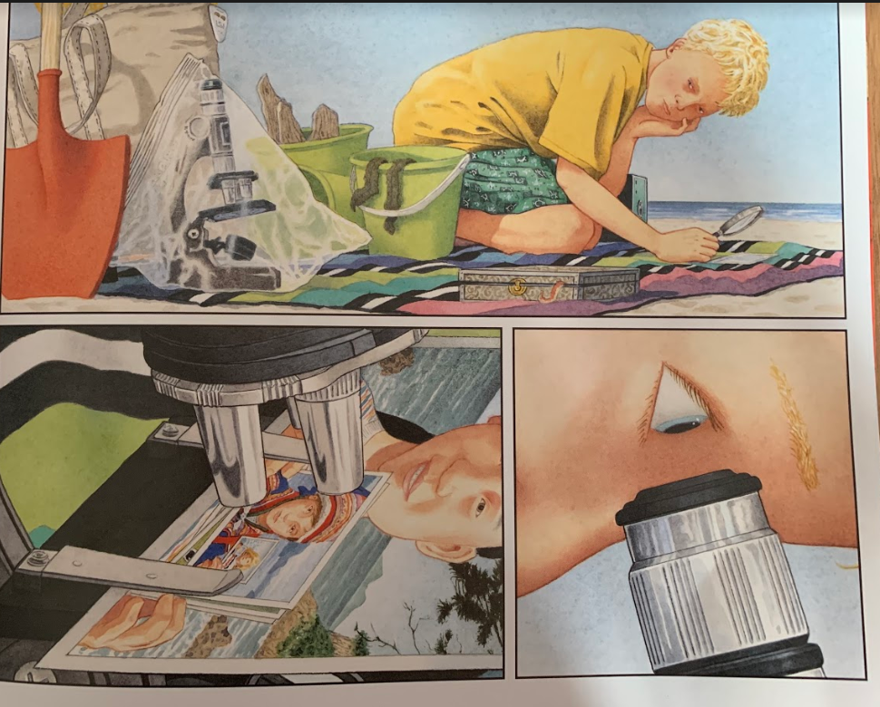
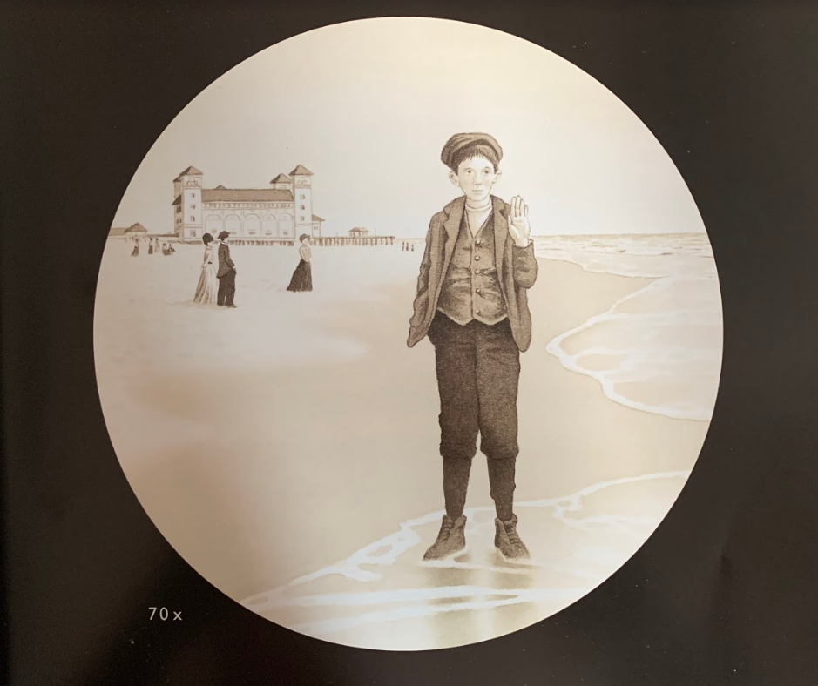

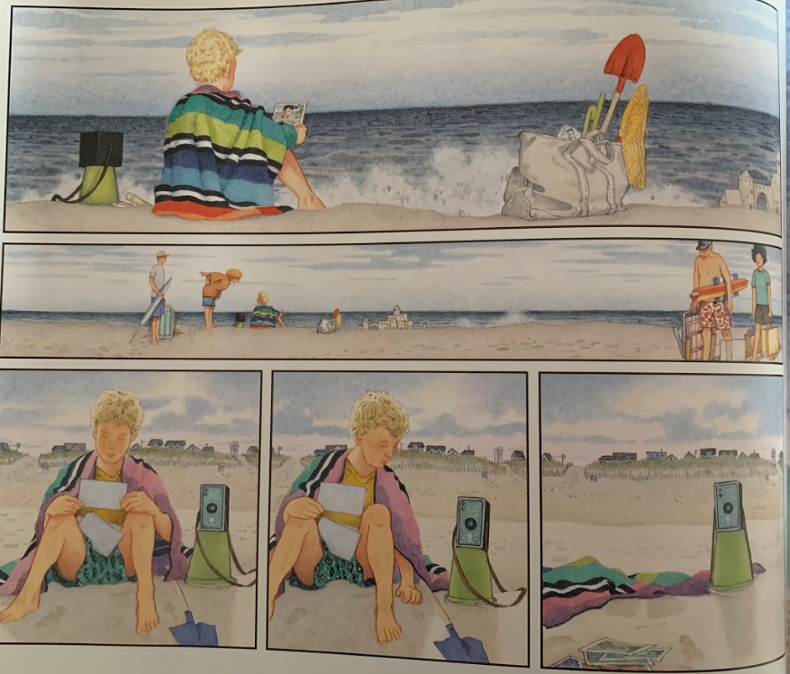

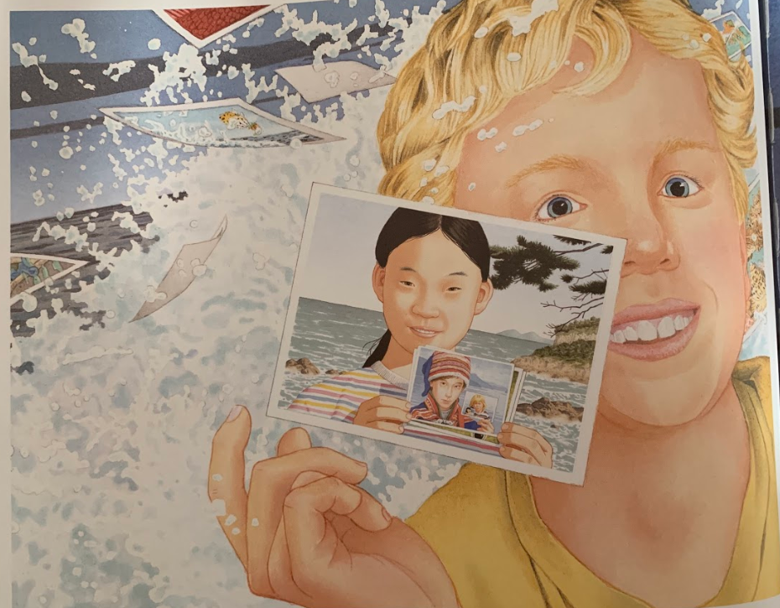
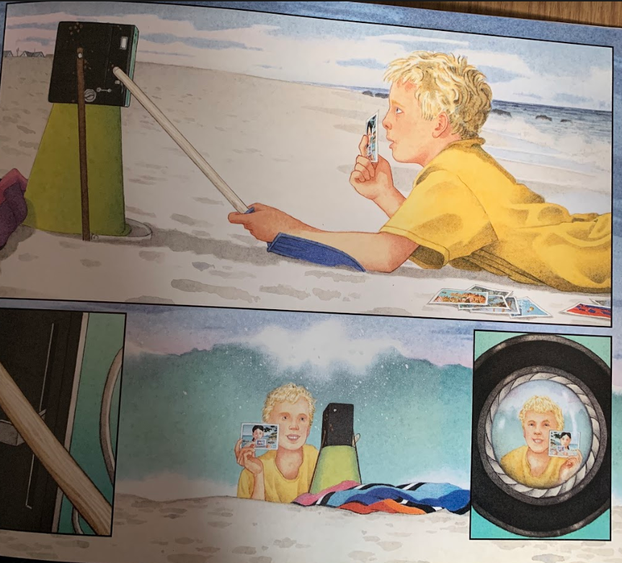
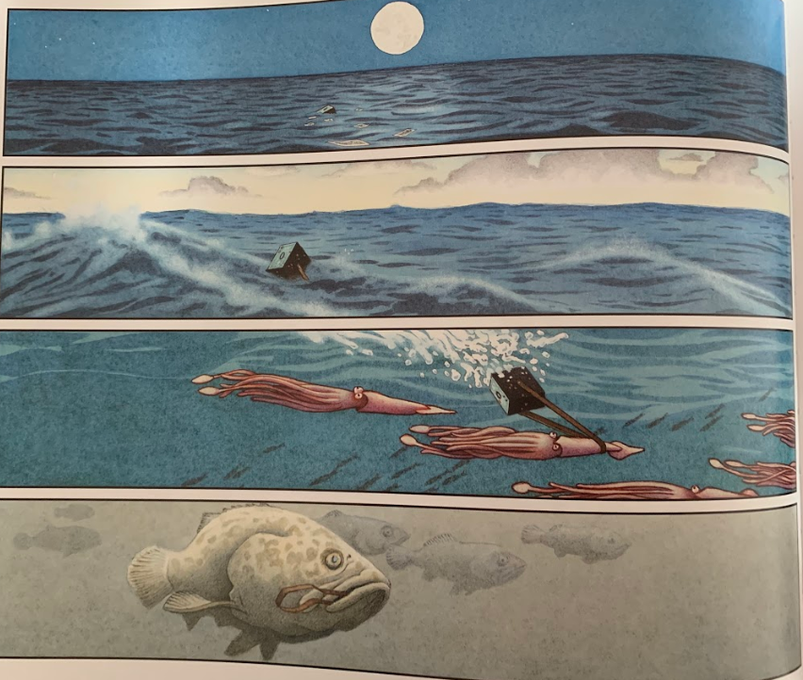
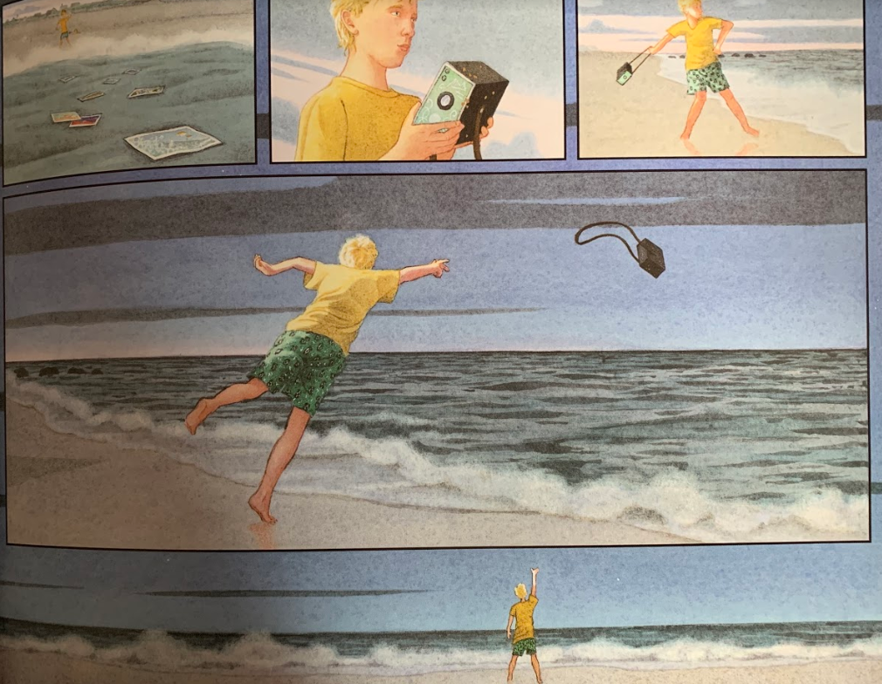

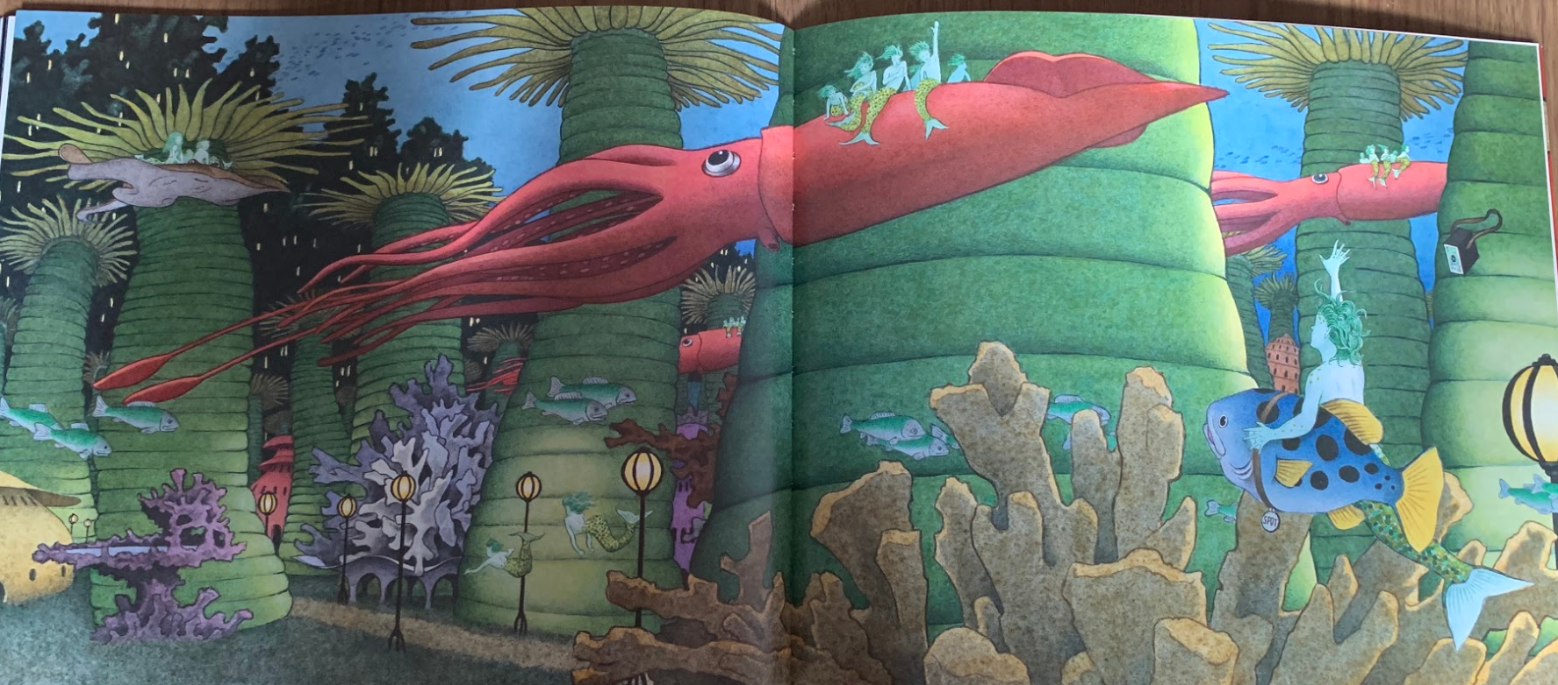
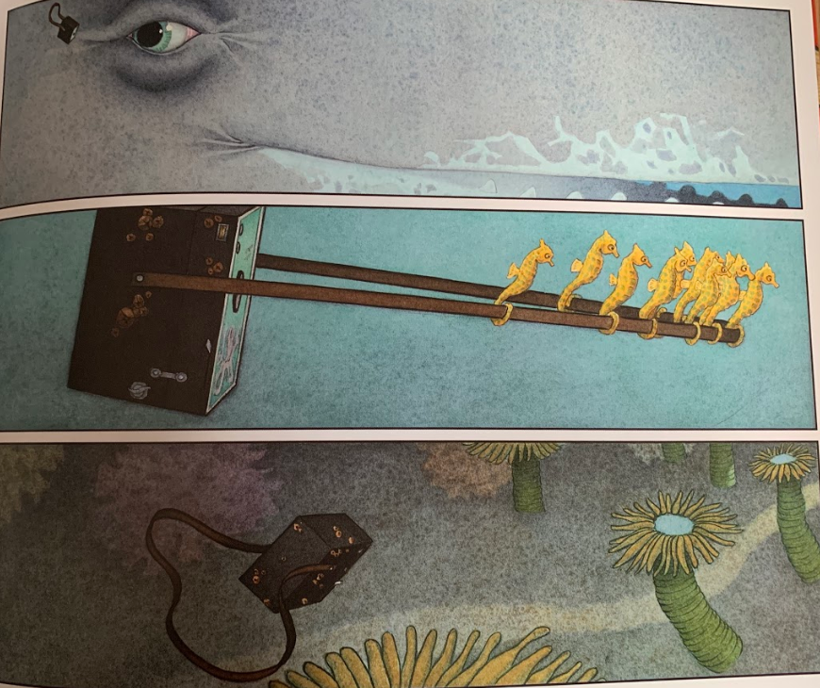

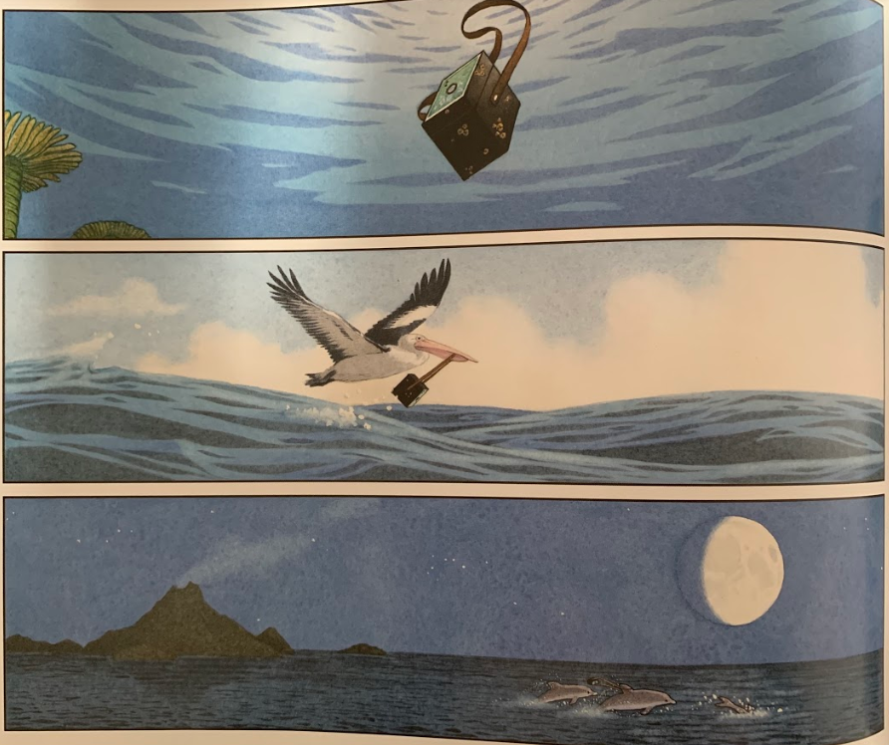
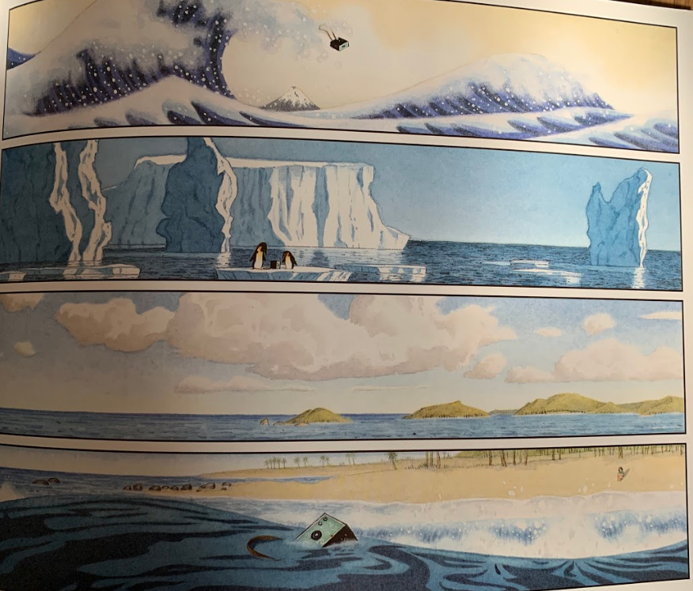
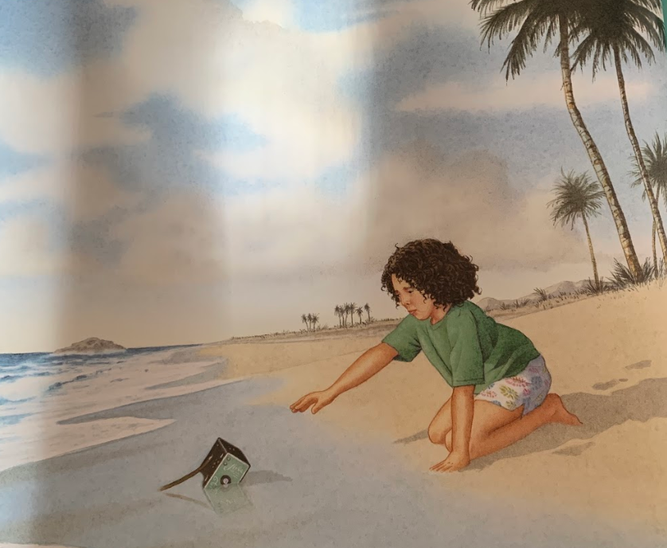
It looks like the final photos were of other children who had also found the camera. We can see photos taken from decades ago. The boy decides to take a photo of himself (like the other children had) to show that he had found the camera too. He threw it back into the sea and we can see lots of creatures taking the camera to different locations to take new photos. At the end of the story, a little girl finds a camera washed up on the shore.

We use ‘bare bones’ planning to show a simple version of what happened in Flotsam.
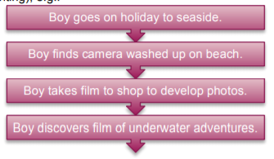

Today, you are going to fill in a bare bones frame to create a sequel to Flotsam, telling the story of the child who found the camera next.

This is an example of how your bare bones planning might look:
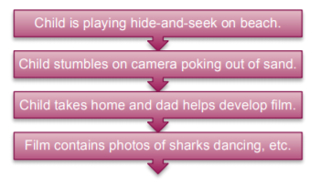

Try to use an innovative way of the girl finding the camera. She could have been playing hide and seek, building a sandcastle, the sun could have been gleaming on the lens etc.

Maths Activity
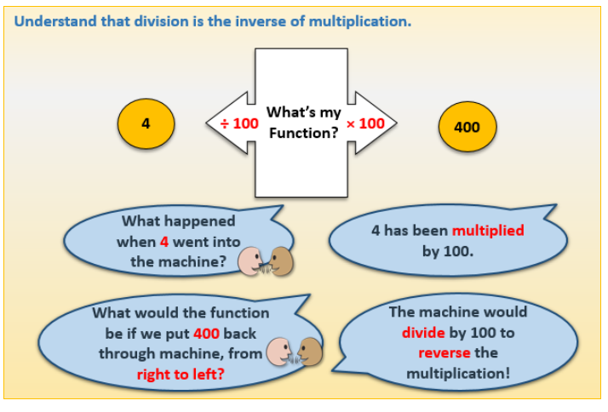
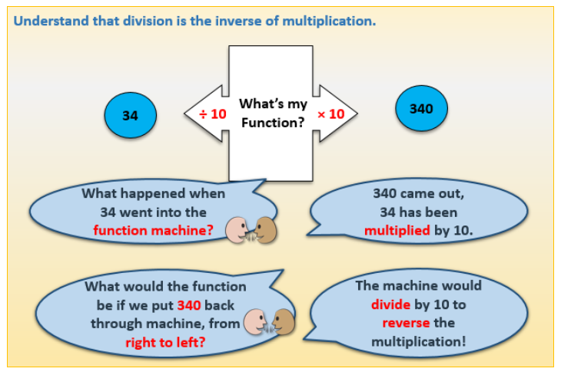

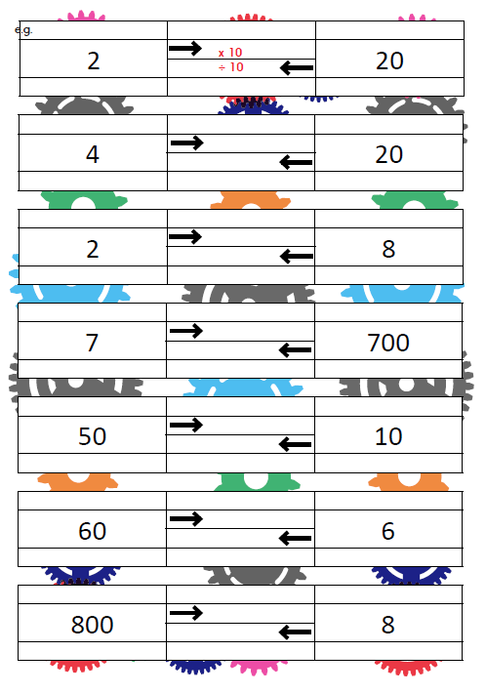

You are calculating how you would get to 20 if you started on 2 (x10) and how to get to 2 if you started on 20 (divide by 10)

This is on Google Classroom also.

Afternoon Activity
Mental Health Week – Get Active
For our second day of Mental Health Week, we are focusing on getting active.
Exercising and moving around can help to reduce stress, it can also help to improve sleeping. Especially during tricky times, it is important to get fresh air or move around indoors to reduce stress & anxiety and to boost your mood. Have fun!
Activities:

- Take part in our KS2 Dance Activity by BYMT. They have created a 15 minute dance video to ‘Zero to Hero’ which you will recognise from the film Hercules.


- Find a tiny figurine, a toy, or draw on a piece of paper and hide it in your home or garden. Ask a member of your household to find it! You could time each other and see who can find it the quickest.
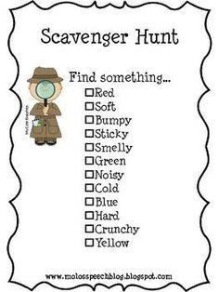
- Go on a Scavenger Hunt around your home or garden. Can you find all the items on the list?

Afternoon Activities – Coding
A micro:bit is a piece of hardware which we have at school, unfortunately we did not have the time to play and experiment with them. However, micro:bit have a website where you can code virtually. Start with the ‘flashing heart’ tutorial and see how you get on. You shouldn’t need to log into the website.
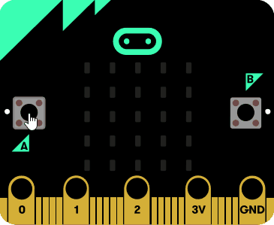
https://makecode.microbit.org/#


Joke for the day

Why do polar bears like snow?

Because they want to be cool!
Thank you for the joke Becky!



