Monday 18th May
Spellings for the Week – On Spelling Shed
(Linked to our new book)
- submarine
- submerge
- subnormal
- automatic
- automation
- autograph
- refill
- redo
- reuse
- restart

Reading Activity
Please read your own book, it may be a fact file, a leaflet or an online book from PurpleMash. Remember you can quiz on your books, message us if you need support with this.

Remember – you can quiz on lots of your home books! https://ukhosted65.renlearn.co.uk/2240525/

Writing Activity
Last week, we found incredible photos which were taken under the sea! It looked like the sea creatures were doing some amazing things – like reading a newspaper, living on a turtle and flying on a puffer fish hot air balloon!

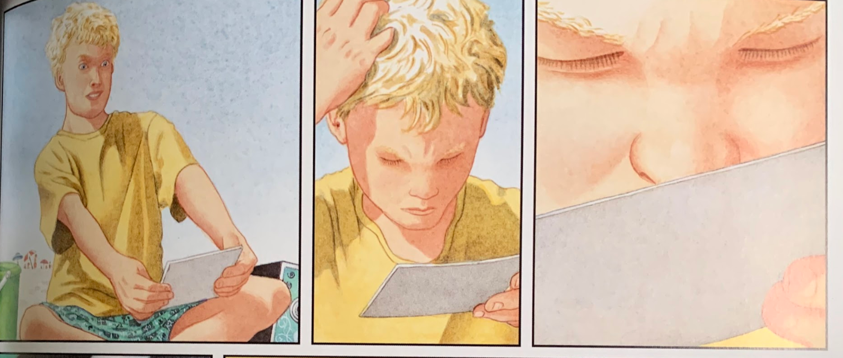
However, there is one last photo which we have not seen yet. This is the boy’s reaction to the photo.

Considering he has already seen lots of peculiar photos, this one looks like it has confused him. I think he is confused because of his expression in the first illustration, he is scratching his head in the second and is taking a closer look in the third.

Writing Activity
Today, you are going to draw what you think is on the final photograph. Once you have finished your drawing, please write a few sentences about what is happening.

Remember on Friday, we used lots of features in our sentences. Try and do the same today.
Eg – A scaly turtle with a mottled shell glided through the gleaming ocean.
Blue = noun phrase
Purple = verb
Orange = preposition (with, of, through, around and onto)

__________________________________________________________________________________________________________________________________________________________________________________________________________________________________________________________
If you prefer to complete your learning online, we have set a 2Do on PurpleMash with the same template as above.
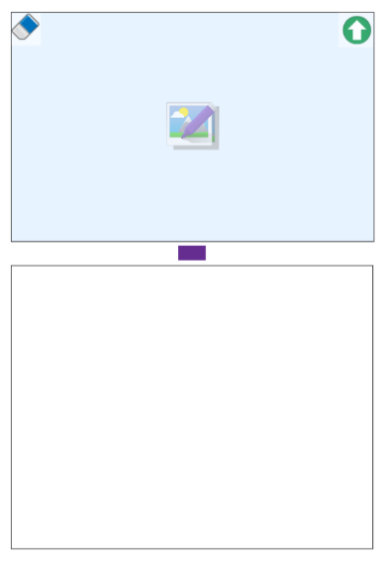

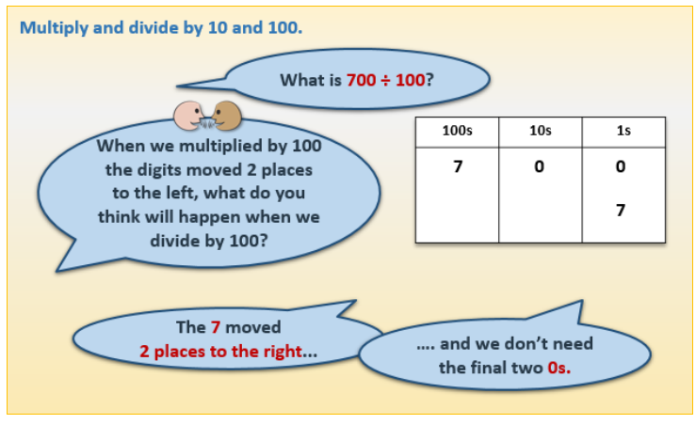
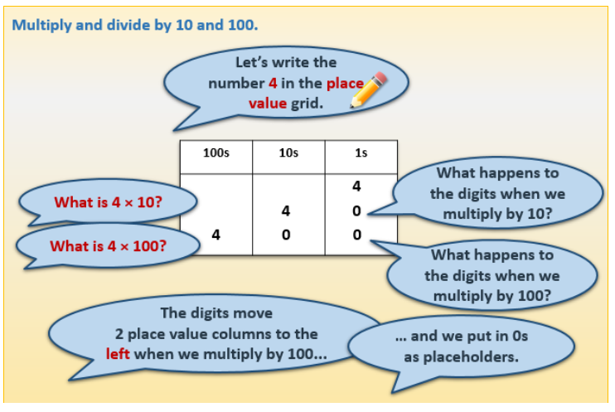
Maths Activity

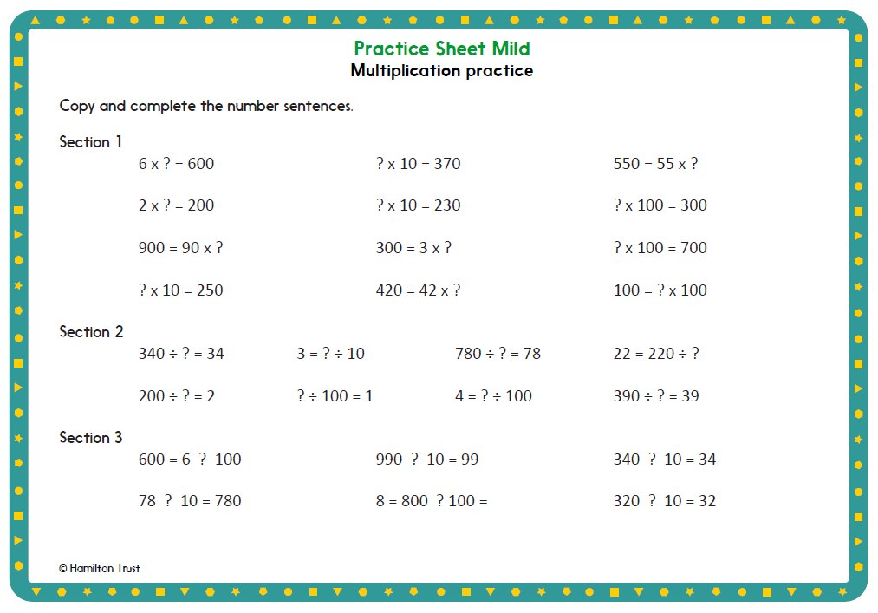

The questions are also on Google Classroom.

Afternoon Activities
Mental Health Week – Time to Talk
It is Mental Health Week this week so every day we will have a theme for the afternoon and an activity to go alongside it. Today, the theme is ‘Time to Talk’.
Talking to each other is so important, especially during tricky times. Talking can help to let out emotions or express feelings which might be hard to show. Talking also helps to build bonds and relationships with others, you may feel calmer or relaxed after you have spoken to someone.
Activity Ideas:
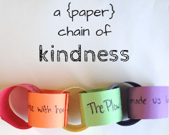
- Create a kindness paper chain with messages on each chain.

- Write a letter or postcard to your ‘future self’ to remind them of what you were grateful for during this period of time.

- Try answering these questions with members of your household to find out how they are feeling.

What made you smile today?
Name one thing which went well today.
On a scale of 1 – 10, how do you feel today?

What have you learnt today?
Describe the contents of your ultimate packed lunch.
If you could make one wish, what would it be?

Afternoon Activities – Geography
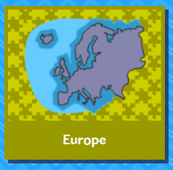
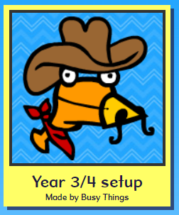
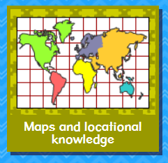
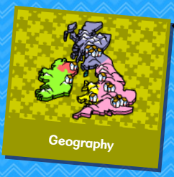
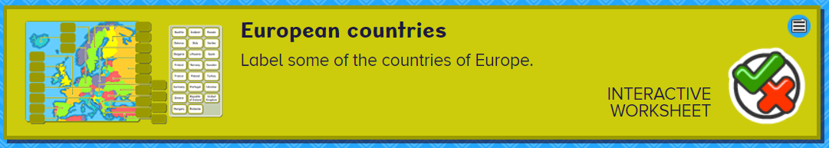
Please complete the ‘European Countries’ activity on BusyThings.

Joke for the day

How does a dog stop a DVD player?

He presses the ‘paws’ button!
Thank you Dimitar for the joke!


