Friday 15th May
Remember – We are going to attempt a Hive game today for our spellings on Spelling Shed.
1st code posted at 9:45am for a 10am start.
2nd code posted at 11:45am for a 12pm start.
Both games will have the same spellings.

Reading Activity
Read this information about a famous artist (amongst many other things), named William Morris.
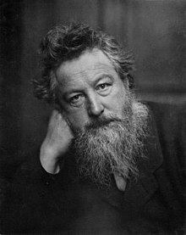
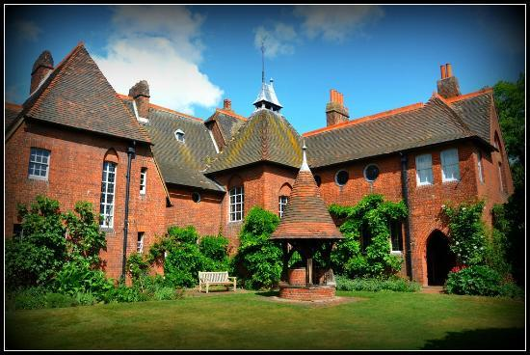
William Morris was an English artist, poet and politician. He was incredibly creative and he produced decorative art in a range of different forms, including: textiles, furniture, wallpaper, stained glass windows, book design and tapestry. William Morris lived and worked during the Victorian era. He was born in 1834 and he died in 1896. William Morris was friends with the painters Edward Burne-Jones and Dante Gabriel Rossetti, and he soon stopped being an architect in order to become a painter.
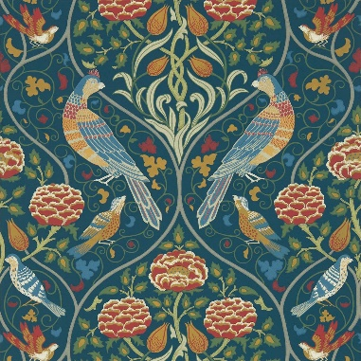
In 1859 William Morris married Jane Burden. Soon after they had a house built for them on Bexleyheath. The house was called Red House and was designed by Philip Webb. William and Jane designed all of the interiors and decoration themselves.
By the mid-1860s, William Morris concentrated on designing wallpaper. His patterns were inspired by the natural world, and these are some his best-known works of art. You can buy wallpaper inspired by William Morris today!

Writing Activity
Today, we are going to try and move away from listing adjectives which have similar meanings, we want to describe different parts of the sea animals.
Eg – The large, enormous goldfish. These adjectives have similar meaning.
Eg – The large, scaly goldfish. These adjectives describe two aspects of the fish.

We are going to describe each photograph that the boy found using a noun phrase and a verb. We will also use the prepositions ‘with’, ‘of’, ‘through’, ‘around’ and ‘onto’.
Eg – A scaly turtle with a mottled shell glided through the gleaming ocean.
Blue = noun phrase
Purple = verb
Orange = preposition (with, of, through, around and onto)

Below are some ideas which you may use!
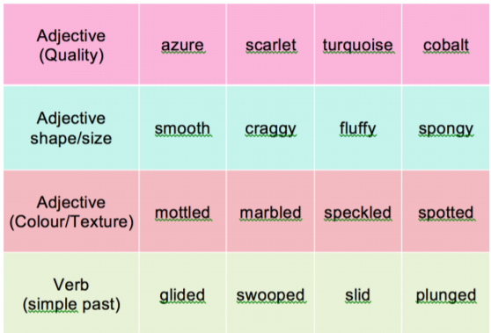

Write one sentence for each illustration, using all the the features we explored.
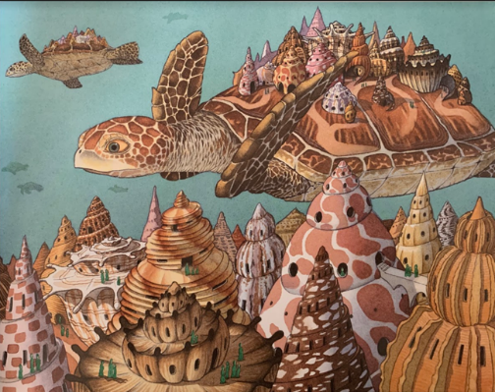
Eg – A scaly turtle with a mottled shell glided through the gleaming ocean.
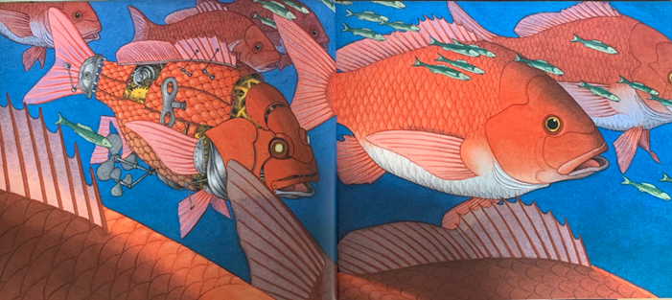

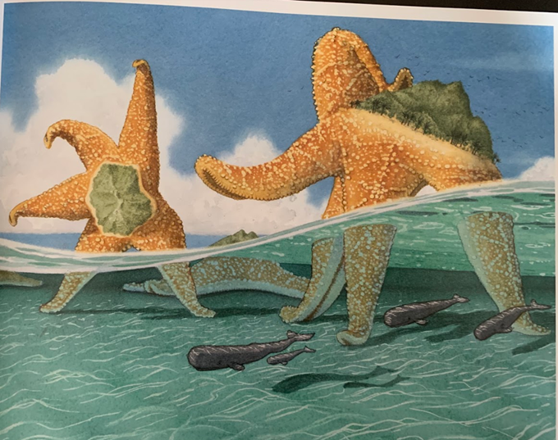
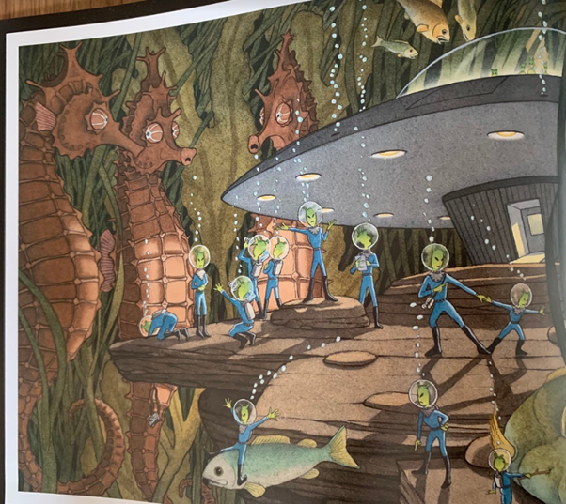
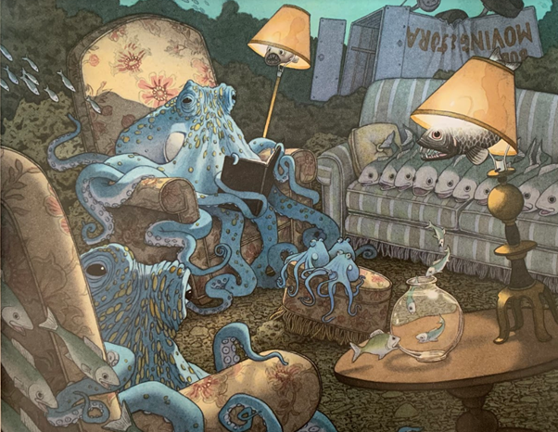

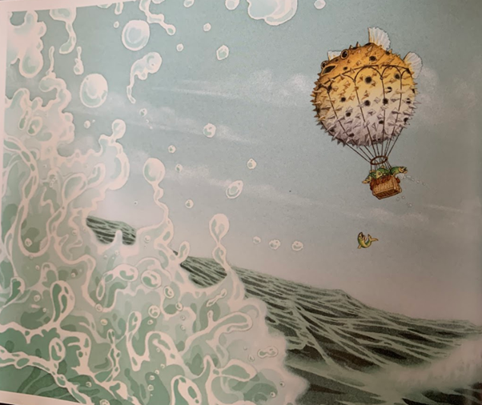

Maths Activity
To recap subtraction, we are going to use some fluency and reasoning problems from White Rose Maths.
Once you have finished, please play TTRockstars/Mathletics/Numbots.
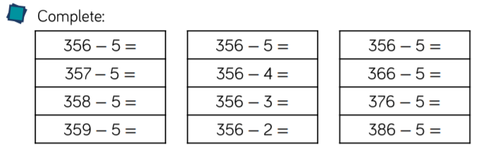

Did you notice a pattern which made it easier to find the answer?

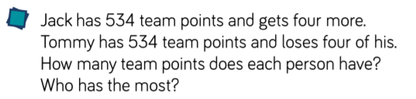

Jack has…
Tommy has…
The person with the most points is…

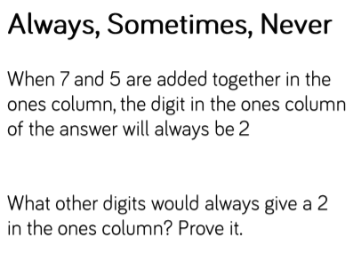

Other addition calculations could be:
Eg – 6 + 6

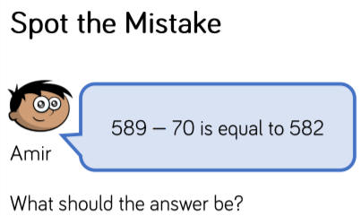

The answer should be…

Afternoon Activity
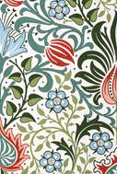

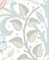

Above is half of a section of a wallpaper design by William Morris, called ‘Persian Wallpaper’. You can see how this section is repeated, by reflection. This is called: reflective symmetry.
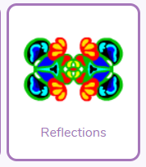
Try and copy this piece of wallpaper. If you are finding this tricky, there is a clever tool on PurpleMash where you can create your own reflective wallpaper design. We have set this as a 2Do.

Joke for the day

What happens when cats go crazy?
It’s a cat-astrophe!
Thank you for the joke Jacob!

