Thursday 14th May
Remember – Keep playing Spelling Shed!
Hive Games tomorrow.
1st code at 9:45am for a 10am game.
2nd code at 11:45am for a 12pm game.

Reading Activity

Read your own book at home, this might be a story book, magazine, recipe book or even the back of a cereal box!
PurpleMash have some great online stories, which are split into chapters. Each chapter has a quiz and accompanying activity on PurpleMash. To find this, click on ‘Serial Mash’ on the home page.

PE
Today, we would usually have PE.
You could carry on with the Joe Wicks workouts. Can you create your own workout too? Think about the different techniques Mr Duffin has taught you to ensure you are using all your muscles, you could even post your workout on Class Dojo. Try to use different moves from last week so we can see something different!
https://www.youtube.com/watch?v=EXt2jLRlaf8

Or you could try something new! Phoebe sent me a great video of her dancing with Oti Mabuse from Strictly, which looked like so much fun. This dance is to ‘I like to move it, move it’ which is featured in Madagascar. It is 12 minutes long and easy to follow.

https://www.youtube.com/watch?v=aACgMV9_FmQ

Music
We would usually have a music lesson today. As a school, we have links with the Bromley Youth Music Trust (BYMT) who have created music lessons through video.
The video is on Google Classroom, please watch Week 3.

Afternoon Activities
Class Dojo Big Ideas – Positive Stories, part 3/3.
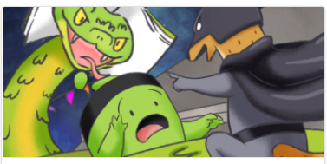
Class Dojo often create videos to discuss topics and this video is all about optimism. This is the final part of the video. Follow the link to watch the video on YouTube. https://www.youtube.com/watch?v=Tw0bF3trVBs
There are some discussion cards to accompany the video. You can think/talk about these questions.
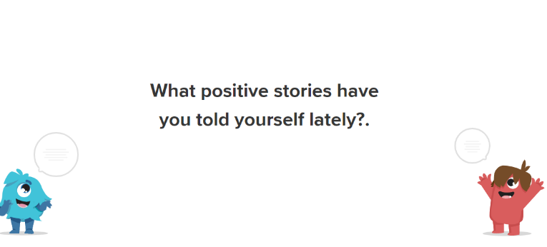
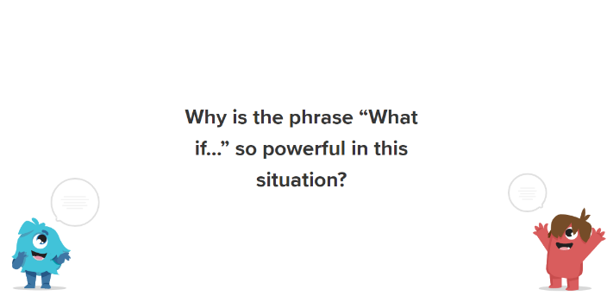
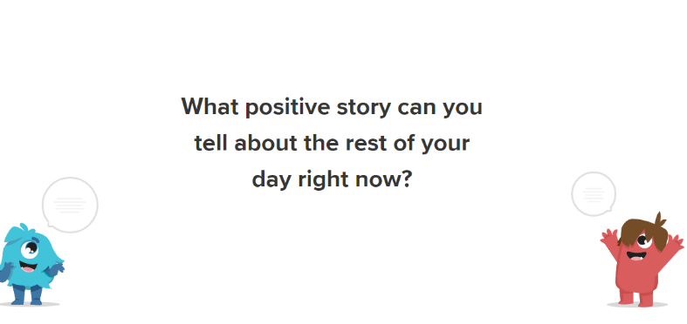

Spanish
Well done to all the children who have been playing Language Nut. We are really pleased with your scores and to see you giving it a go! Especially David & Jake from Birch class who are 1st and 2nd in the leader board for Poverest! Congratulations!
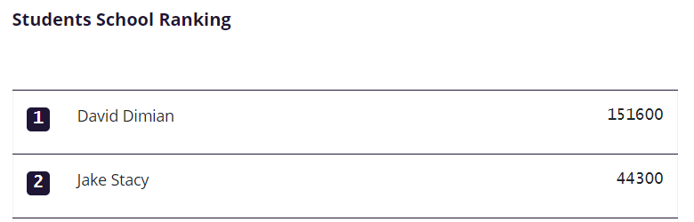

This week, we have assigned a ‘How old are you?’ activity, which says it will take approximately 9 minutes. Please message your class teacher for the username and password for your child.
https://www.languagenut.com/en-gb/

Joke for the day

What happens if somebody rips something?
It’s tear-ible!
Thank you for the joke Jacob!


