Wednesday 13th May

Remember – Keep playing Spelling Shed!

Reading Activity
Read this short poem.
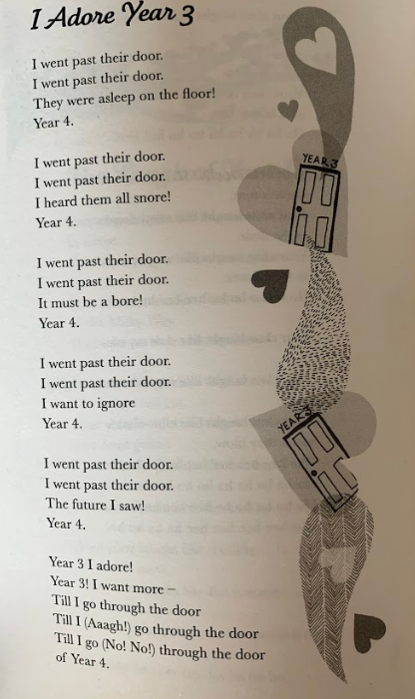

Questions
- What is the poem about?
- Clarify the word ‘adore’
- Can you spot 3 rhyming pairs?
- Why do you think Carol Ann Duffy uses repetition in this poem?
- Why are there brackets () in the final paragraph?
- The author describes Year 4 as a ‘bore’ and a ‘snore’, why do they feel this way?

Writing Activity

From the first pages of the story, we found out the boy discovered an old waterproof camera and he developed the film. On the film were amazing adventures of sea creatures! Flotsam is a wordless book so you are going to write the first few pages of the story from the boy’s point of view. Use this photo strip to help you. Imagine you are writing 1 or 2 sentences describing each photo, remember it is from the boy’s point of view. Imagine you are the boy, use the word I.

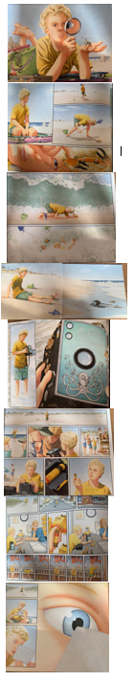

Maths Activity
This half term we are going to use Hamilton Trust for our maths learning. Each day, there will be ‘learning slides’ and an activity which matches. Please complete the activity on paper.
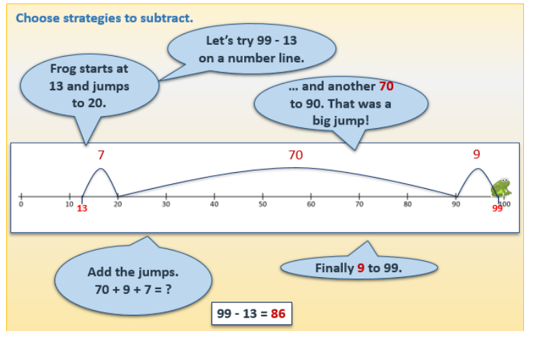
Once you have finished, please play TTRockstars/Mathletics/Numbots.
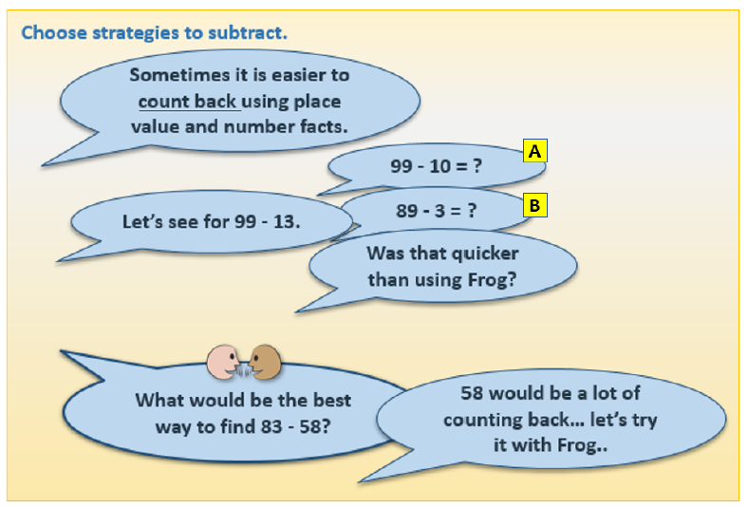
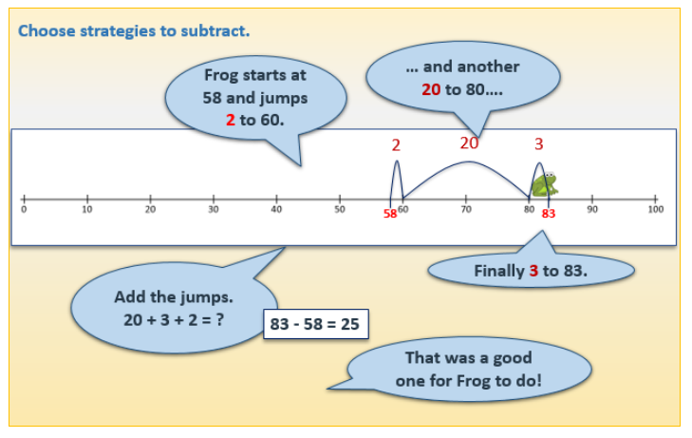
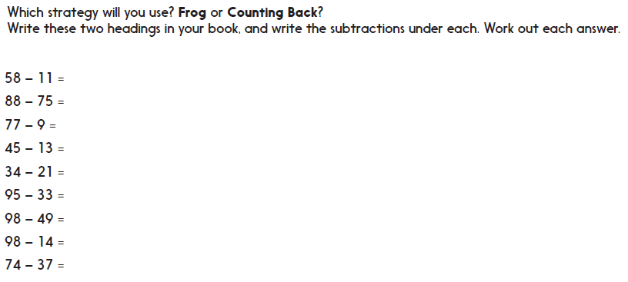

You could also use column subtraction, choose the method which you find easiest. These calculations are on Google Classroom.

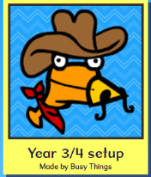
Afternoon Activities - Geography
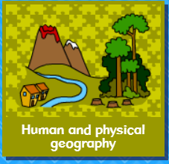
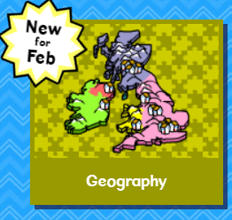




Please complete the ‘World Climate Zones 1’ activity on Busy Things.

Afternoon Activities – Warburton’s
Warburton’s were supposed to visit us in school so we could take part in one of their great workshops. As that is not possible, they have sent us some online resources to share with you.

Follow this link to access the page for today: https://www.warburtons.co.uk/corporate/teaching-resources/sandwich-making-project

There is a great video to watch and some downloadable resources. Our favourite is the ‘sandwich generator’. You can google ‘online dice’ to find a dice to roll and talk about the sandwich you would have created. You could draw it too!

Joke for the day

What did one math book say to the other?

I have so many problems!

