Monday 11th May
Spellings for the Week – On Spelling Shed
(Linked to our new book)
- bicycle
- material
- occasion
- occasionally
- recent
- separate
- strange
- various
- mysterious
- flotsam (we will look at this word together but you might like to clarify it)

Reading Activity
Please read your own book, it may be a fact file, a leaflet or an online book from PurpleMash. Remember you can quiz on your books, message us if you need support with this.

Remember – you can quiz on lots of your home books! https://ukhosted65.renlearn.co.uk/2240525/

Writing Activity
We are reading a new book for the next two weeks and it is called Flotsam. We will look at the front covers and first few pages tomorrow, today we are going to try and predict the theme of the story.

Here are lots of different photos, your task is to sort these items into four different headings. Treasure, creature, nature and man-made. Some of the objects could go into more than one heading, it is your decision.

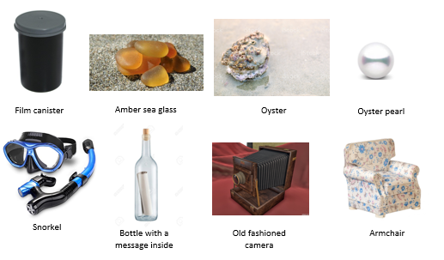
Once you have sorted the objects, can you predict what the story is going to be about?

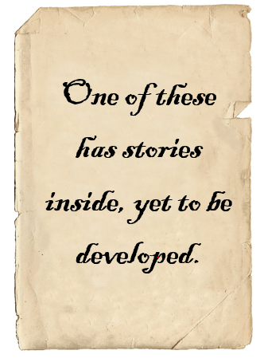
The message inside the bottle reads:

What could this mean? Which objects could have stories inside?

Maths Activity – Subtracting 9, 11, 19 and 21
This half term we are going to use Hamilton Trust for our maths learning. Each day, there will be ‘learning slides’ and an activity which matches. Please complete the activity on paper.
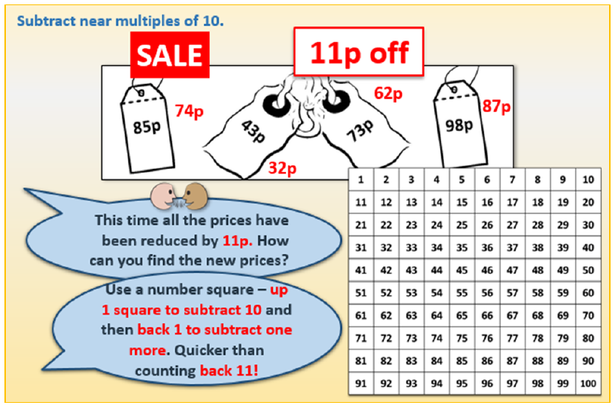
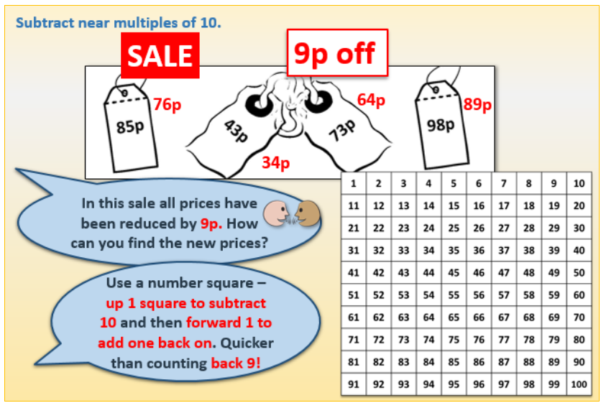
Once you have finished, please play TTRockstars/Mathletics/Numbots

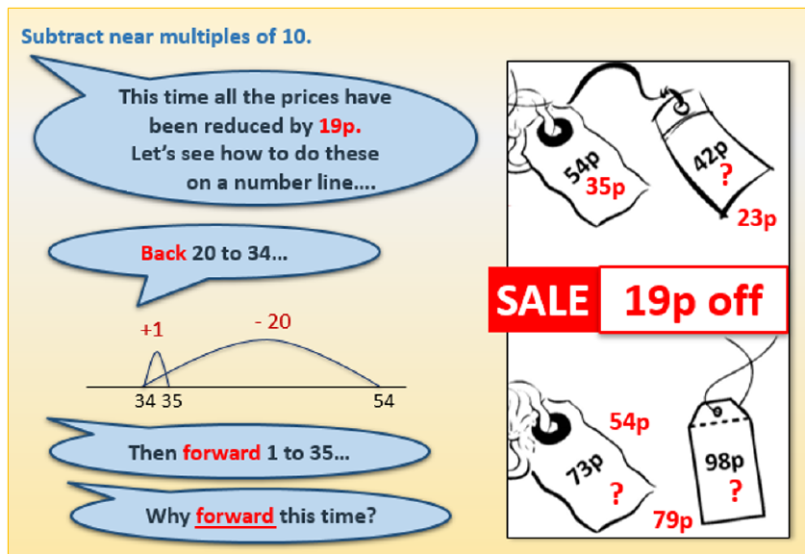
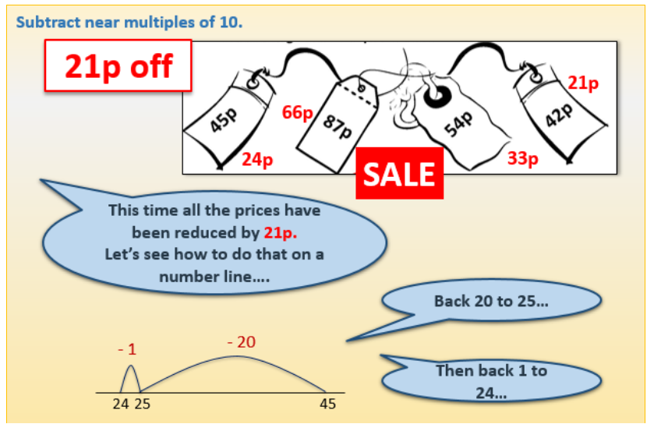

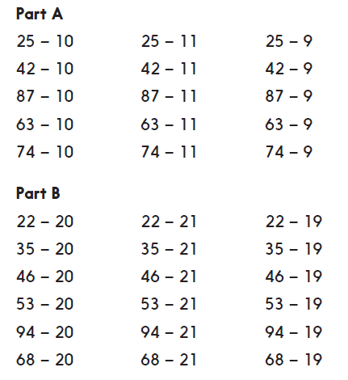

These questions are on Google Classroom if you’d prefer to complete it online.

Afternoon Activity
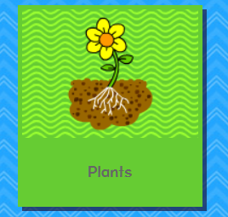

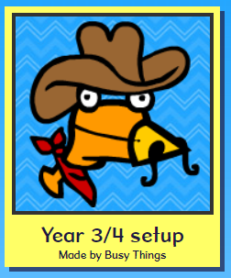

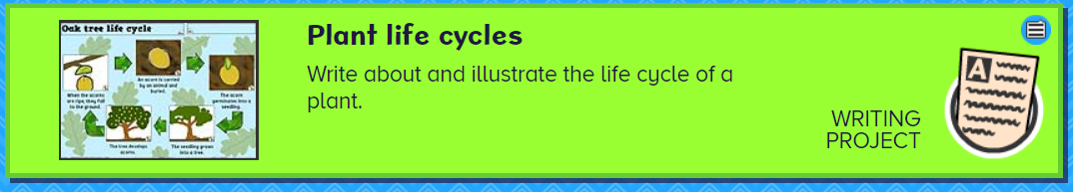

Please complete the ‘Plant Life Cycles’ activity on Busy Things.

Joke for the day

Why are teddy bears never hungry?

Because they are stuffed!



