Thursday 7th May
Remember – Keep playing Spelling Shed!
We’ll have two hive games today as it’s bank holiday tomorrow.
1st code posted at 9:45am for a 10am game.
2nd code posted at 11:45am for a 12pm game.

Reading Activity
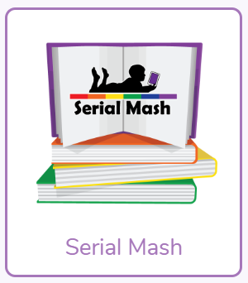
Read your own book at home, this might be a story book, magazine, recipe book or even the back of a cereal box!
PurpleMash have some great online stories, which are split into chapters. Each chapter has a quiz and accompanying activity on PurpleMash. To find this, click on ‘Serial Mash’ on the home page.

PE
Today, we would usually have PE.
Mr Haylock posted a great resources on our School Story from England Athletics last week. Maybe you could try a different activity this week. https://funetics.co.uk/for-parents/funetics-activity-videos/

Otherwise, you can carry on with the Joe Wicks workouts. Can you create your own workout too? Think about the different techniques Mr Duffin has taught you to ensure you are using all your muscles, you could even post your workout on Class Dojo. Try to use different moves from last week so we can see something different!
https://www.youtube.com/watch?v=u0_1QBQ8Syk

Music
We would usually have a music lesson today. As a school, we have links with the Bromley Youth Music Trust (BYMT) who have created music lessons through video.
The video is on Google Classroom.

Afternoon Activities
Class Dojo Big Ideas – The Story Snake Pt.2
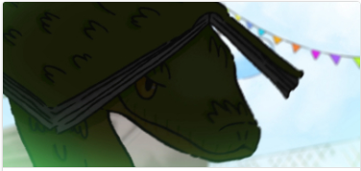
Class Dojo often create videos to discuss topics and this video is all about optimism. This is part 2 of the video, we will watch part 3 (the final part) next week. Follow the link to watch the video on YouTube. https://www.youtube.com/watch?v=s5u1DsNwIKk
There are some discussion cards to accompany the video. You can think/talk about these questions.
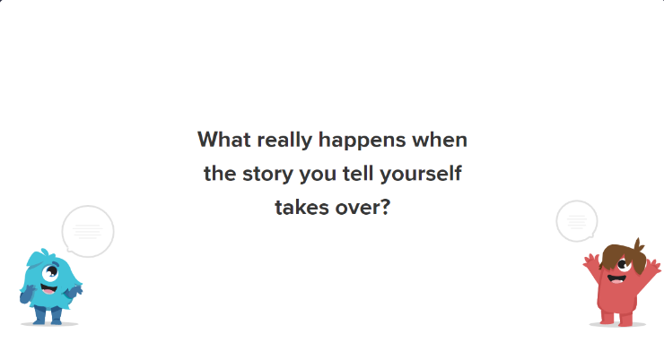
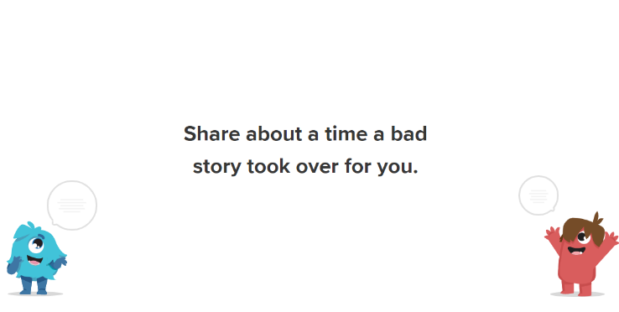

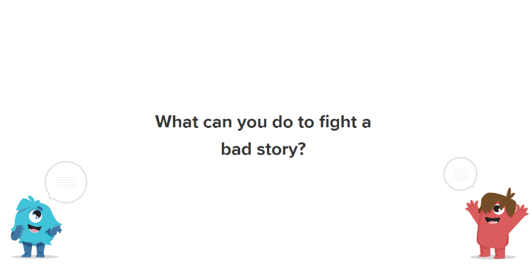

A new Spanish website!
Our modern foreign languages leader has found a fantastic website to help us continue with our Spanish learning at home. This week, we have assigned an ‘About Me’ activity.
Please follow this link for the website:
https://www.languagenut.com/en-gb/
The children require a log in, please message your class teacher for the username and password. Thank you.

VE Day Celebrations (8th May)
Tomorrow is VE Day so if you’d like to join in with the celebrations, here are a few ideas of activities you can do at home. We’re aware that resources at home may be running low so there are some online activities too.

Horrible Histories produced a great VE Day song.
https://www.bbc.co.uk/cbbc/watch/horrible-histories-songs-ve-day-song

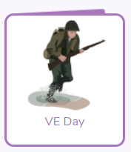
PurpleMash have a folder for VE Day. To find this, search for ‘VE Day’.

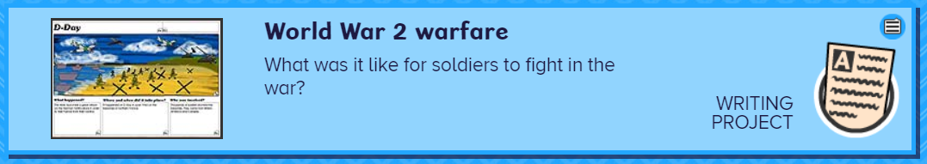
BusyThings have a VE Day writing project.

Twinkl also have some great resources, you can download these for free on their website or find them below.







Joke for the day

Why can’t Elsa have a balloon?
Because she will let it go!

