Wednesday 6th May

Remember – Keep playing Spelling Shed!
We’ll have two hive games tomorrow (Thursday). One game at 10am and another at 12pm. Same spellings for both games, see you then!

Reading Activity
Read this short poem.
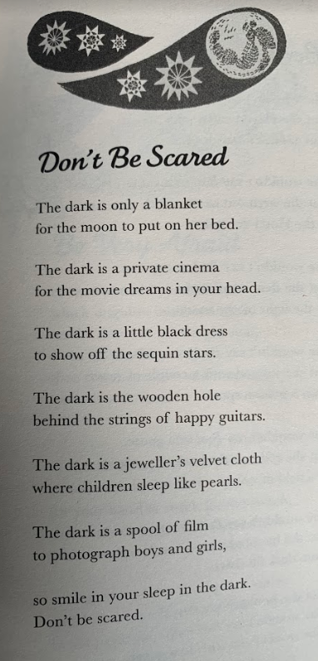

Questions
- What is the poem about?
- Name 3 different things the author compares the dark to.
- Clarify ‘spool of film’.
- Does the author describe the dark as a positively or negatively?
- Why is the poem called ‘Don’t Be Scared’?
- Have you ever felt afraid of the dark? How do you deal with this fear?

Writing Activity
Today, we are going to write our own version of ‘I am Hungry’ by Michael Rosen. Let’s refresh our minds with the structure of the poem. He repeats the emotion 6 times at the beginning of the poem. Afterwards, he lists all the things he would do.

I am hungry. Really hungry. Hungry.
Hungry. Hungry. I’m so hungry I’ll eat a cheese roll.
Cornflakes in a bowl.
A plate of fried rice. Two chocolate mice.
A slice of toast. A Sunday roast.
A gingerbread man. A frying pan.
A piece of cake. A headache.
A giant prune. A bit of the moon.
Some fried fish. A birthday wish.
A real live mouse. The side of a house.
An egg yolk. A funny joke.
A plastic tray. One fine day.
A television show. The sound of no.
A game of chess. The sound of yes.
One pea. Then I’ll eat me.

The beginning of your poem should be the same. Use your planning from yesterday.
I am hungry. Really hungry. Hungry.
Hungry. Hungry. I’m so hungry I….

Eg - I am happy. Really happy. Happy.
Happy. Happy. I’m so happy I….

Eg - I am upset. Really upset. Upset.
Upset. Upset. I’m so upset I….

Eg - I am angry. Really angry. Angry.
Angry. Angry. I’m so angry I….

Once you have written the beginning of your poem (like the examples above), you need to list all the things you would do if you felt that way. Use your planning from yesterday, you should already have some ideas written down.

Eg - I am happy. Really happy. Happy.
Happy. Happy. I’m so happy I’ll run through flowers in a field.
Jump up and down on my bed. Play Romans with my brother, using a shield.
Look at the sun. Bake chocolate chip cupcakes with my Nan.
Smell the roses. Fly around town, pretending I’m Superman.

Try and put two ideas on each line, separated with a full stop.

Maths Activity – Bar Charts
This half term we are going to use Hamilton Trust for our maths learning. Each day, there will be ‘learning slides’ and an activity which matches. Please complete the activity on paper.
Once you have finished, please play TTRockstars/Mathletics/Numbots.
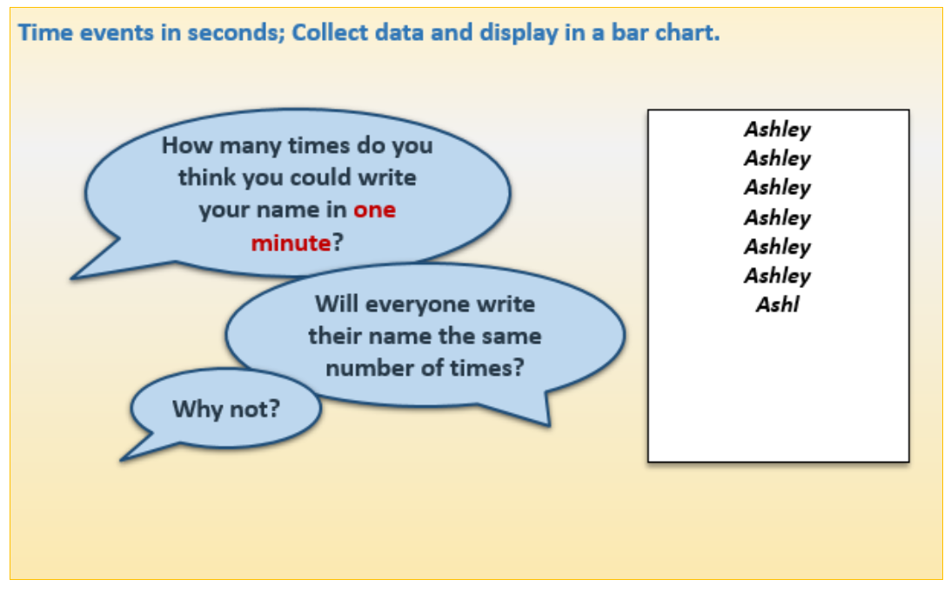
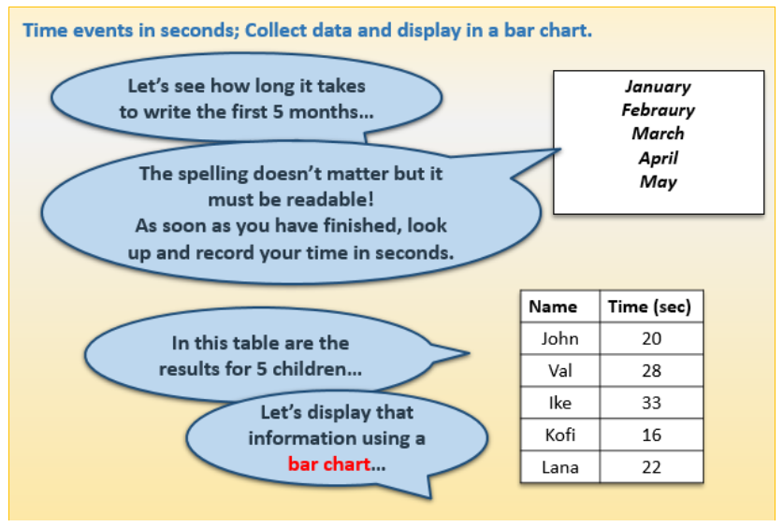

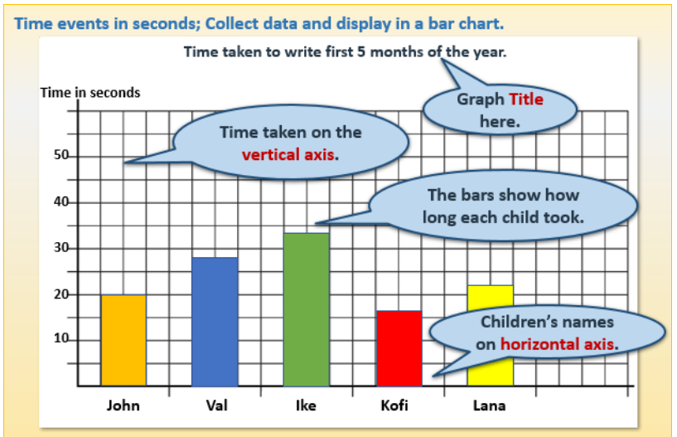

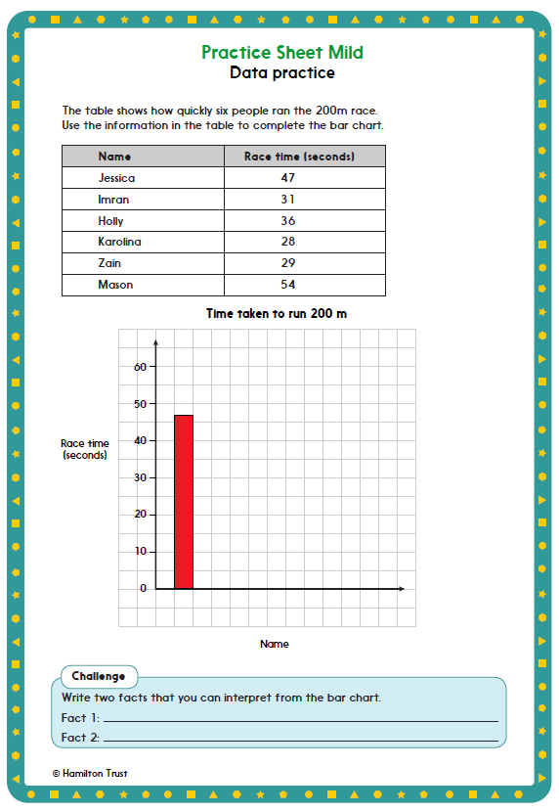

This activity can be easily completed on PurpleMash. We have set a ‘bar chart’ as a 2Do, the children can input the data on there. If they save it, we can see it on PurpleMash.

Afternoon Activity
We’re going to carry on finding out facts and information about Leonardo Da Vinci. Watch this BBC video, by Dick & Dom, to find out more about his invention ideas.
https://www.bbc.co.uk/teach/class-clips-video/science-ks2-discovering-the-work-of-Leonardo-da-Vinci/zhn47nb

Once you’ve watched this, there are a set of photos below of SOME of Leonardo Da Vinci’s invention ideas. Your job is to find out which ones belong to Leonardo Da Vinci and which belong to someone else.
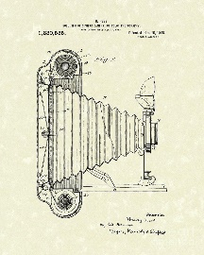
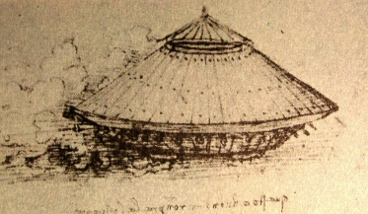
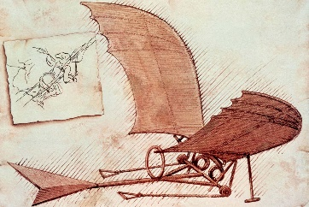
Aeroplane Tank Camera
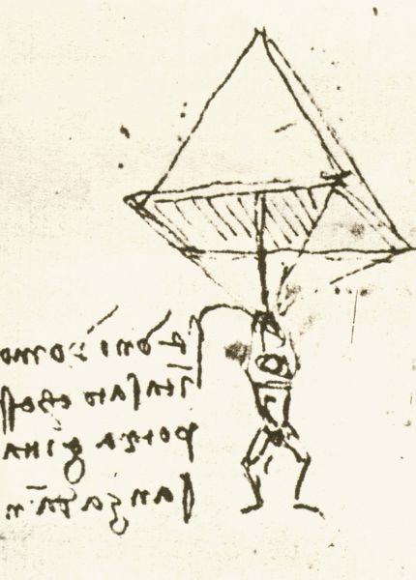
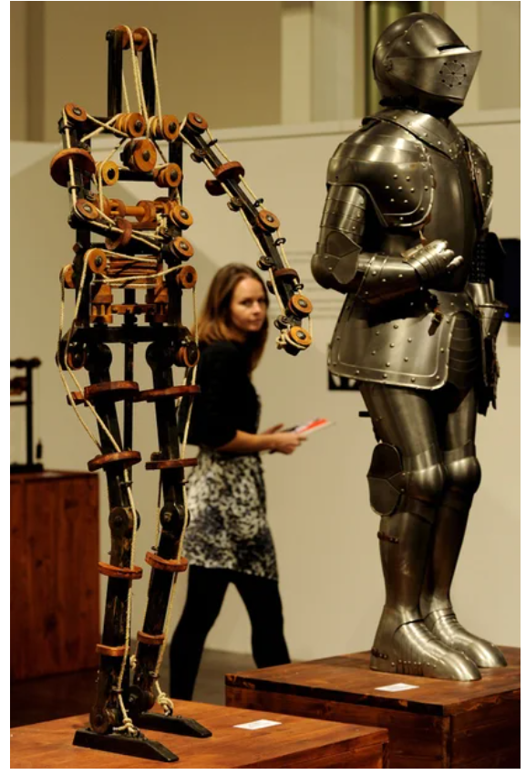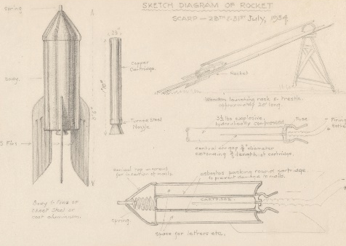
Robotic Knight Rocket Parachute

There is a museum called the ‘Leonardo Da Vinci’ museum. It is in Florence, which is in Italy. You can watch this video which is a 2 minute tour of part of the museum. https://www.youtube.com/watch?v=iB7C32pws7o

Joke for the day


What is a rabbit’s favourite music?

Hip – Hop
Thank you for the joke Ronnie!

