Tuesday 5th May
Remember to keep playing Spelling Shed.
Our Hive games will be on Thursday 7th May as Friday 8th May is a bank holiday.
Reading Activity
Please log onto Read Theory and complete 3 activities or visit the Collins BigCat website (https://connect.collins.co.uk/school/Portal.aspx) and log in using this username and password to access hundreds of eBooks. There are also worksheets which can be used alongside the books, which can be found here: https://collins.co.uk/pages/big-cat-ebooks
Go to https://connect.collins.co.uk/school/Portal.aspx and click on the Teacher portal and enter:
Username: parents@harpercollins.co.uk
Password: Parents20!
Click Login.

Writing Activity
Today, we are going to start planning our own poems based on Michael Rosen’s poem – I am hungry.
In the poem, I am hungry, Michael Rosen focuses on the hunger emotion. Today, you need to decide which emotion you will focus on for your own poem. This could be: happy, upset, angry, hyper etc.
Once you’ve decided your emotion, you need to think about all the things you would do if you were feeling that way! Remember, Michael Rosen used some ‘normal’ ideas and some ideas which weren’t so.
This is also the day when you need to decide whether your poem will rhyme. Although this is tricky, it is a good challenge. Maybe you could include one rhyming couple in your poem! Use Google to help you with rhyming words, type in ‘what rhymes with….’ and it will give you ideas.
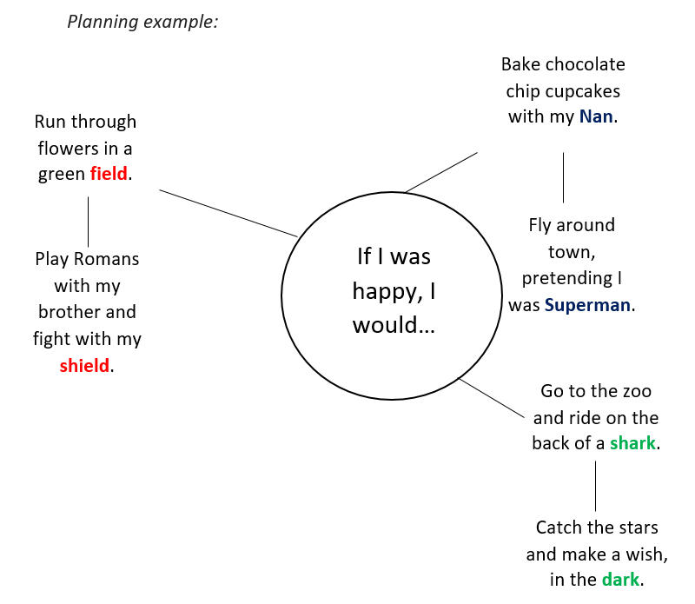

Maths Activity- Telling the Time
This half term we are going to use Hamilton Trust for our maths learning. Each day, there will be ‘learning slides’ and an activity which matches. Please complete the activity on paper.
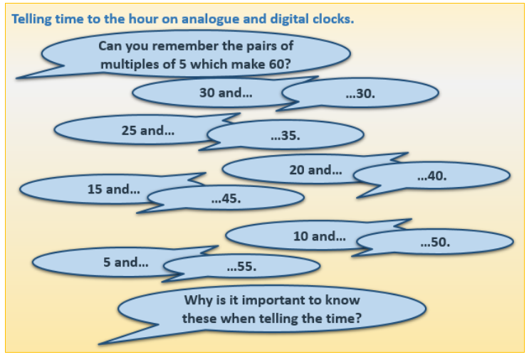
Once you have finished, please play TTRockstars/Mathletics/Numbots.
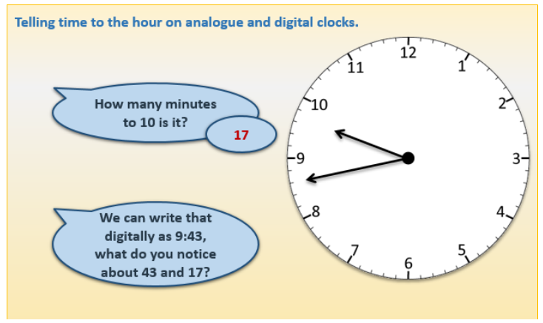

Today, we are going to convert an analogue clock to a digital clock. This activity is on Google Classroom if you prefer to complete it online.
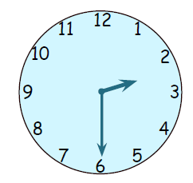The time is XX:XX
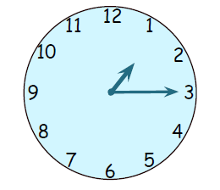 The time is XX:XX
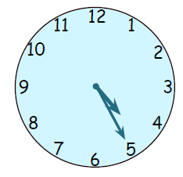 The time is XX:XX
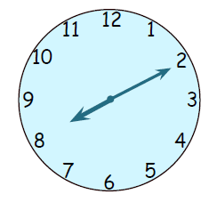 The time is XX:XX
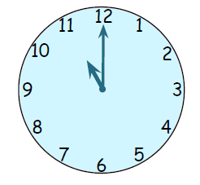 The time is XX:XX
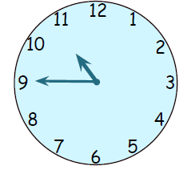 The time is XX:XX

Afternoon Activity
Please go onto ‘Hour of Code Learn’ and complete ‘Peep: Dance with Friends’.
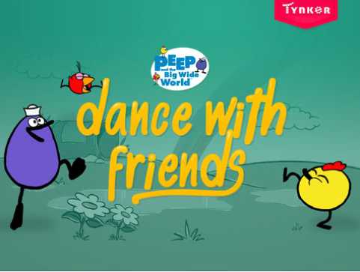

Here is a direct link: https://hourofcode.com/tynkerpd

Joke for the day

Why are drummers never late?

They beat the clock!


