
Monday 4th May

Spellings for the Week – On Spelling Shed
- woman
- weight
- various
- through
- thought
- though
- although
- therefore
- surprise
- support
Reading Activity
Please read your own book, it may be a fact file, a leaflet or an online book from PurpleMash. Remember you can quiz on your books, message us if you need support with this.

Remember – you can quiz on lots of your home books! https://ukhosted65.renlearn.co.uk/2240525/

Writing Activity
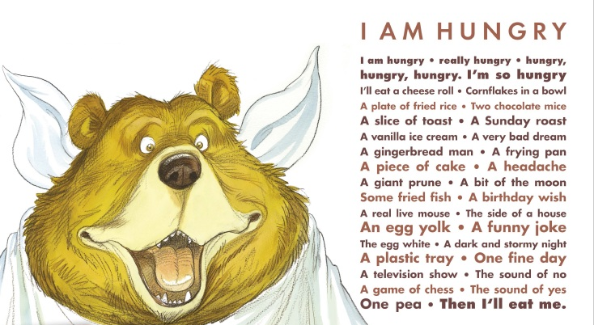
We are going to have a mini poetry week for the next 3 writing activities. For this, we are going to use the poem ‘I am Hungry’, written by Michael Rosen.

I AM HUNGRY – Michael Rosen
I am hungry. Really hungry. Hungry.
Hungry. Hungry. I’m so hungry I’ll eat a cheese roll.
Cornflakes in a bowl.
A plate of fried rice. Two chocolate mice.
A slice of toast. A Sunday roast.
A gingerbread man. A frying pan.
A piece of cake. A headache.
A giant prune. A bit of the moon.
Some fried fish. A birthday wish.
A real live mouse. The side of a house.
An egg yolk. A funny joke.
A plastic tray. One fine day.
A television show. The sound of no.
A game of chess. The sound of yes.
One pea. Then I’ll eat me.

You can also watch Michael Rosen perform the poem: https://www.youtube.com/watch?v=nmToXQzon5A

Today, we are going to focus on the vocabulary and ideas which Michael Rosen uses in his poem.

At the beginning of the poem, we find out the character is hungry. Why do you think Michael Rosen repeats the word ‘hungry’ lots of times? What is he trying to tell us?

The poem starts off with the character wanting to eat normal foods that we might eat, like a slice of toast. What does the character want to eat which isn’t so normal?

This is a rhyming poem. Can you find 5 rhyming pairs? These are words which have the same sound. (Eg – man + pan)

Why does Michael Rosen say the character will eat things like ‘the side of a house’?

Maths Activity – Telling the Time
This half term we are going to use Hamilton Trust for our maths learning. Each day, there will be ‘learning slides’ and an activity which matches. Please complete the activity on paper.
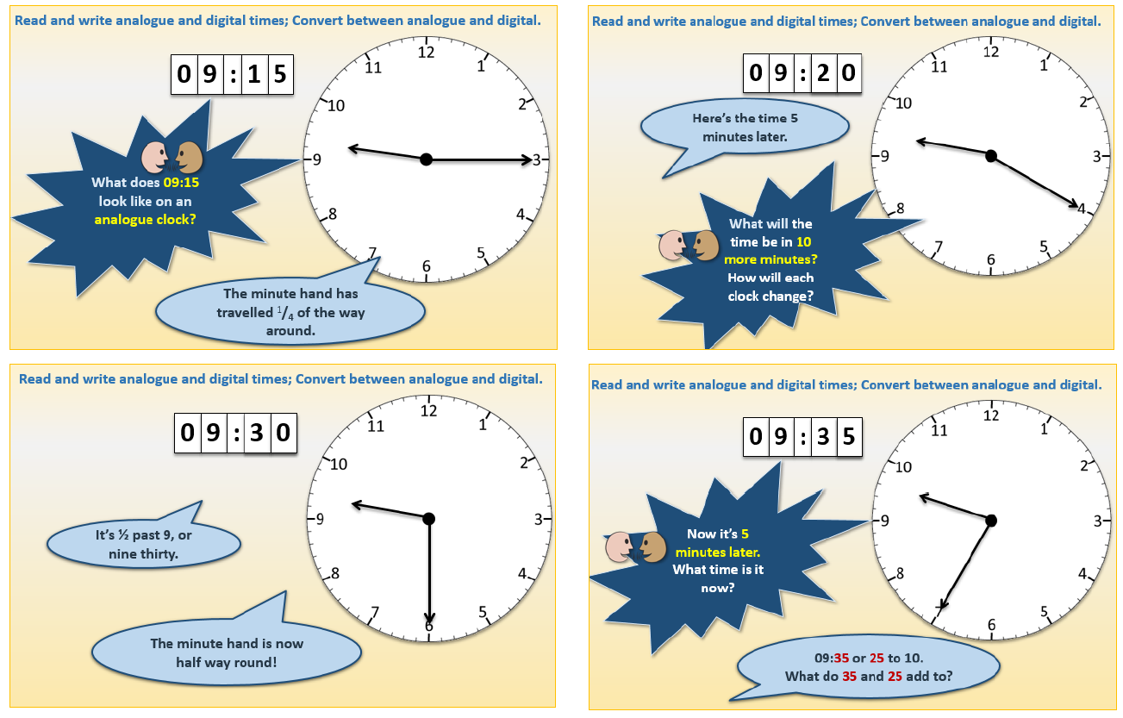
Once you have finished, please play TTRockstars/Mathletics/Numbots

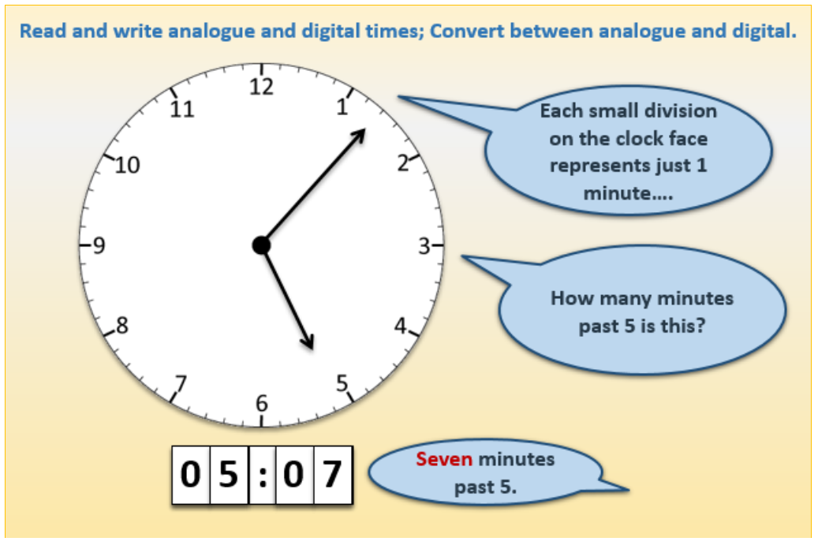

You may find it useful to use the interactive clock which we use at school to go through a few more examples. Unfortunately, it does require flash player. If you would like to use it then please follow this link: https://www.interactive-resources.co.uk/
Username: ppsmaths Password: mathsfun
Stay on the Early Years tab and scroll down, until you find ‘class clock’.

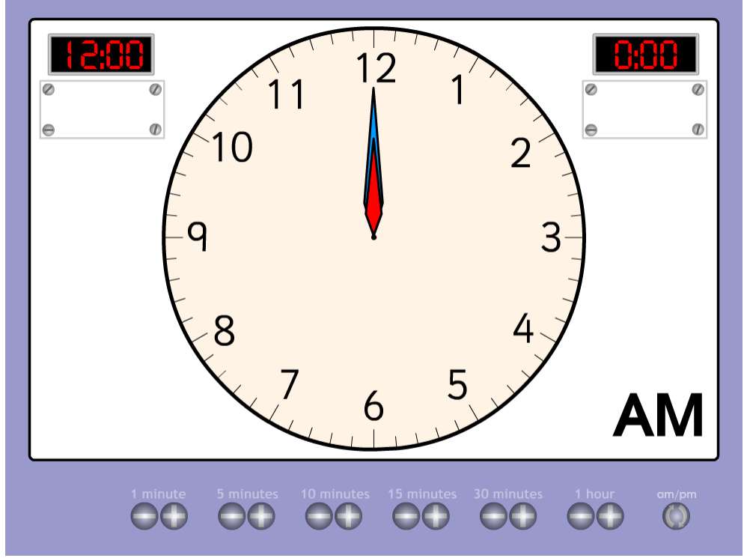

The Activity
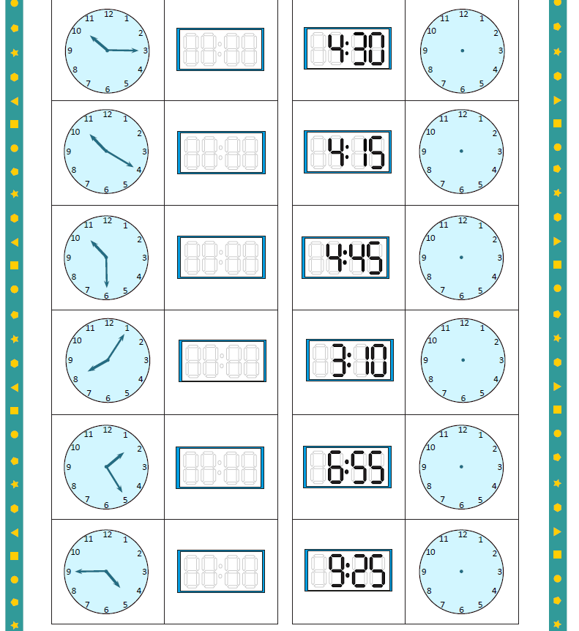
On a piece of paper, write the times you can see on the analogue clock. You may need to draw 6 circles for your child to draw the hands on the analogue clock for the second part. This is available on Google Classroom to complete online.

Afternoon Activity
Please complete the ‘Order the Mountains’ activity on BusyThings.
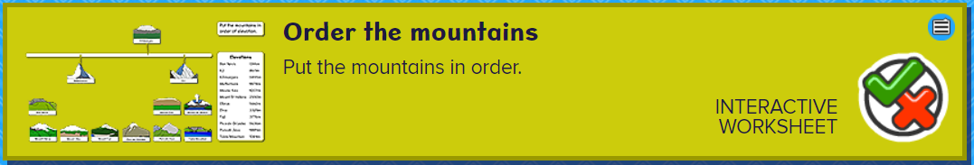

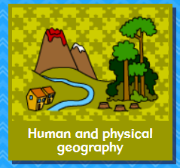

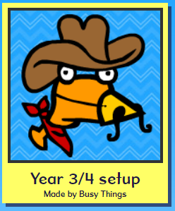

Joke for the day


What type of monkey can fly??

A hot air baboon
Thank you for the joke Ronnie!

