Friday 1st May
Remember – We are going to attempt a Hive game today for our spellings on Spelling Shed.
1st code posted at 9:45am for a 10am start.
2nd code posted at 11:45am for a 12pm start.
Both games will have the same spellings.

Reading Activity
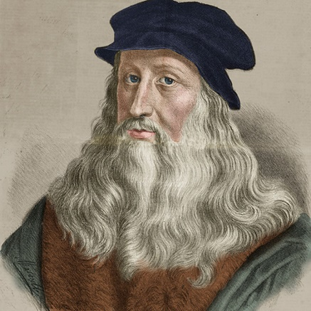
Read this information about a famous artist you may have heard of, named Leonardo Da Vinci.
Leonardo da Vinci was born on April 15, 1452 and he was Italian. He lived during the Renaissance era, which was a period in time during which important developments and discoveries in areas such as art and science took place. He was a brilliant artist, sculptor, draftsman, inventor, scientist, mathematician, engineer, costume maker, writer and musician. He was also very interested in the laws of science and nature, which greatly influenced his work.
Leonardo was one of the first Italians to use oil paint. He was left-handed and used a mirror to write backwards because a quill pen was easier to pull from right to left than actually push it. It also made it harder for others to dig through his notes and steal his ideas. It’s incredibly hard to write backwards and not many people can do it.
If you would like to, we have set a Leonardo Da Vinci Fact File on PurpleMash as a 2Do. There are hundreds of more facts so research further if you’d like to.

Writing Activity
We thoroughly enjoyed reading ‘How to Live Forever’ and hope you did too. To find out your thoughts, today’s activity is to complete a book review. You can use our template on Google Classroom or you can create your own book review on PurpleMash or on paper.

How to Live Forever Book Review

Name of the book:
Author:
Rating out of 10:
Summarise the story in 2 or 3 sentences:

Which part of the story did you like?

Which part of the story (if any) didn’t you like?

Were you surprised by the ending?

Do you have any questions about the story?

Would you recommend this book?

Maths Activity - Perimeter
This half term we are going to use Hamilton Trust for our maths learning. Each day, there will be ‘learning slides’ and an activity which matches. Please complete the activity on paper.
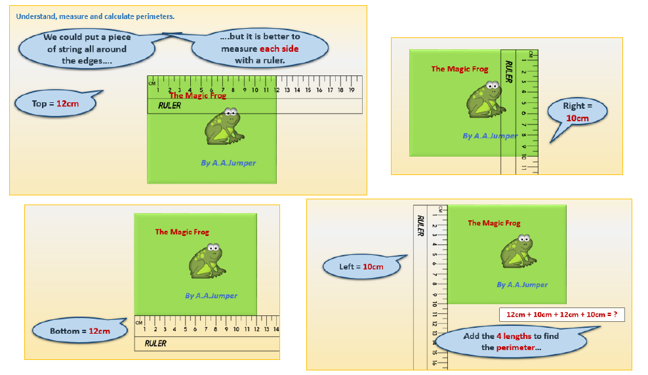
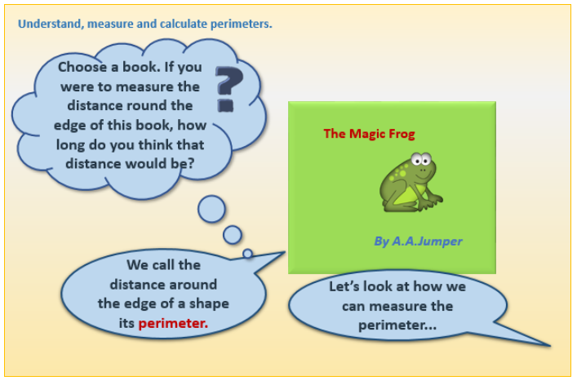
Once you have finished, please play TTRockstars/Mathletics/Numbots.

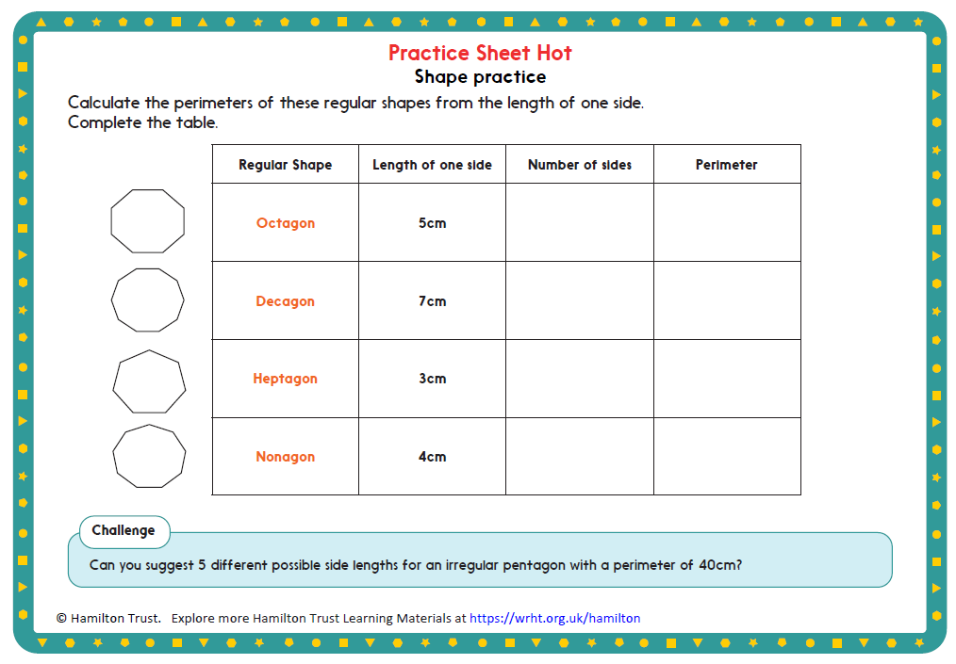
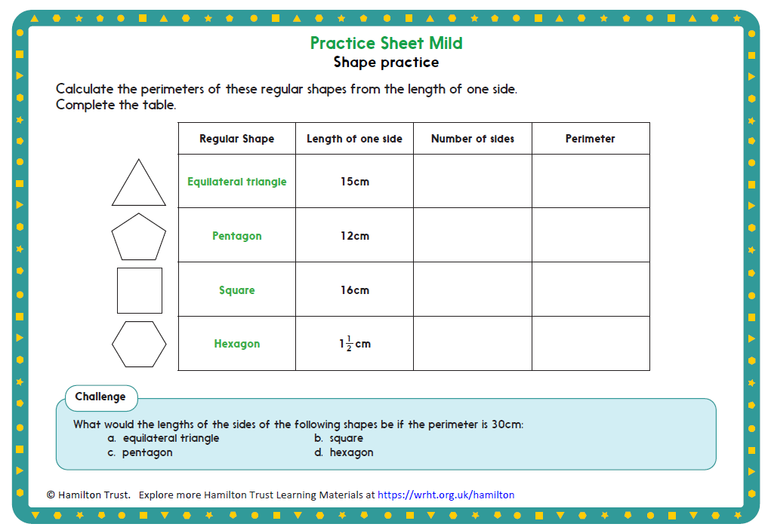

Afternoon Activity
Look at this website which tells you explores Leonardo Da Vinci’s face facts.
https://www.rct.uk/collection/themes/exhibitions/leonardo-da-vinci-a-life-in-drawing-0/face-facts
Leonardo da Vinci used and recorded a number of rules to help him when drawing the head and face. Many of these rules involved the observation of certain features of the face and their measurements between each other. These observations now provide artists with a method of accurately drawing the head and face.

Take part in the online activity, it is tricky! Press ‘continue’ twice and it will load.
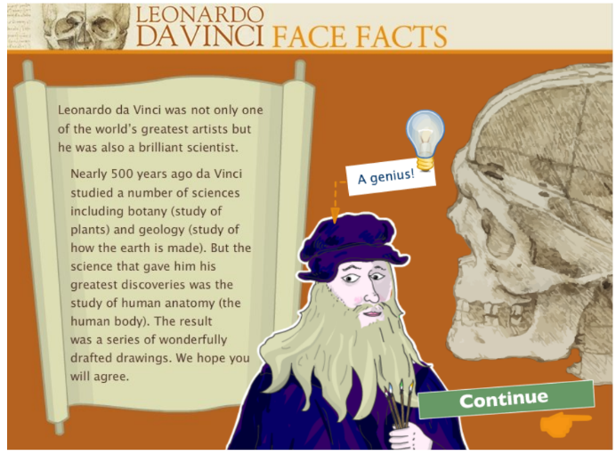

Joke for the day

How do bees get to school?


On the school buzz!

