Thursday 30th April
Remember – Keep playing Spelling Shed!
We’ll have two hive games tomorrow (Friday). One game at 10am and another at 12pm. Same spellings for both games, see you then!

Reading Activity

Read your own book at home, this might be a story book, magazine, recipe book or even the back of a cereal box!
PurpleMash have some great online stories, which are split into chapters. Each chapter has a quiz and accompanying activity on PurpleMash. To find this, click on ‘Serial Mash’ on the home page.

PE
Today, we would usually have PE.
Mr Haylock posted a great resources on our School Story from England Athletics. There are some great PE ideas to follow at home. https://funetics.co.uk/for-parents/funetics-activity-videos/

Otherwise, you can carry on with the Joe Wicks workouts. Can you create your own workout too? Think about the different techniques Mr Duffin has taught you to ensure you are using all your muscles, you could even post your workout on Class Dojo. Try to use different moves from last week so we can see something different!
https://www.youtube.com/watch?v=rN0h6EZd6TM

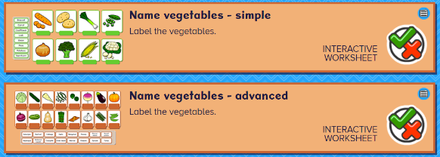
If it is raining, Mr Duffin often talks to the children about nutrition and healthy diets. There are some fun labelling activities on BusyThings about fruit and vegetables.
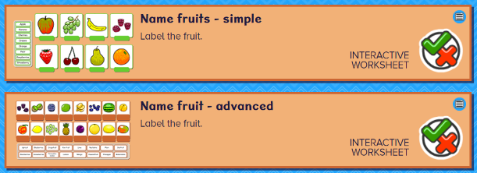


Music
We would usually have a music lesson today. As a school, we have links with the Bromley Youth Music Trust (BYMT) who have created music lessons through video.
Please follow this link to view the Year 3 activity.
https://bromleyyouthmusictrust-my.sharepoint.com/personal/jrabin_bymt_co_uk/_layouts/15/onedrive.aspx?originalPath=aHR0cHM6Ly9icm9tbGV5eW91dGhtdXNpY3RydXN0LW15LnNoYXJlcG9pbnQuY29tLzpmOi9nL3BlcnNvbmFsL2pyYWJpbl9ieW10X2NvX3VrL0V0aXlac1pmSmcxRHNILVotX29ORmVrQkFLaklnR2JRdFdqR0ZRc2tLRlEwclE%5FcnRpbWU9MkFnRWNWVHIxMGc&id=%2Fpersonal%2Fjrabin%5Fbymt%5Fco%5Fuk%2FDocuments%2FVideo%20Lessons%20Week%201%2FYear%203%201%2Emp4&parent=%2Fpersonal%2Fjrabin%5Fbymt%5Fco%5Fuk%2FDocuments%2FVideo%20Lessons%20Week%201

Afternoon Activities
Class Dojo Big Ideas – Fact or Fiction Pt.1
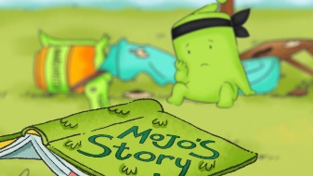
Class Dojo often create videos to discuss topics and this video is all about optimism. This is part 1 of the video, we will watch part 2 next week. Follow the link to watch the video on YouTube. https://www.youtube.com/watch?v=9o0wagkrzKw
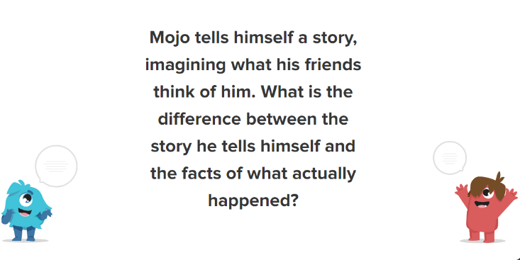
There are some discussion cards to accompany the video. You can think/talk about these questions.
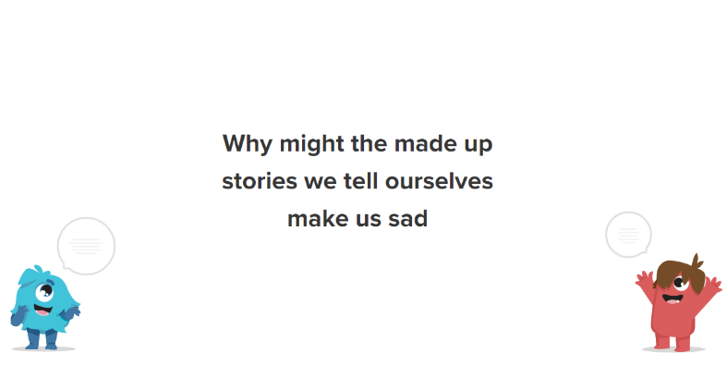
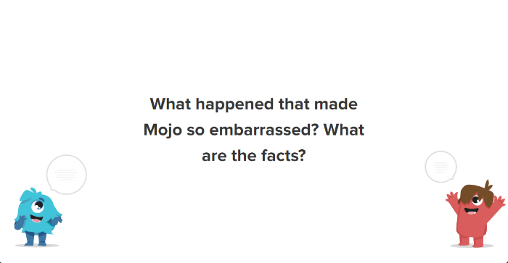

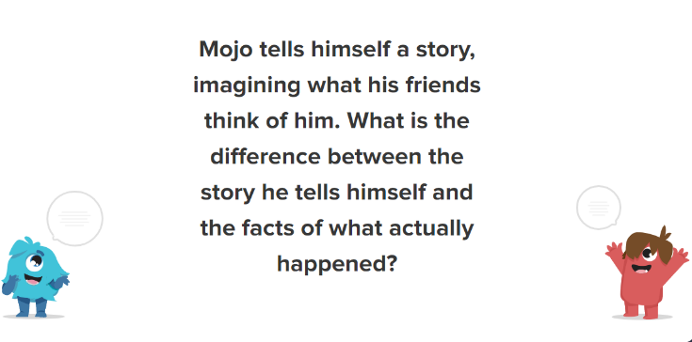

A new Spanish website!
Our modern foreign languages leader has found a fantastic website to help us continue with our Spanish learning at home. This week, we have assigned a Spanish Numbers (1-10) activity so the children can become familiar with the website. Next week, we will assign a new topic for the children to learn.
Please follow this link for the website:
https://www.languagenut.com/en-gb/
The children require a log in, please message your class teacher for the username and password. Thank you.

Joke for the day

Why did the tap dancer give up?

She kept falling in the sink!


