Wednesday 29th April

Remember – Keep playing Spelling Shed!

Reading Activity
Read this short poem.
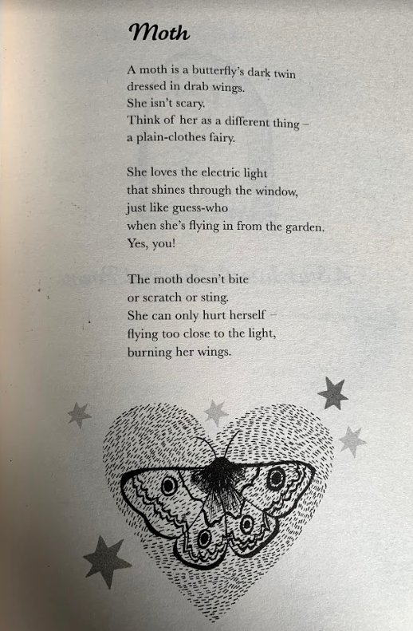

Questions
- What does the author mean by ‘a moth is a butterfly’s dark twin’?
- Clarify the word ‘drab’.
- How is a moth similar to a butterfly?
- What does the moth love?
- Does the author suggest that a moth is harmful to humans?
- How does the moth hurt herself?
- Why do you think the author says the moth is a ‘she’?

Writing Activity
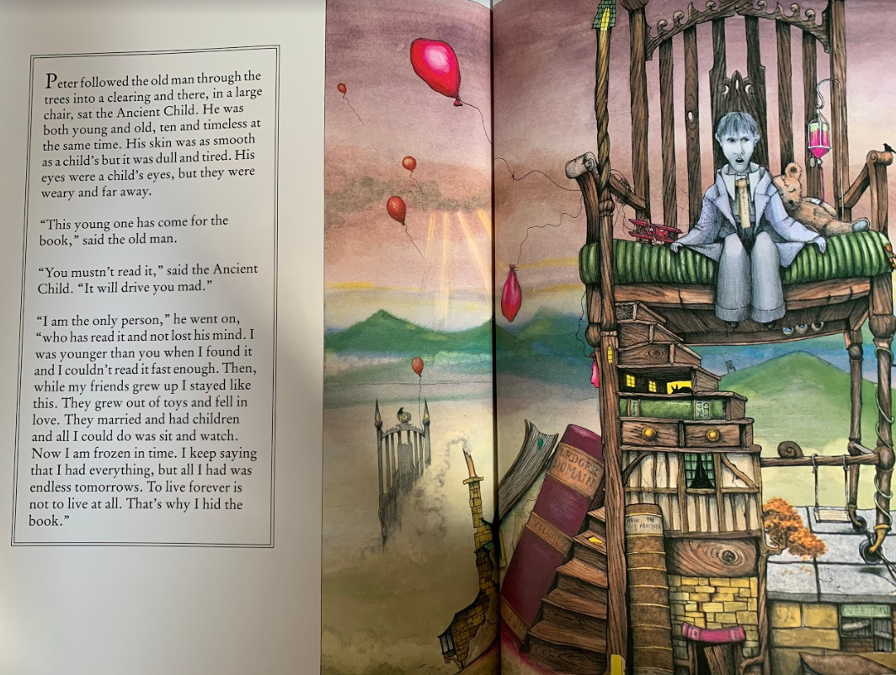
Please read to the end of the book.

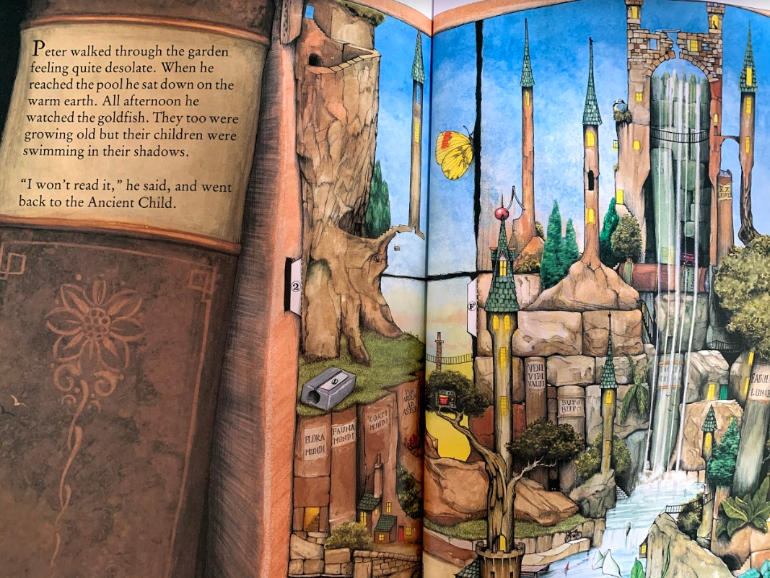
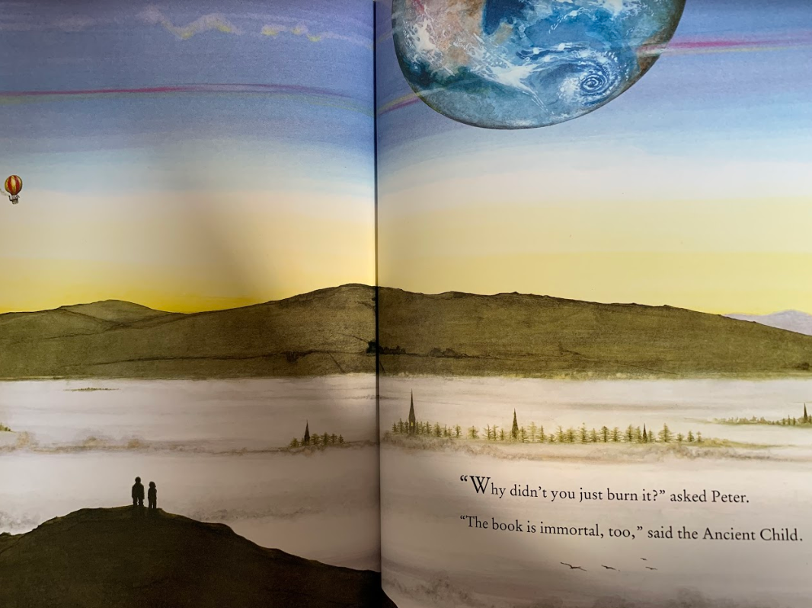
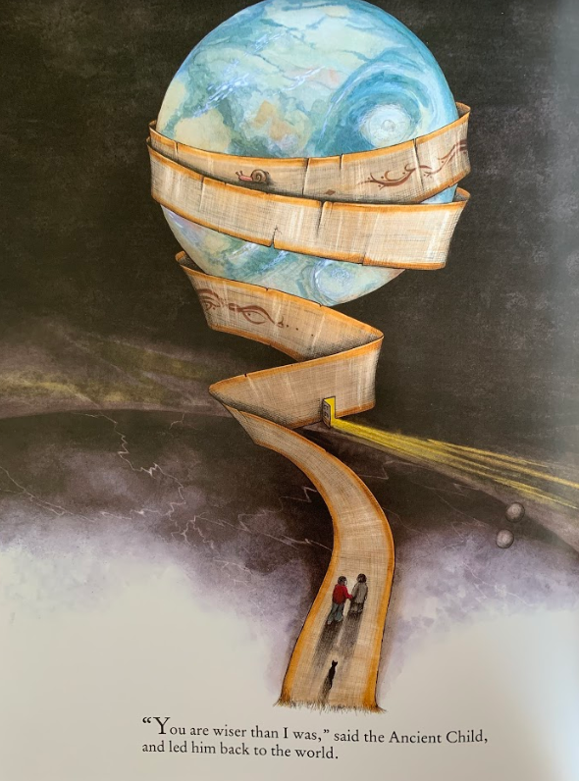

Writing Activity

We found out at the end of the story that the character was the Ancient Child who is the only person who has read the book and not lost their mind. What do you think that means?

The child watched his friends grow up and leave him, the Ancient Child is frozen in time. He says to live forever is to not live at all. He hid the book so nobody else would have to go through the same experience as him. The Ancient Child also says that Peter is wiser than he was as Peter decides not to read the book.

Today, the writing activity is to write a persuasive letter from the Ancient Child telling others not to read the book ‘How to Live Forever’. The letter will be placed on the shelf where the book should be in the library so if others wonder why a book is missing, they can read your letter and be persuaded not to look for it or read it.

Here is a checklist to ensure that you’ve included all the features of a persuasive letter. You can make up the addresses or leave part out.
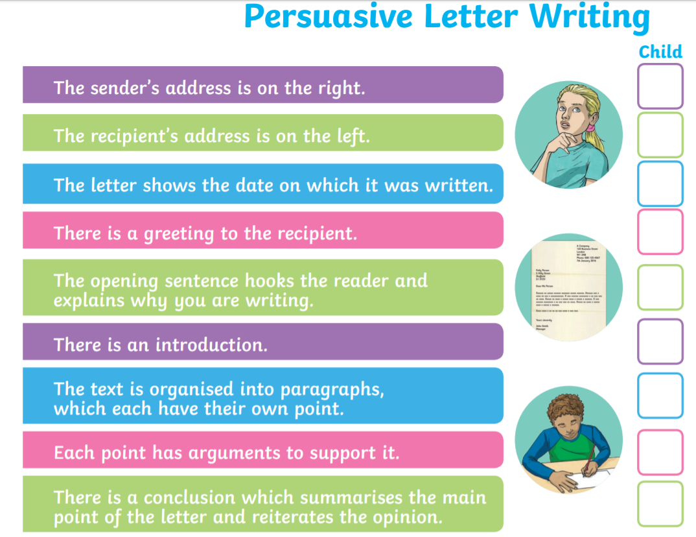

Maths Activity – Length
This half term we are going to use Hamilton Trust for our maths learning. Each day, there will be ‘learning slides’ and an activity which matches. Please complete the activity on paper.
Once you have finished, please play TTRockstars/Mathletics/Numbots.

If you do not have 9 pencils to measure or a ruler at home, please make up the measurements.
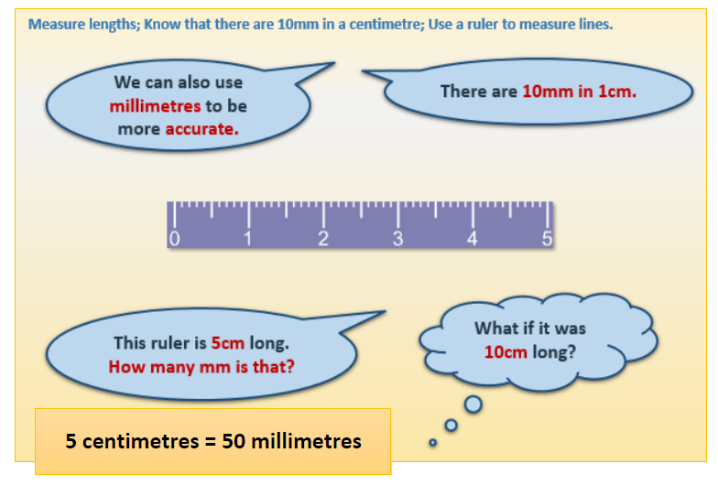

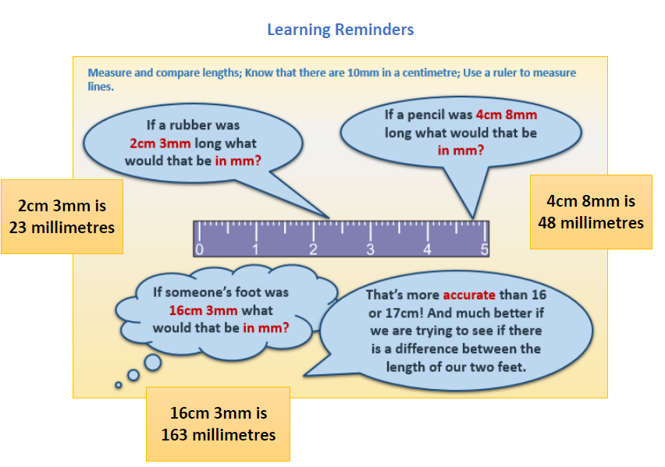

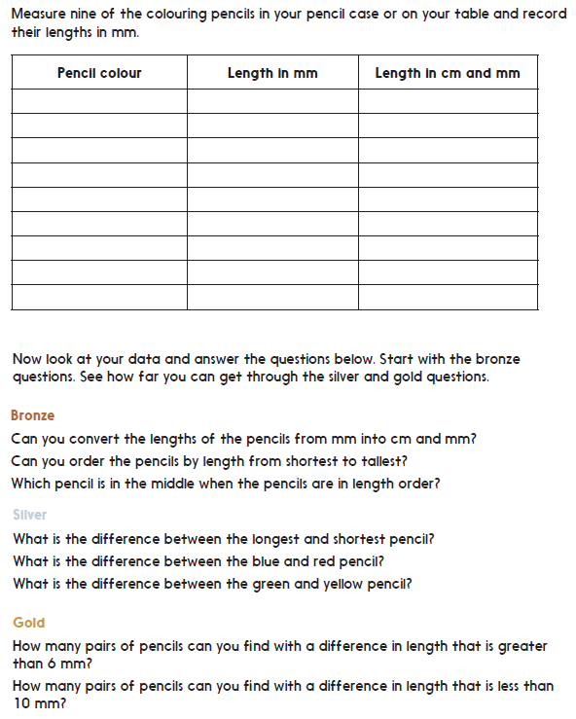
This activity is on GoogleClassroom if you prefer to complete it on there.

Afternoon Activity
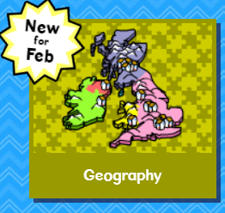
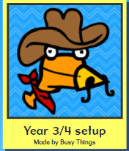
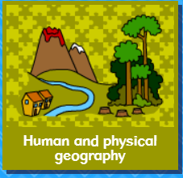
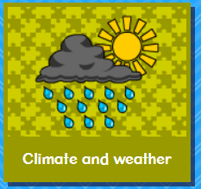
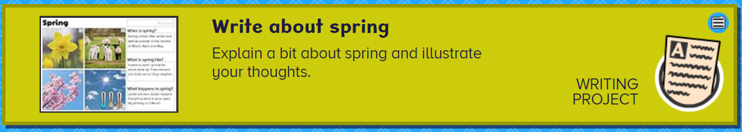

Please complete the ‘Write about Spring’ activity on Busy Things.

Joke for the day
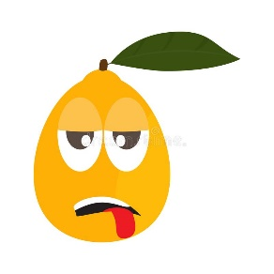
Why didn’t the orange win the race?

It ran out of juice!

