Tuesday 28th April
Remember to keep playing Spelling Shed.
Nessy
Mrs Mills posted on our School Story yesterday about an app called Nessy. This is an app we usually pay for at school and Nessy are currently offering it for free until tomorrow.

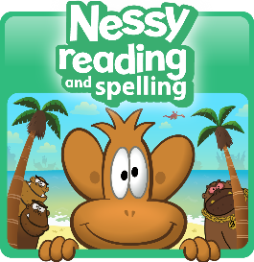
The app teaches letter sounds and early sound blending, foundational phonics with consonant digraphs and vowel digraphs, and teach the 100 most frequent sight words.

If you feel your child would benefit from this, please download it.

Reading Activity
Please log onto Read Theory and complete 3 activities or visit the Collins BigCat website (https://connect.collins.co.uk/school/Portal.aspx) and log in using this username and password to access hundreds of eBooks. There are also worksheets which can be used alongside the books, which can be found here: https://collins.co.uk/pages/big-cat-ebooks
Go to https://connect.collins.co.uk/school/Portal.aspx and click on the Teacher portal and enter:
Username: parents@harpercollins.co.uk
Password: Parents20!
Click Login.

Writing Activity
On the next page of ‘How to Live Forever’ we see this illustration.
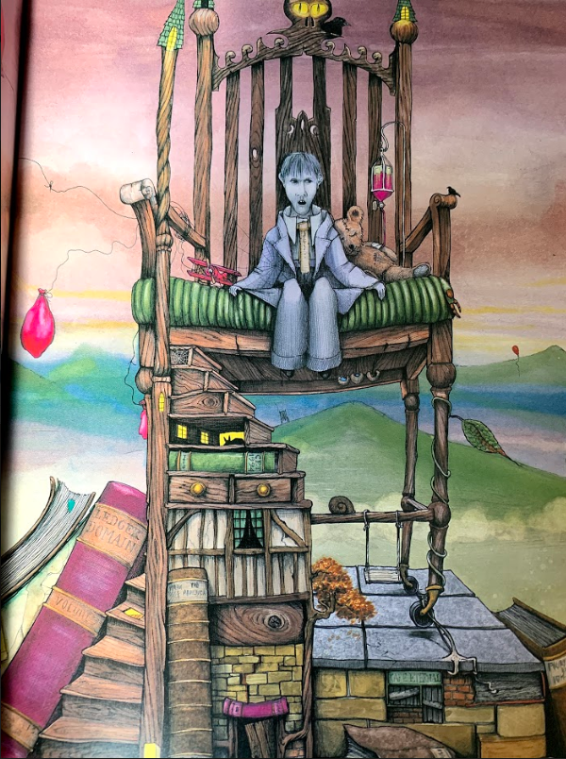

The Activity
Look at the illustration and answer the following questions in as much detail as you can.

Who do you think this is?

How do you know?

Why is the character completely grey? What is the author trying to tell us?

Look at the character’s expression, how do you think he is feeling?

What does the deflated balloon, aeroplane and teddy bear tell us about the character?

Predict what the character will say to Peter.

Maths Activity- Adding and Subtracting Money
This half term we are going to use Hamilton Trust for our maths learning. Each day, there will be ‘learning slides’ and an activity which matches. Please complete the activity on paper.
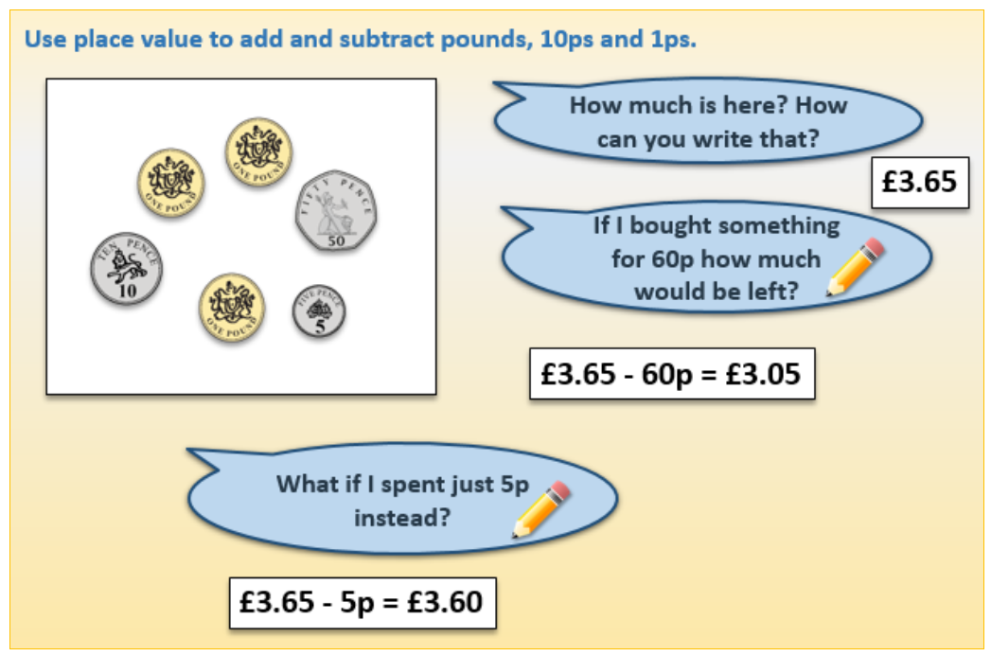
Once you have finished, please play TTRockstars/Mathletics/Numbots.

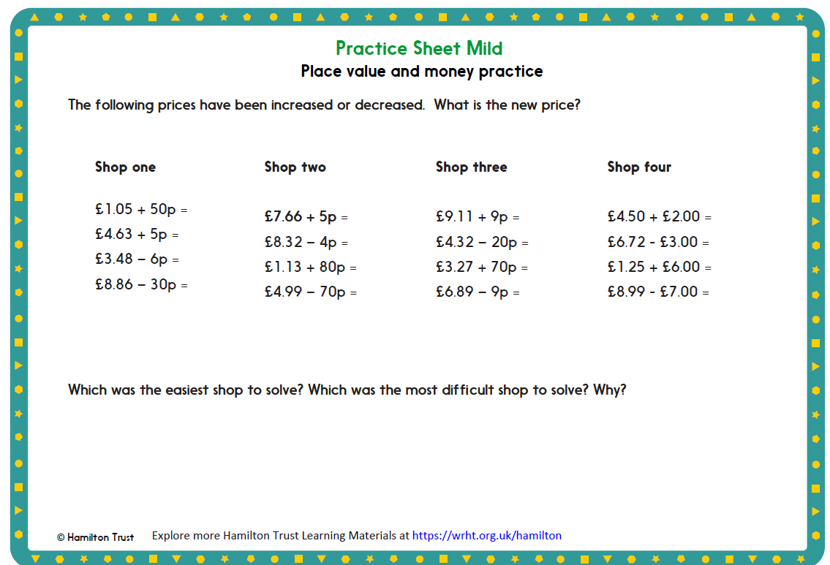

Afternoon Activity
Please go onto ‘Hour of Code Learn’ and complete ‘Dragon Dash’.
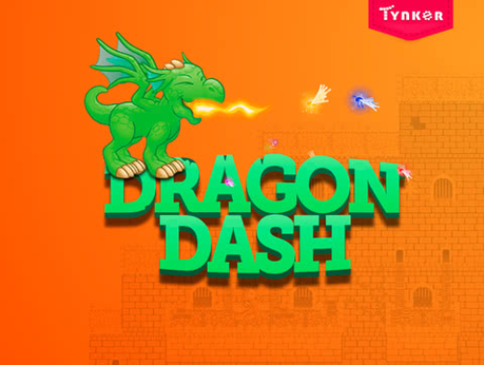

Here is a direct link: https://hourofcode.com/tynkerdd

Joke for the day

What is worse than finding a worm in your apple?

Finding half a worm…


