Monday 27th April
Spellings for the Week – On Spelling Shed
- really
- definitely
- absolutely
- actually
- certainly
- should
- would
- could
- leave
- alone
Reading Activity
Please read your own book, it may be a fact file, a leaflet or an online book from PurpleMash. Remember you can quiz on your books, message us if you need support with this.

Remember – you can quiz on lots of your home books! https://ukhosted65.renlearn.co.uk/2240525/

Writing Activity
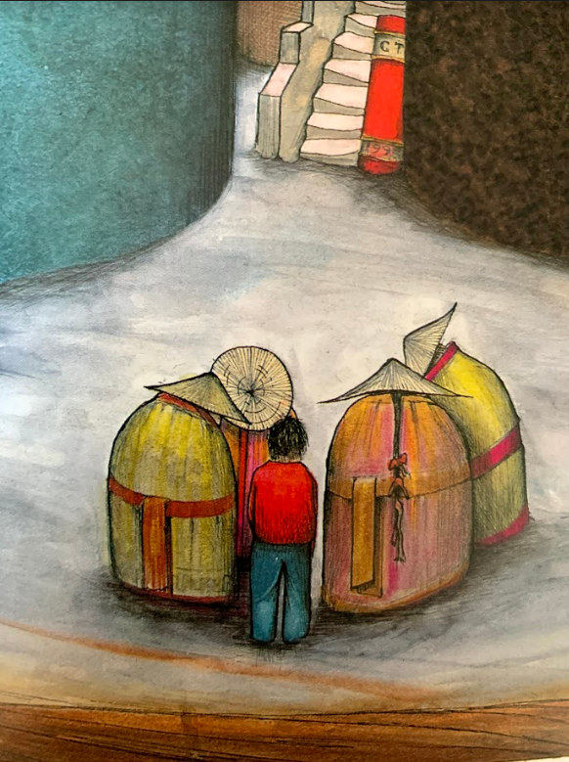

Here is an illustration of Peter and the Old Men.

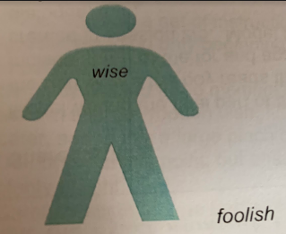
Today, you are going to write adjectives to describe the appearance and personality of the men. To do this, you might like to draw an outline of a person and write adjectives to describe their personality on the inside and adjectives to describe their appearance on the outside.

Word Bank – old, wise, white haired, foolish, gentle, kind, wrinkled, deceiving, caring, trustworthy/untrustworthy

Once you have done this, you might like to put your adjectives into sentences to write a descriptive paragraph about the old men.
Example – The old men are foolish because if the book worked, why do they appear so old? However, it is possible that the men know something about the book which Peter does not so they could be wise.

Maths Activity – Ordering Fractions
This half term we are going to use Hamilton Trust for our maths learning. Each day, there will be ‘learning slides’ and an activity which matches. Please complete the activity on paper.
Once you have finished, please play TTRockstars/Mathletics/Numbots
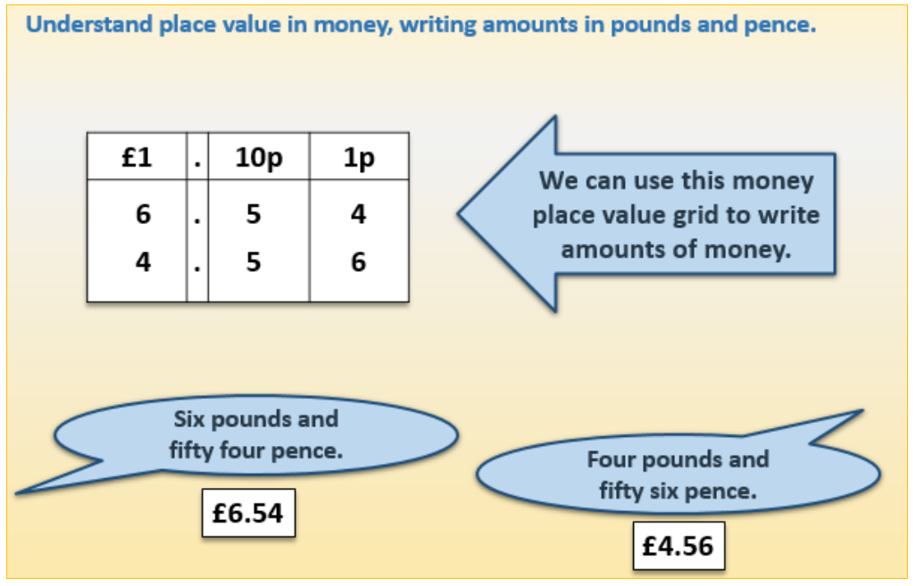
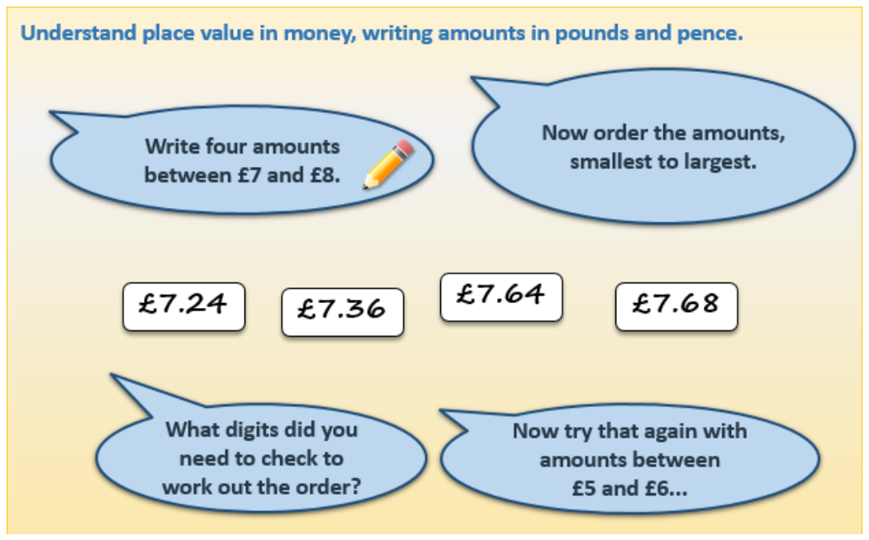

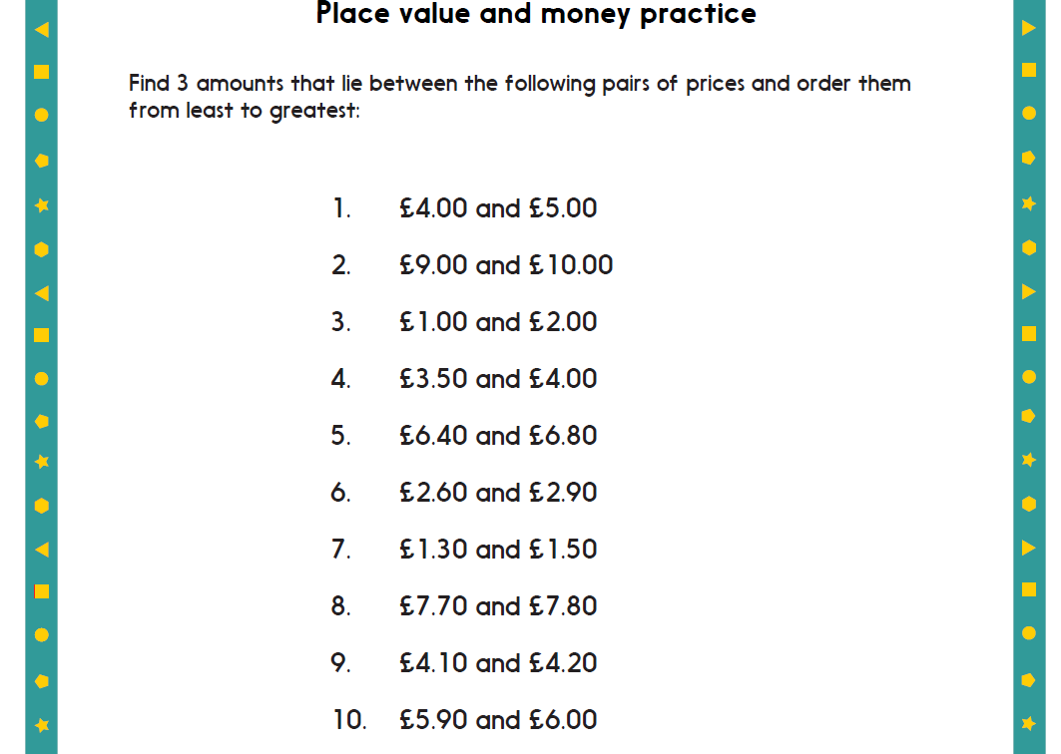

Afternoon Activity
Please follow this website link to access a virtual experiment for our current Science topic – plants!

http://ve34.lgfl.org.uk/

The children may need to log in using their LGfL username and password – please contact us if you need this.
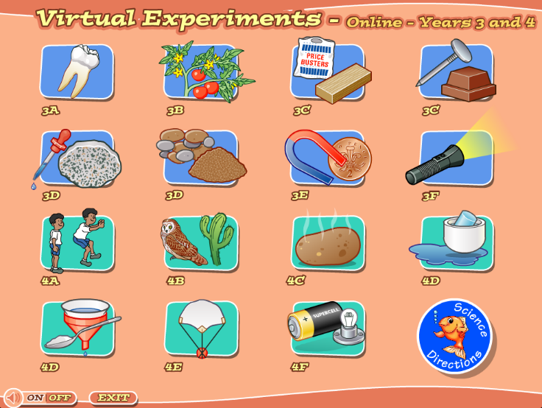
Click on 3B for the plant experiment.

The virtual experiment may be something you can complete at home, you will need celery or a white flower & food colouring.

Joke for the day

What did one volcano say to the other?

I lava you!

