Friday 24th April
Remember – We are going to attempt a Hive game today for our spellings on Spelling Shed.
1st code posted at 9:45am for a 10am start.
2nd code posted at 11:45am for a 12pm start.
Both games will have the same spellings.

Reading Activity
Read this information about a famous sculpture called Barbara Hepworth.
https://www.tate.org.uk/kids/explore/who-is/who-barbara-hepworth
Barbara Hepworth was a British sculpture, who was born in 1903 in Wakefield. Barbara Hepworth's earliest memories were from driving though the countryside with her family. She never forgot the shapes made by the roads, hills and fields and they inspired her to make some amazing artwork.
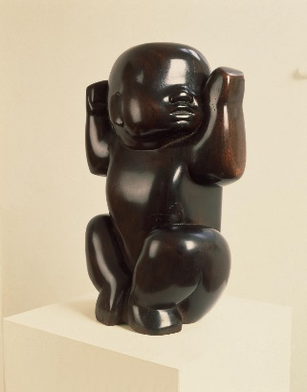
This is an early sculpture by Hepworth made in 1929. It is of her son Paul, who was born in 1929. It is made of wood that has been sandpapered until it is smooth and glossy. The baby looks as if he is lying on his back, but Hepworth has made the sculpture stand upright. It also looks a bit like an African carving. Many modern artists were influenced by African art at this time.
Hepworth wanted to create art that was calm, that people could enjoy looking at and wouldn’t make them feel uncomfortable or anxious. She began to make sculptures and drawings that were inspired by the landscape and nature around her.
You might like to create a fact file about Barbara Hepworth on PurpleMash.

Writing Activity
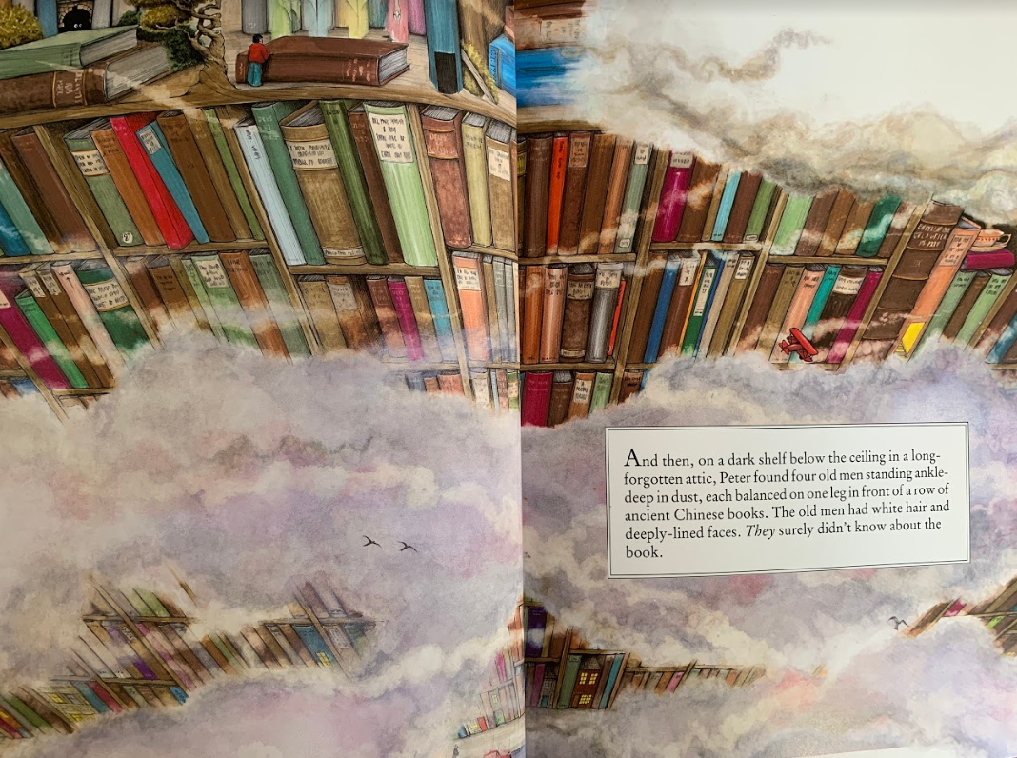
Read the next pages of the story.

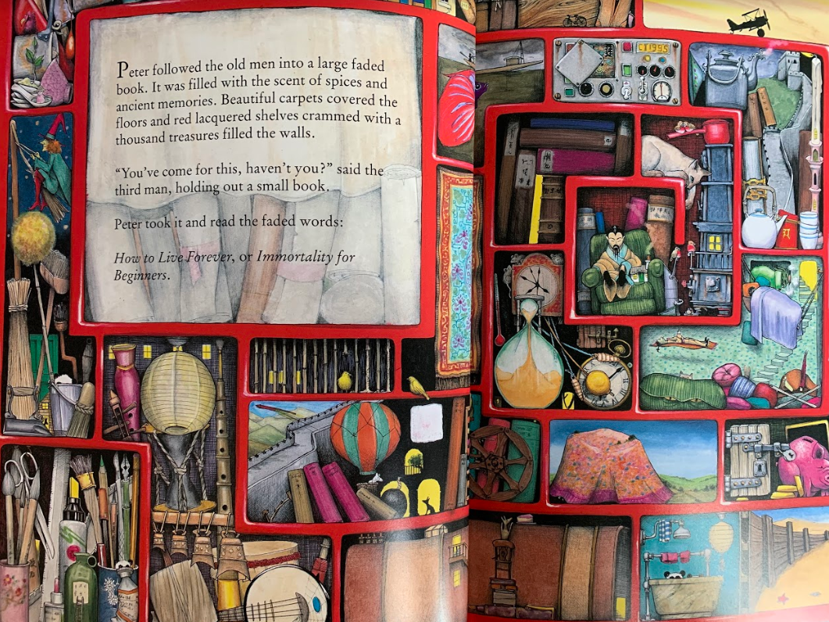
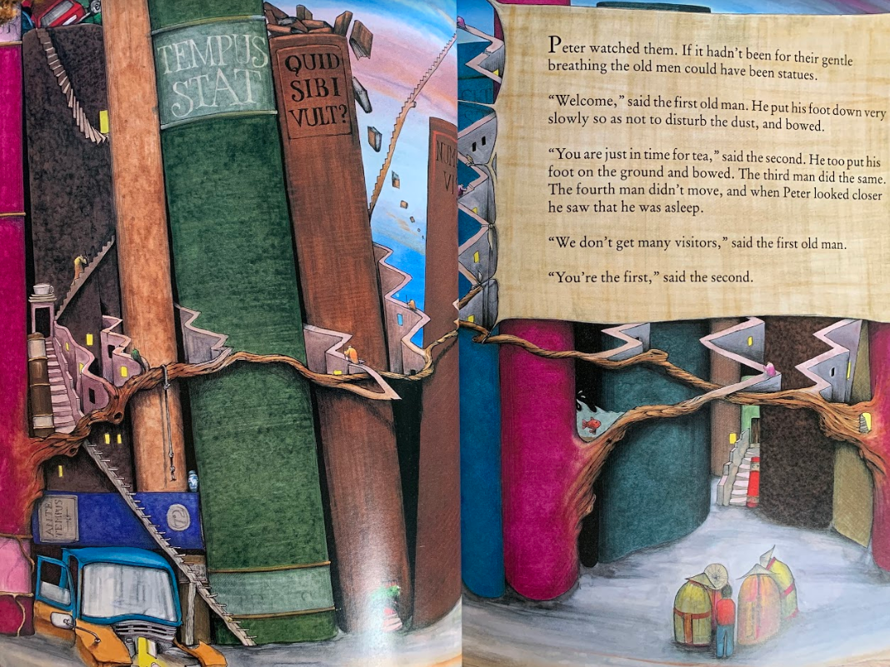
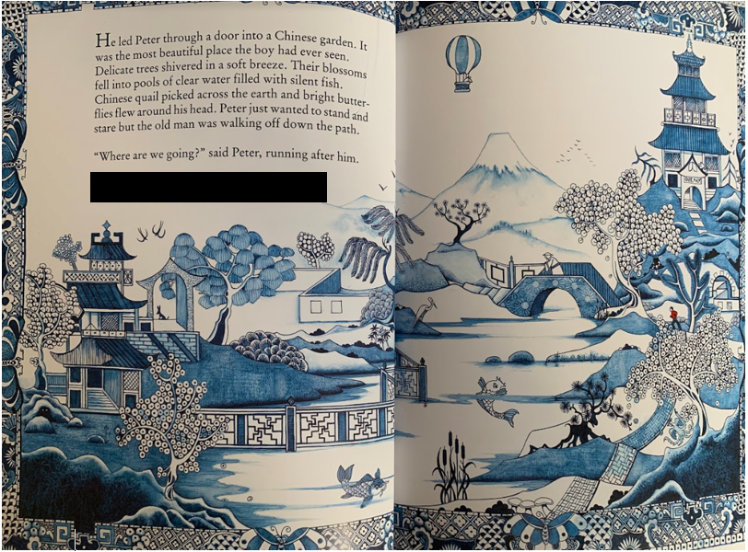
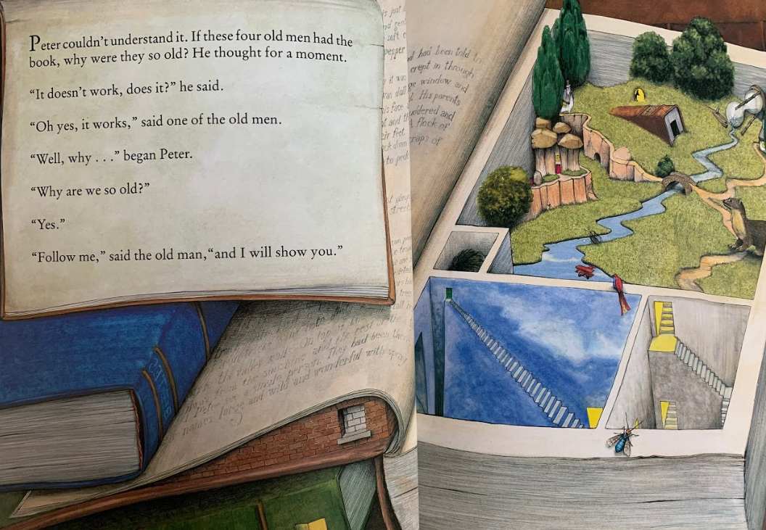

Colin Thompson (the author) uses lots of different sentences to create a vivid description of the Chinese garden. He uses the words ‘with’ and ‘of’ to add information. ‘Their blossoms fell into pools of clear water filled with silent fish.’

Make a list of all the nouns you can see in the Chinese garden. Put these nouns into phrases, with adjectives to create a setting description of your own.

Challenge – Use the words ‘of’ and ‘with’ to add extra detail.

Maths Activity -
This half term we are going to use Hamilton Trust for our maths learning. Each day, there will be ‘learning slides’ and an activity which matches. Please complete the activity on paper.
Once you have finished, please play TTRockstars/Mathletics/Numbots.
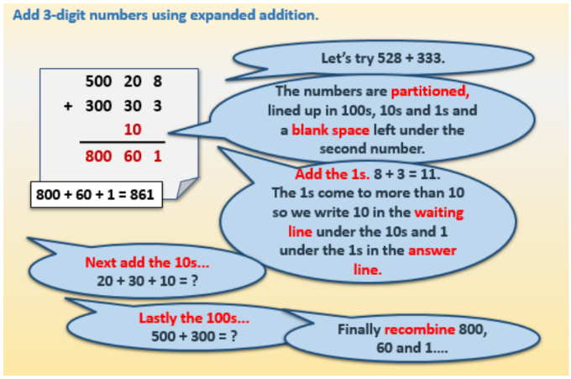

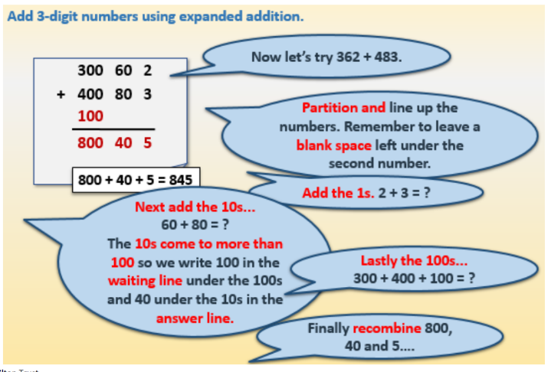

The following calculations can be solved using any method you choose, you may like to use expanded addition but if you can remember how to calculate the answers using standard column addition then please do, or you may be able to solve them in your head/use a number line/use resources to help you. We don’t mind how you get to the answer!

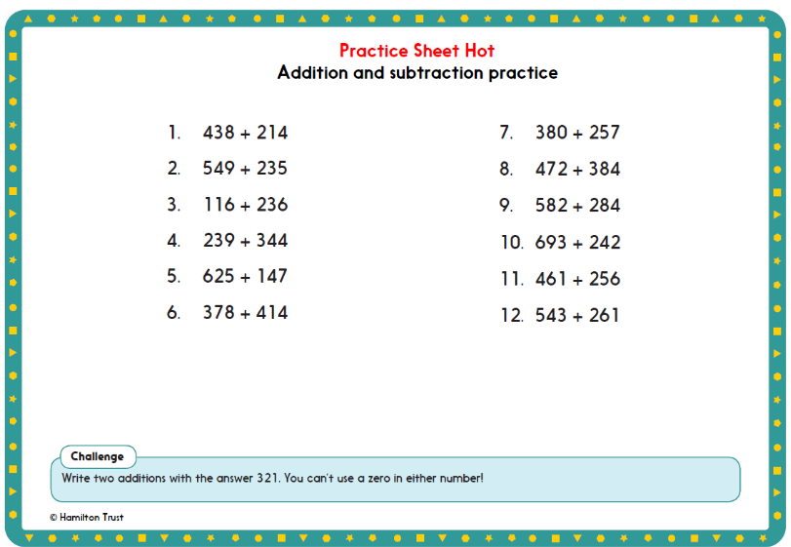
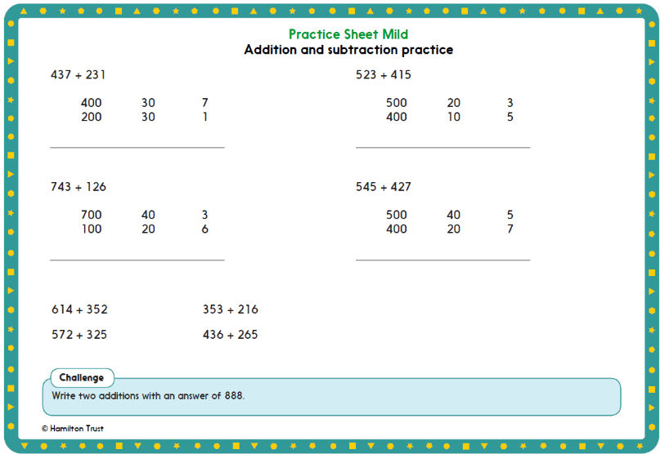

Afternoon Activity
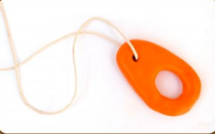
Look at this website which tells you how to make a ‘Hepworth necklace’, which is based on Barbara Hepworth’s sculptures.
https://www.tate.org.uk/kids/make/sculpture/make-hepworth-necklace
If you have the materials available (or substitutes) then you might like to create a Hepworth necklace.

Otherwise, this is a piece of art created by Barbara Hepworth in 1972, called ‘Moonplay’. Recreate this piece of art by drawing it or using PurpleMash. You could change the colours to make it personal to you.

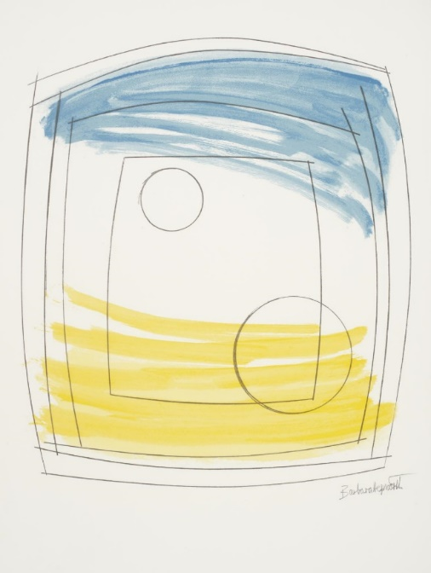

Joke for the day

Why did the cookie go to hospital?
He was feeling crummy!

