Thursday 23nd April
Remember – Keep playing Spelling Shed!
We’ll have two hive games tomorrow (Friday). One game at 10am and another at 12pm. Same spellings for both games, see you then!

Reading Activity
Read your own book at home, this might be a story book, magazine, recipe book or even the back of a cereal box!

PE
Today, we would usually have PE. Access this link to complete a Joe Wicks workout. Can you create your own workout too? Think about the different techniques Mr Duffin has taught you to ensure you are using all your muscles, you could even post your workout on Class Dojo. Try to use different moves from last week so we can see something different!

https://www.youtube.com/watch?v=fAUckPMJKSY

Music
We would usually have a music lesson today. Please complete the ‘Colour Choir’ activity which you’ll find in Music on Busy Things. Unfortunately, you may be unable to save this activity as BusyThings don’t allow that feature for this game.
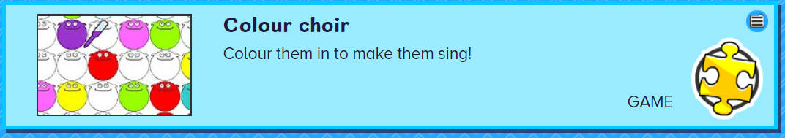
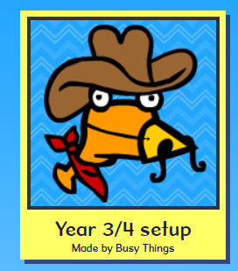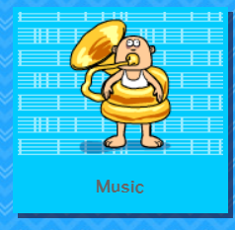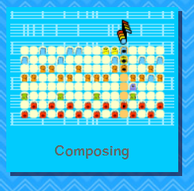

As an addition, please complete the 2Do on Purple Mash named ‘2Explore’

Afternoon Activity
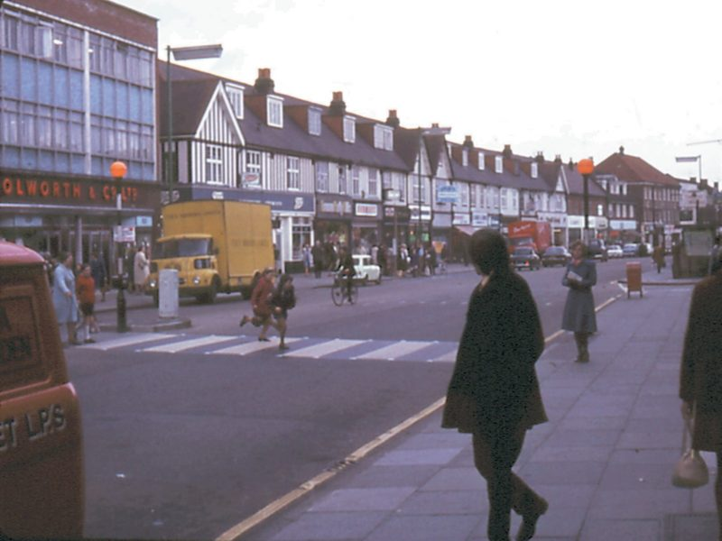
Below are two photos from Orpington town. One photo is from 1971 and the other is more recent. However, if you visited Orpington today then one shop is definitely not there anymore!

Look at the 2 photos.

Write or think about the similarities (what is the same) and differences (what has changed) between the 2 photos.

Do the changes show how technology has changed? Does 1 photo have changes which makes it safer?

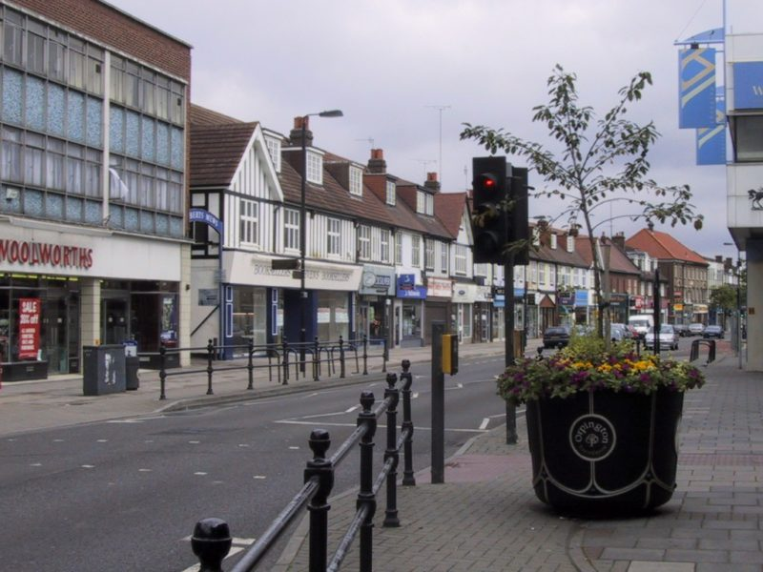

St George’s Day
Today is St George’s Day, St George (famous for slaying the dragon) is the patron saint of England. He was a Roman soldier who protested against the Roman torture of Christians, and was killed for his beliefs. He is most famous for the story of his fight against the dragon.

If you would like to take part in activities based around St George’s Day, please see our ideas below. There are hundreds more online too!
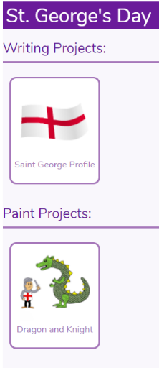

Search for ‘St George’s Day’ on Purple Mash.

Read the information about St George’s Day to create a fact file or poster! https://www.bbc.co.uk/newsround/17816642

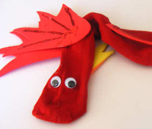 Create a dragon out of a red sock!

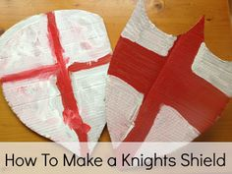 Design and make a shield!

Joke for the day

Why was 6 afraid of 7?

Because 7, 8, 9!


