Wednesday 22nd April

Remember – Keep playing Spelling Shed!

Reading Activity
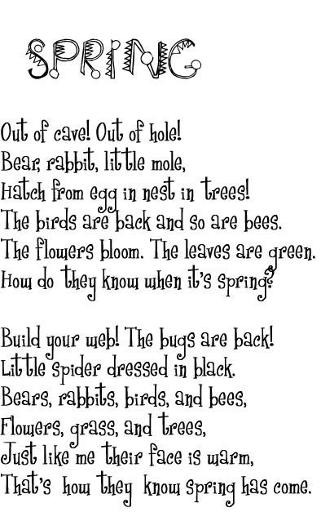
Read this short poem.

Answer the questions:
- What is the poem about?
- Clarify ‘hatch’
- Name 3 animals which are mentioned in the poem
- How do the animals know it is Spring?
- Why should the spider build his web?
- What do you like about Spring?

Writing Activity
Please read the next pages of the story.

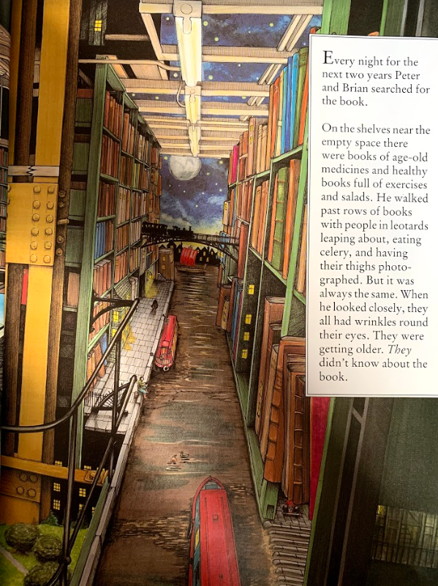

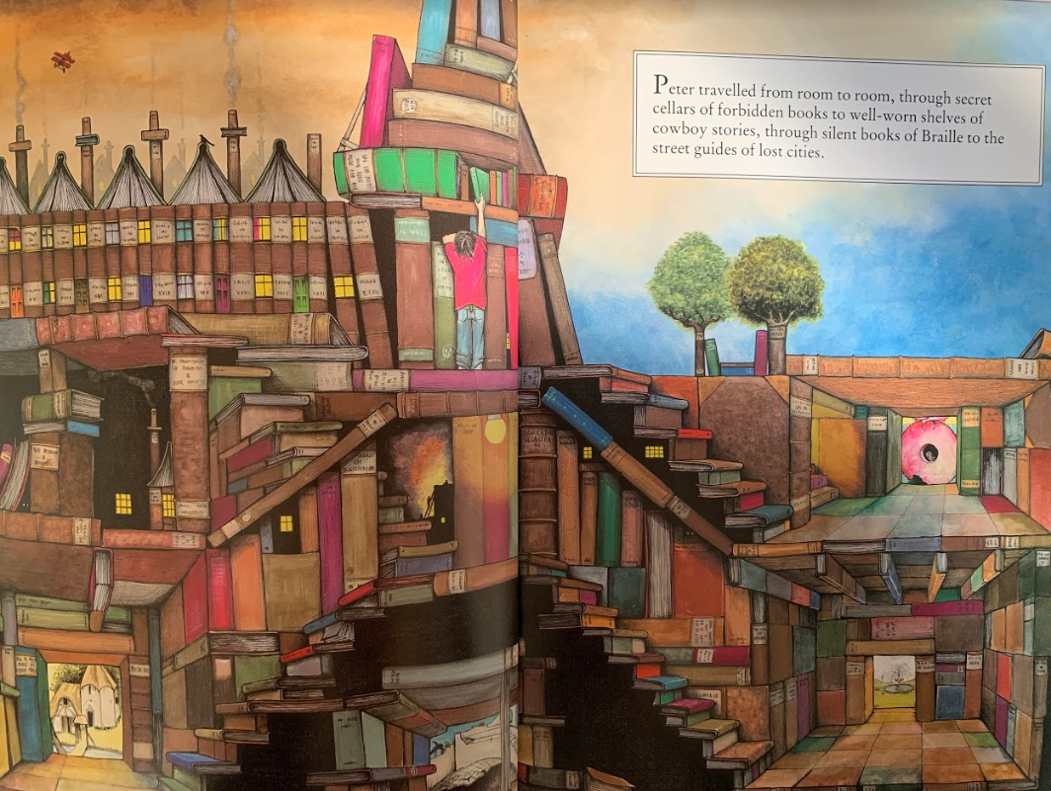
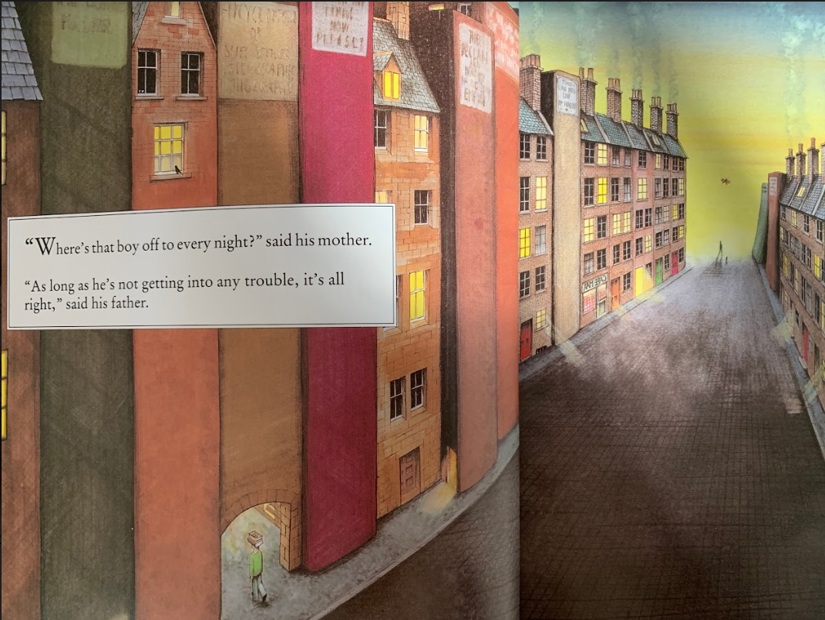

Think about a time when you have lost something.
How long would you look for something before you gave up?
The boy looked for the book for over two years. What does this tell us about the boy’s relationship with the book?
How did the boy know that the people with wrinkles didn’t know about the book?

To help the boy, create a lost poster for the book.
Challenge – Remember the book has magical powers, can you include sentences or phrases which means the book is found but the person who finds it doesn’t open it?

Would you open a book as dangerous as this?

There is a huge reward for returning the book unopened!

Leave the book alone – it can cause harm!

Maths Activity – Adding Mentally
This half term we are going to use Hamilton Trust for our maths learning. Each day, there will be ‘learning slides’ and an activity which matches. Please complete the activity on paper.
Once you have finished, please play TTRockstars/Mathletics/Numbots.

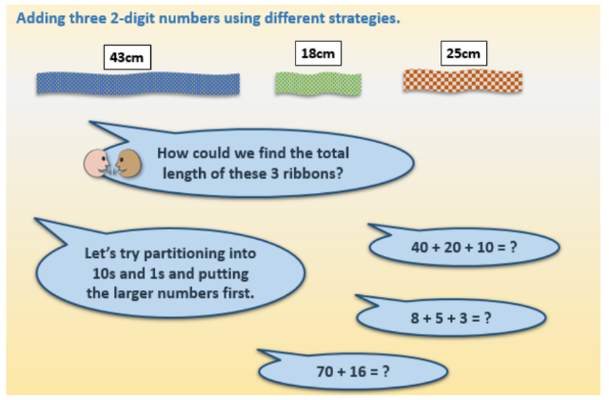

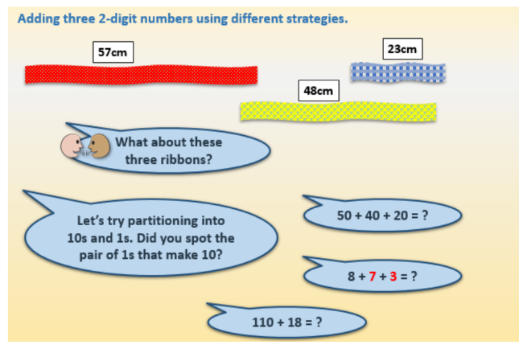

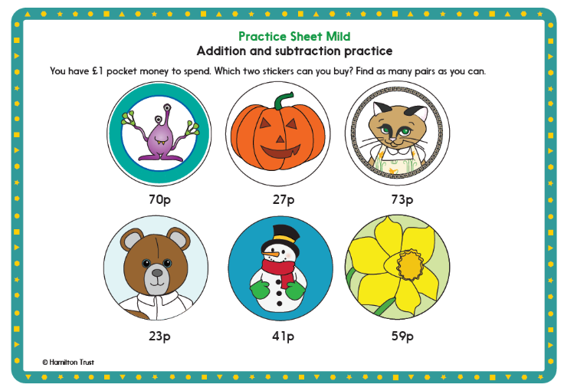
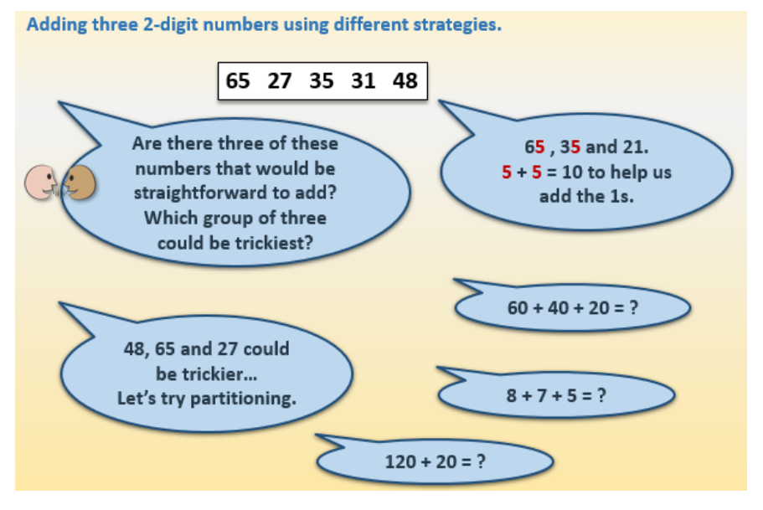

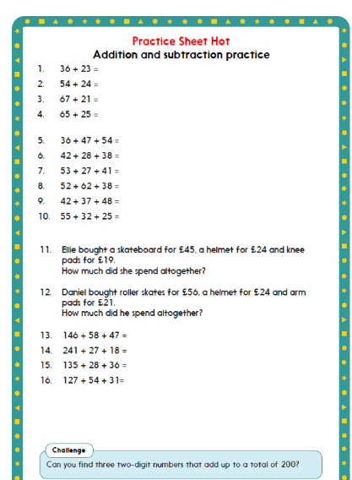

Afternoon Activity

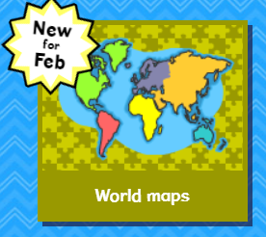
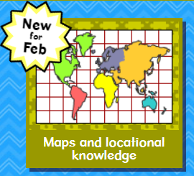
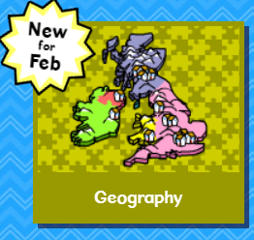
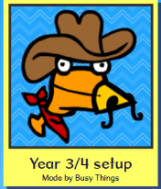
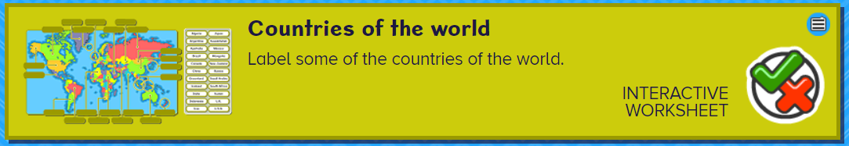
Please complete the ‘Countries of the World’ activity on Busy Things.

Joke for the day

What do you get when you cross a vampire and a snowman?

Frost bite!


