Tuesday 21st April
Remember to keep playing Spelling Shed.

Reading Activity
Please log onto Read Theory and complete 3 activities

Writing Activity
Please read part of the story.
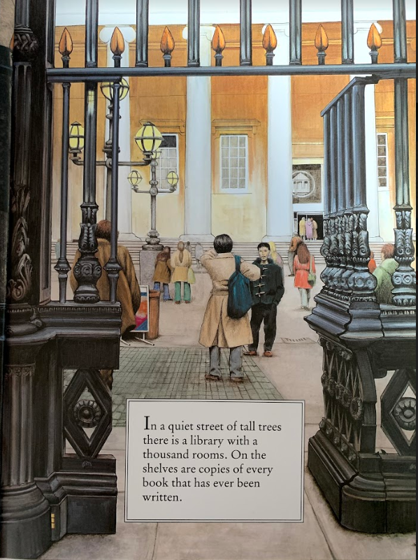
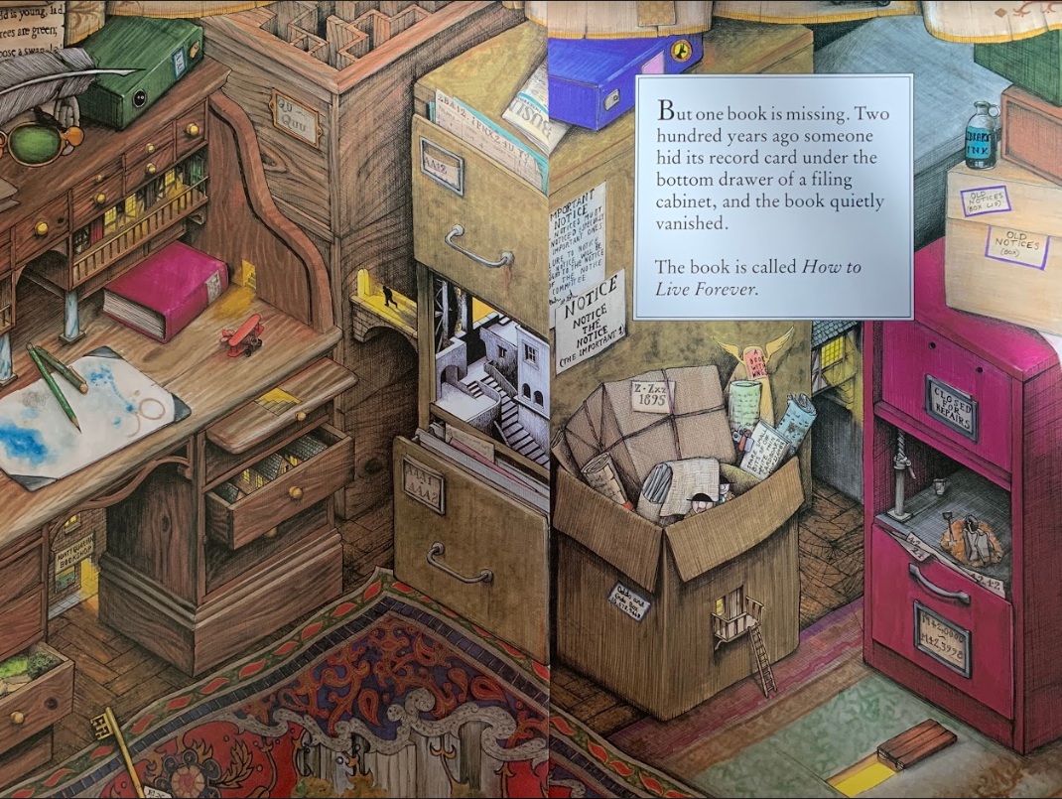

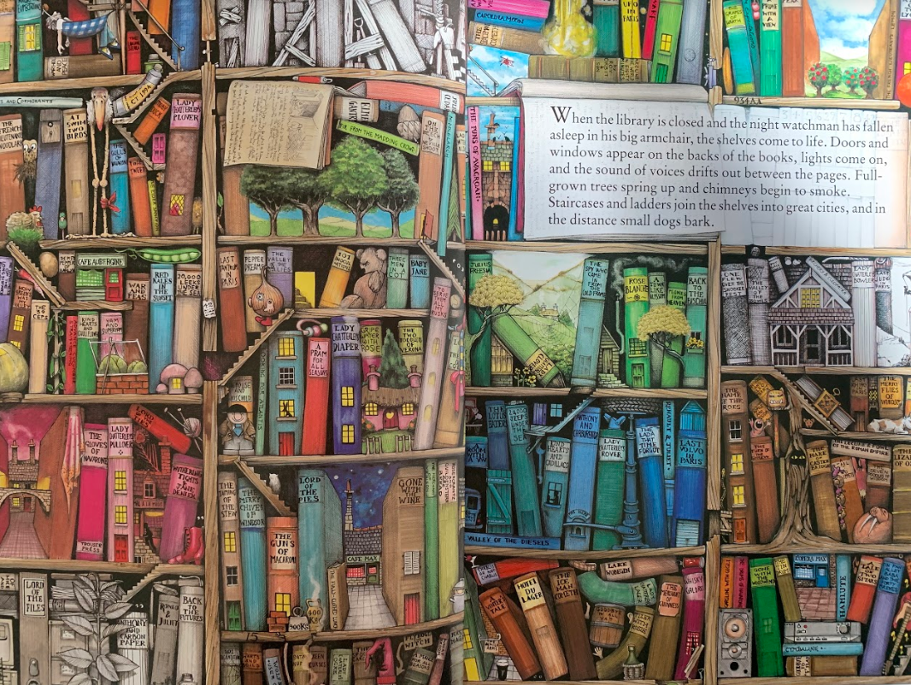

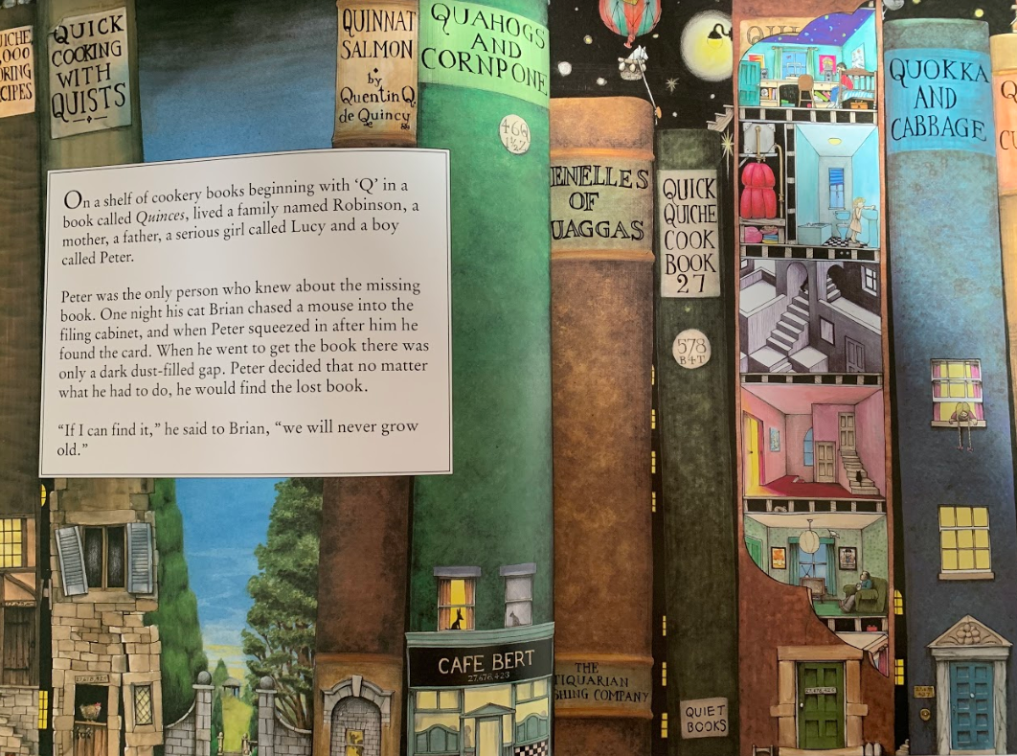

Today, we are going to think about the pros and cons (advantages/good things and disadvantages/bad things) about living forever. Write 3 pros and 3 cons about living forever.

Ask other people in your household, would they like to live forever? What could you gain from living forever? What might you lose if you lived forever?

Maths Activity – 3 Digit Numbers
This half term we are going to use Hamilton Trust for our maths learning. Each day, there will be ‘learning slides’ and an activity which matches. Please complete the activity on paper.
Once you have finished, please play TTRockstars/Mathletics/Numbots.
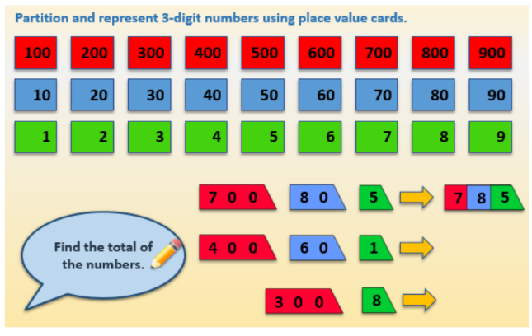
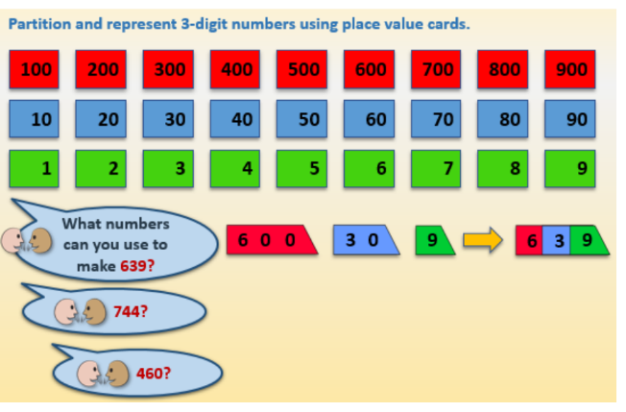

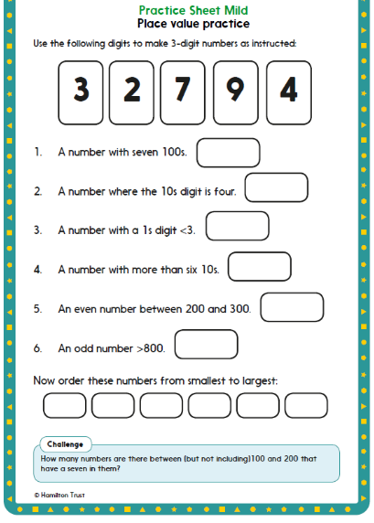
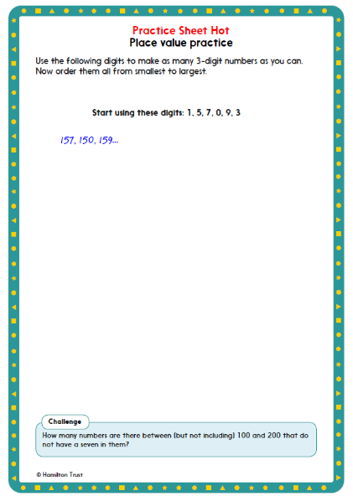

Afternoon Activity
Please go onto ‘Hour of Code Learn’ and complete the ‘Make a Flappy Game’ code.

https://hourofcode.com/uk/learn

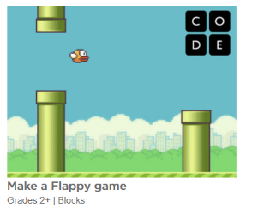

Joke for the day

What did the left eye say to the right eye?

Something between us smells!


