Monday 20th April
Hope you all had a lovely Easter!
Spellings for the Week – On Spelling Shed
- exercise
- knowledge
- length
- library
- ordinary
- peculiar
- weighty
- forever
- shelves
- hundred
Reading Activity
Please read your own book, it may be a fact file, a leaflet or an online book from PurpleMash. Remember you can quiz on your books, message us if you need support with this.

Writing Activity
We are starting a new book for the new few weeks, it is called ‘How to Live Forever’ by Colin Thompson. Predict what you think the book is going to be about. Use the pictures on the front cover to help you. Think about what ‘forever’ means. Is that 100 years, 1000 years or more?
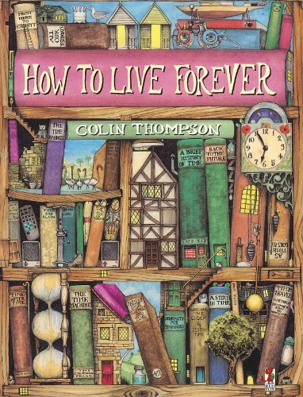

Now read the blurb of the book. Does this give you any more clues as to what the story will be about? Clarify the word ‘immortality’ and ‘beginners’, does that give you any more information?

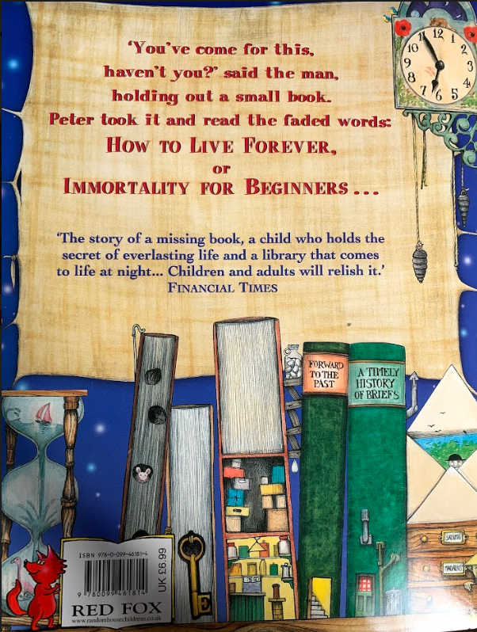

Maths Activity – Number lines
This half term we are going to use Hamilton Trust for our maths learning. Each day, there will be ‘learning slides’ and an activity which matches. Please complete the activity on paper.
Once you have finished, please play TTRockstars/Mathletics/Numbots.
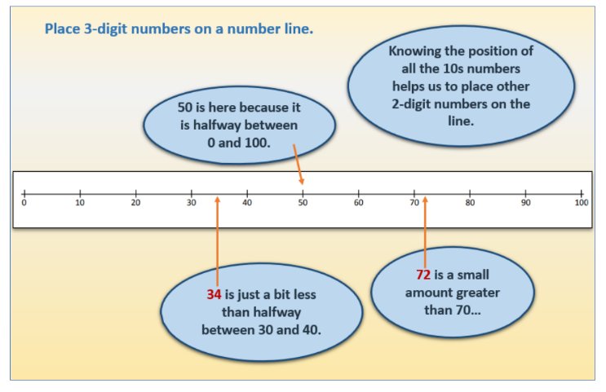

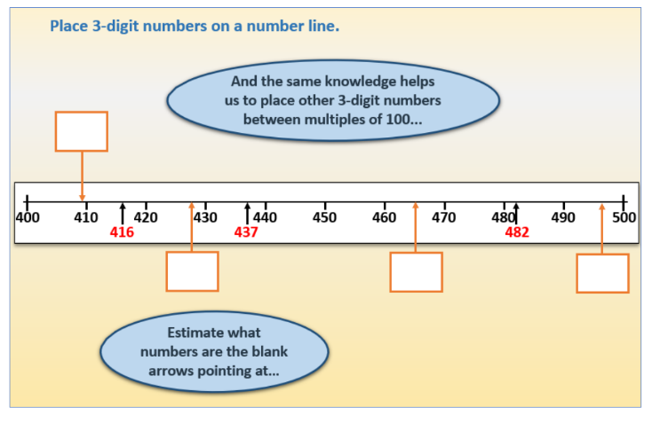

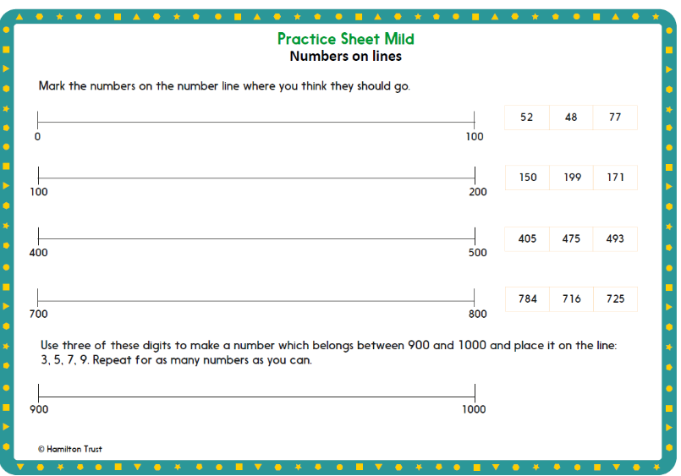

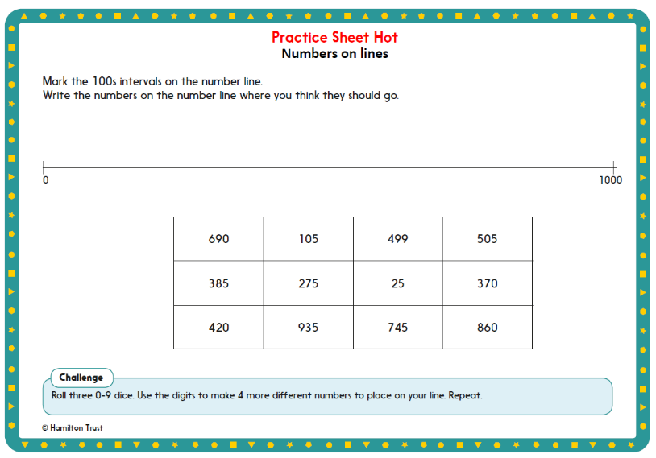

Afternoon Activity
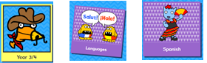
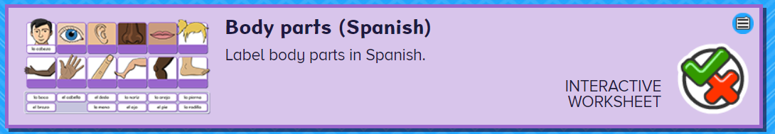
Please complete the activity called ‘Body Parts (Spanish)’ on Busy Things.

Joke for the day

What do you call a pig who does karate?

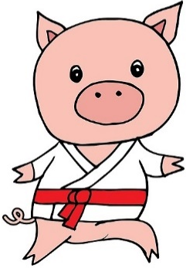
A pork chop!

