Friday 3rd April – Happy Friday!
Remember – We are going to attempt a 2 Hive games today for our spellings on Spelling Shed.
1st game – Code posted at 9:55am for a 10am game.
2nd game – Code posted at 11:55am for a 12pm game.
Same spellings on both games.

Reading Activity
Read this information about a famous artist called L.S Lowry.
- L. S. Lowry (Laurence Stephen Lowry) was born on 1st November 1887 in Stretford, Lancashire.
- Lowry had an unhappy childhood. He wasn’t very popular at school, didn’t have a very close relationship with his parents, and he had few friends.
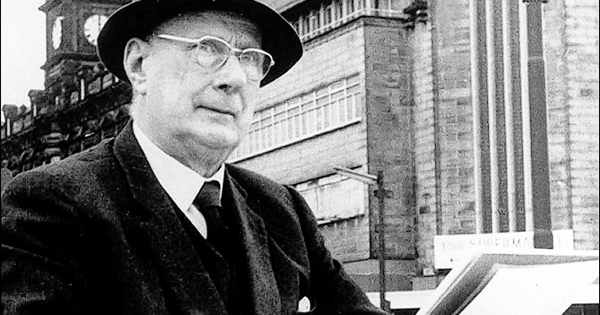
- The Lowry family moved to the industrial town of Pendlebury in 1909. The landscape was dominated by textile mills and the chimneys of factories, and this imagery left its mark on the young L. S. Lowry.
- Lowry had taken art classes as a child and he went to the Manchester School of Art and then Salford Royal Technical College.
- In 1932, Lowry’s father died and he looked after to his mother. After his mother fell asleep, Lowry started to paint, often finishing at 3 a.m.
- Lowry’s paintings often featured industrial Pendlebury and they captured scenes of life in industrial England. His landscapes are often populated by stylised ‘matchstick men’ figures.

There is also a BBC link to a video to watch.
https://www.bbc.co.uk/bitesize/clips/zr4wmp3
If you would like to, we have set you a ‘2Do’ on PurpleMash where you can write some facts about L.S. Lowry. You could also do some of your own research to add to the fact file.

Writing Activity
Read to the end of the book.
Write 2 things you liked about the story, 2 things you disliked, 2 questions you may have about the story and a connection – does this story remind you of another one you have read? Does this story remind you of an experience you have had?
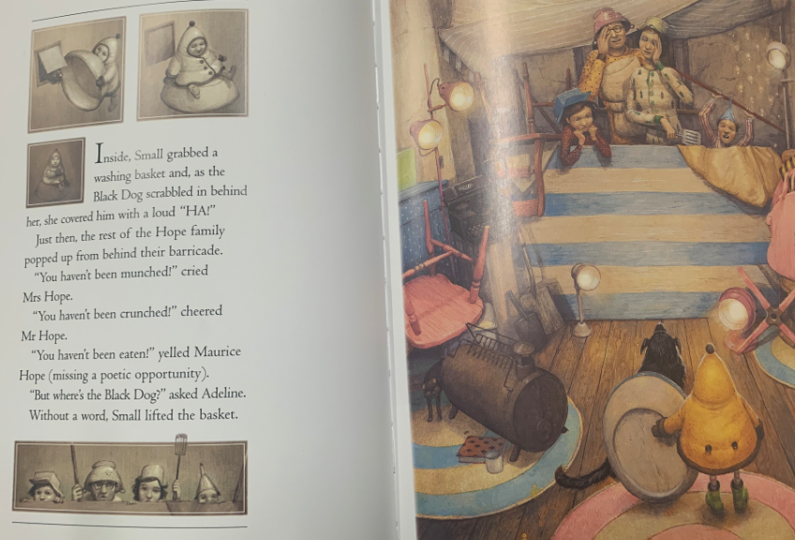
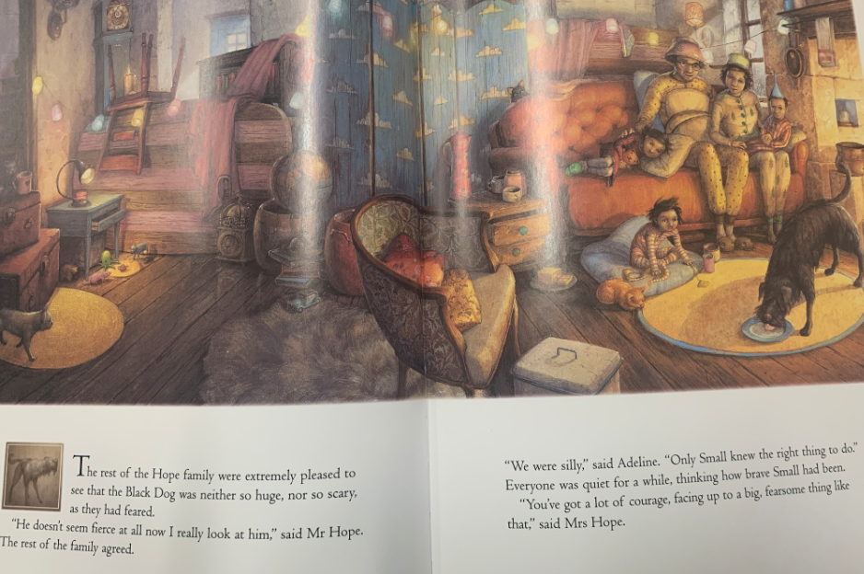
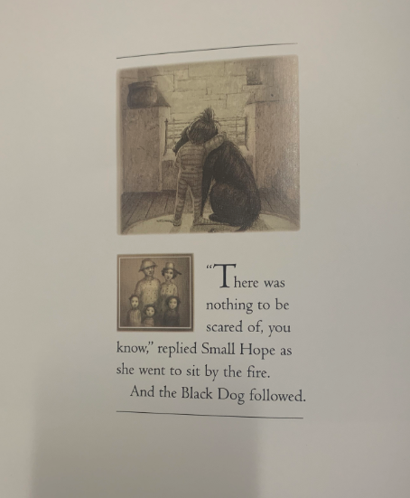

Maths Activity
Please play TTRockstars or Numbots.

Afternoon Activity
Look at this painting by L.S Lowry, it is called ‘A Village Square’. Can you copy this painting? You could draw it, paint it or even use the paint tool on PurpleMash, it is up to you!
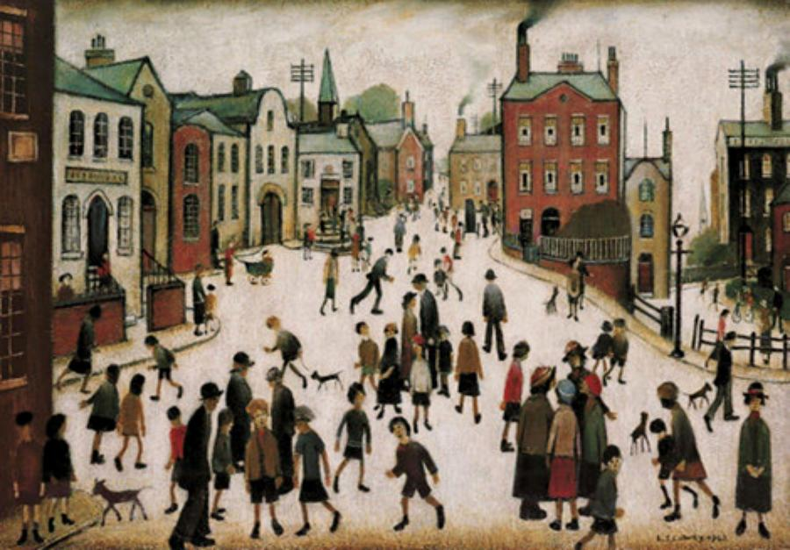

Joke for the day
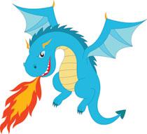
How do you make a dragon angry?

Ask him to blow out a candle!

