Thursday 2nd April
Remember – Keep playing Spelling Shed!
We’ll have two hive games tomorrow (Friday). One game at 10am and another at 12pm. Same spellings for both games, see you then!

Reading Activity
Read your own book at home, this might be a story book, magazine, recipe book or even the back of a cereal box!

PE
Today, we would usually have PE. Access this link to complete a Joe Wicks workout. Can you create your own workout too? Think about the different techniques Mr Duffin has taught you to ensure you are using all your muscles, you could even post your workout on Class Dojo. Try to use different moves from last week so we can see something different!

https://www.youtube.com/watch?v=pnKCGY9ZocA

Music
We would usually have a music lesson today. Please complete the ‘Crazy Cogs’ activity which you’ll find in Music on Busy Things. Unfortunately, you may be unable to save this activity as BusyThings don’t allow that feature for this game.
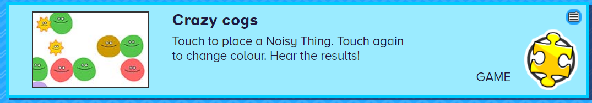
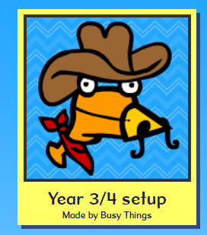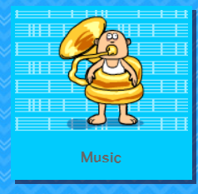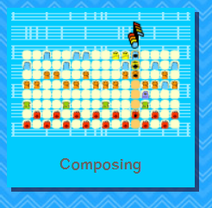
As an addition, please complete the 2Do on Purple Mash named ‘2Sequence’

Afternoon Activity
Please complete the ‘Easter Story’ activity on Busy Things.

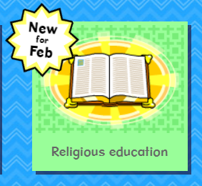
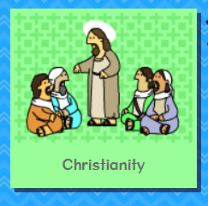
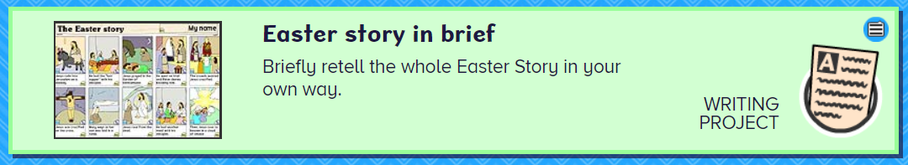

Joke for the day

Which unicorn sleeps until midday?
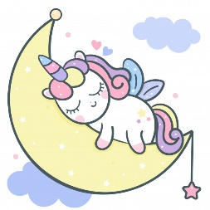
A noon-icorn!

Thank you Phoebe for the joke!

