Wednesday 1st April

Remember – Keep playing Spelling Shed!

Reading Activity
Read this short poem.
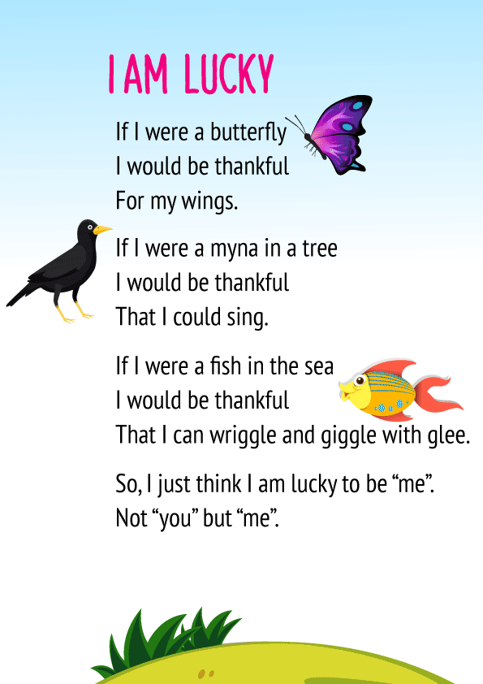

Answer the questions:
- What is the poem about?
- Clarify ‘myna’
- What is the fish thankful for?
- Why should we be thankful?

Writing Activity
Read the next page of the book.
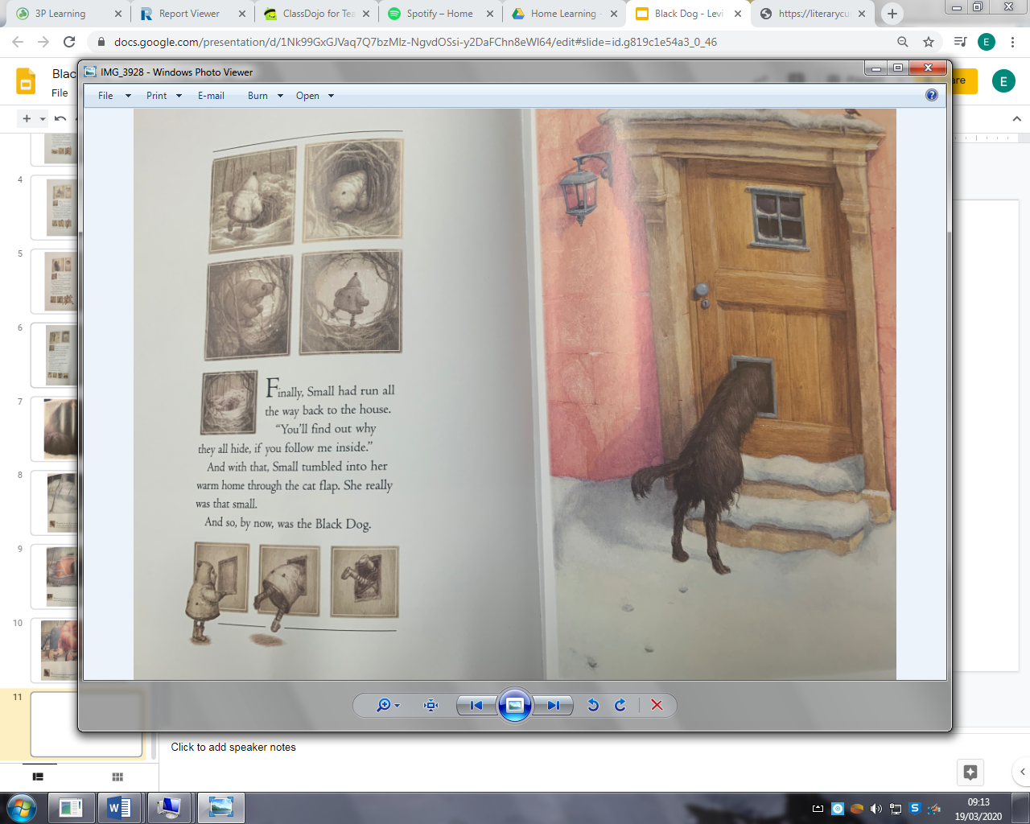

Using the sentences we wrote yesterday, add fronted adverbials onto them.
A fronted adverbial is a word, phrase or clause that is used to modify another clause.
Eg – As the little girl sang, the black dog followed her obediently.
Remember to put your adverbs in the sentence again!
- She scurried into the lowering trees.
- The Black Dog followed.
- She hurried towards the frozen pond.
- She scuttled through the playground.

Maths Activity
Decide which fraction the crocodile will eat. Eg – 1/3 < 1/2
Remember, where would I get more cake? At a party with 3 people or 2 people?
- 1/5 1/7
- 1/2 1/5
- 1/6 1/9
- 1/8 1/3
- 1/2 1/10
Now it gets a little trickier, use the fraction wall to help you.
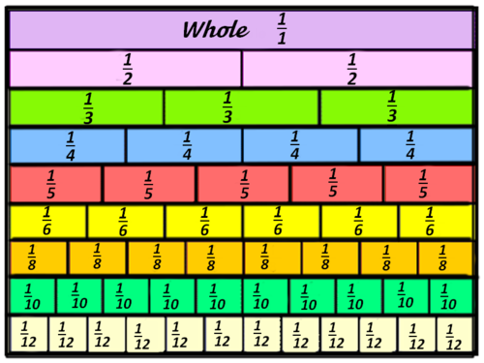

- 2/6 1/2
- 3/9 5/7
- 3/4 8/9
- 4/8 1/2 (Think about this one!)

Afternoon Activity
Look outside your window. How many cars/people can you spot in 5 minutes?
Can you create a graph on PurpleMash to show the different types or colours of cars you saw? Were different parts of the day busier than others?

Joke for the day

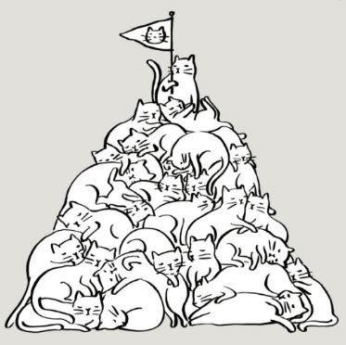
What do you call a pile of cats?

A meow-tain
Thank you Ronnie for the joke!


Which fruit do twins like the most?

Pears!
Thank you Kiyah for the joke!

