Tuesday 31st March
Remember – Keep playing Spelling Shed!

Reading Activity
Please log onto Read Theory and complete 3 activities.

Writing Activity
Read the next pages of the story.

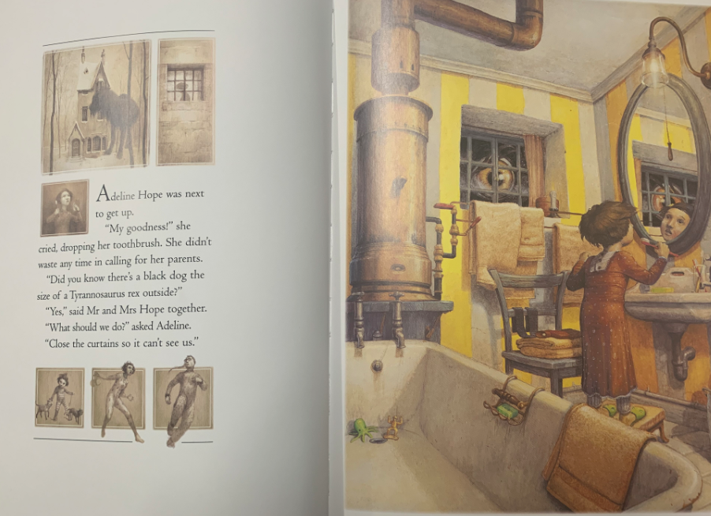

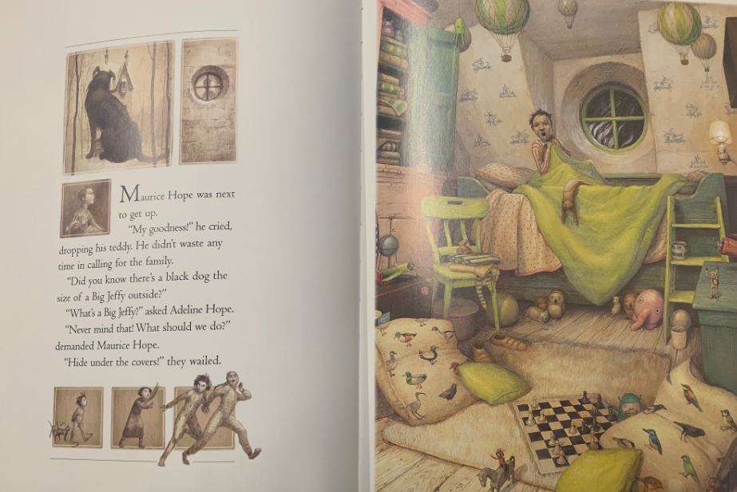
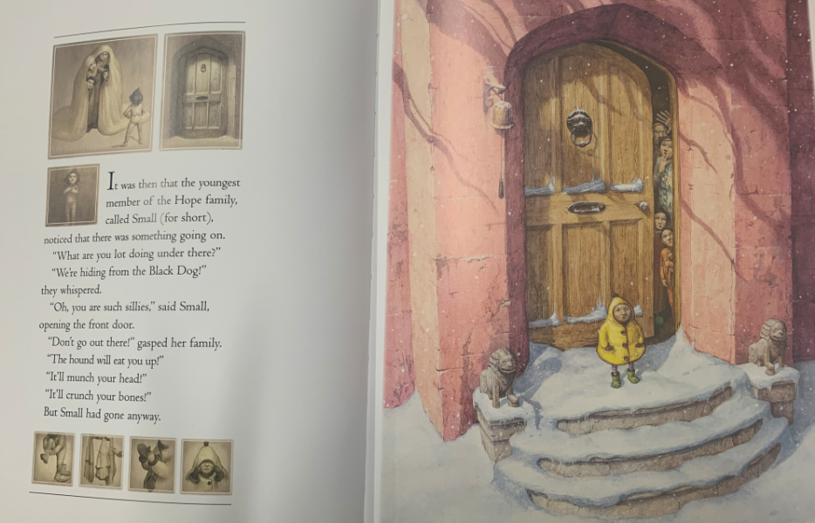
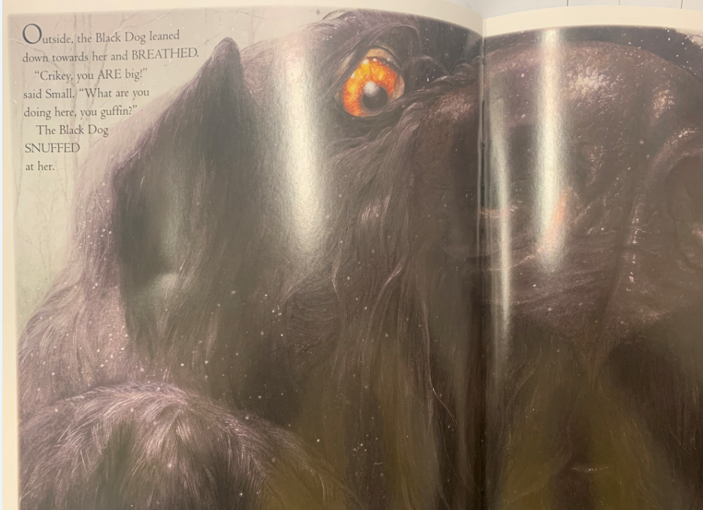

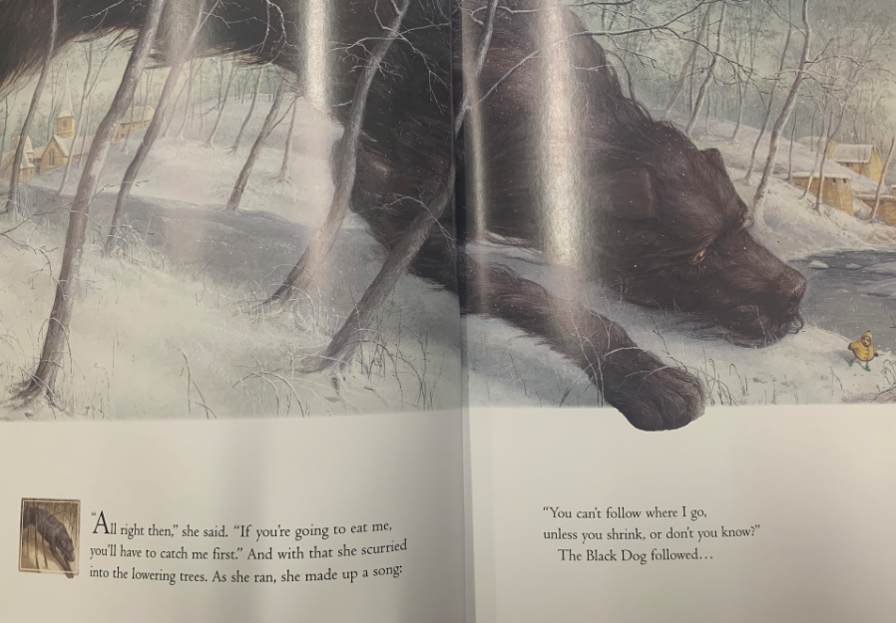
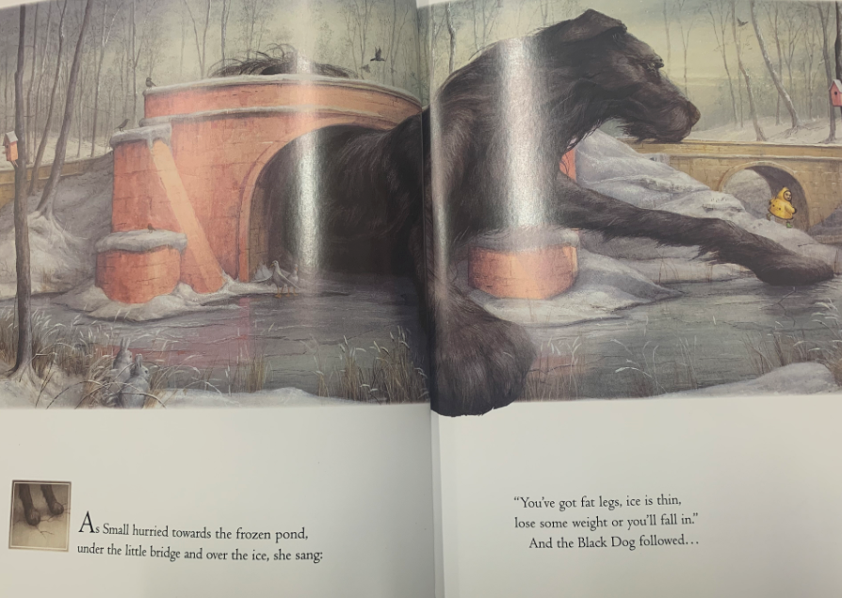
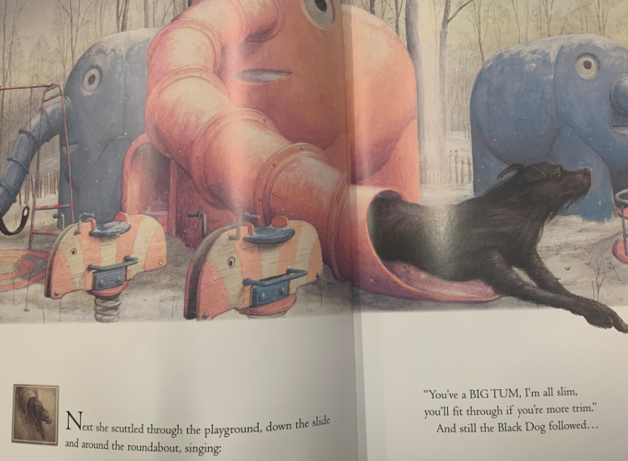

We hope you enjoyed all that reading!
Add adverbs onto these sentences to describe the verbs.
- She scurried into the lowering trees.
- The Black Dog followed.
- She hurried towards the frozen pond.
- She scuttled through the playground.

Thinking about what you have read so far:
- Why is the little girl making the Black Dog follow her?
- How does the little girl know what to do?
- Why isn’t she afraid of the Black Dog?
- Do you think the Black Dog will really eat her?

Maths Activity
Add the fraction to make a whole, remember the denominator will stay the same for these questions so you are focusing on the numerator.
Eg – 1/4 + 3/4 = 1 whole
- 1/5 + ____ = 1 whole
- 3/7 + ____ = 1 whole
- 2/8 + ____ = 1 whole
- 4/9 + ____ = 1 whole
- 1/10 + ____ = 1 whole

Add the fractions together, remember the denominator will stay the same for these questions so you are focusing on the numerators.
Eg – 1/4 + 2/4 = 3/4
- 2/5 + 1/5 =
- 4/8 + 2/8 =
- 1/4 + 2/4 =
- 2/3 + 1/3 =
- 2/9 + 5/9 =

Afternoon Activity
Please complete the Coding 2Do on PurpleMash

Joke for the day

How do trees get onto the internet?

They log on!

Thank you Riley for sending me your joke suggestion! If you’d like to send me a joke then it may be included in our future daily plans

