Monday 30th March
Hope you all had a lovely weekend!
Spellings for the Week – On Spelling Shed
- busy
- calendar
- caught
- century
- certain
- circle
- complete
- consider
- continue
- decide

Reading Activity
Please read your own book, it may be a fact file, a leaflet or an online book from PurpleMash

Writing Activity
Please put the two words into a contraction.
When we are adding ‘not’ onto a word, the n moves to the first word and the apostrophe replaces the o.
Eg – do + not = don’t
- could + not =
- would + not =
- are + not =
- should + not =
When we are adding ‘have’ onto a word, the apostrophe replaces the ha.
Eg – they + have = they’ve
- we + have =
- could + have =
- should + have =
- would + have =

Maths Activity
Please play Mathletics for 20 minutes. This might be Mathletics live or an activity of your choice!

You might also like to try Numbots, use your TTRockstars log in details to enter.

Afternoon Activity
How well can you remember your Spanish colours?
Please complete the ‘Colours (Spanish)’ on Busy Things.
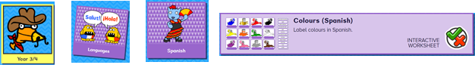
Please also complete the ‘Pets 1 (Spanish)’ Activity on Busy Things.
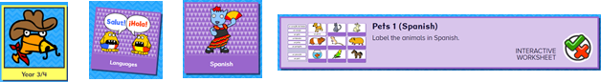

Joke for the day

What is a cat’s favourite colour?


Purrrrrr-ple

