Friday 27th March
Remember – We are going to attempt a Hive game today for our spellings on Spelling Shed. Please access Spelling Shed at 11am, we will post the hive code at 10:55am on Class Dojo. Hope to see you there

Reading Activity
Read this information about a famous artist called Frida Kahlo.
Frida Kahlo was born in 1907, in Coyoacán, Mexico. She grew up in the famous “Caza Azul” (blue house) with her parents and 6 sisters! Drawing and art was always a passion of hers, even as a little girl.
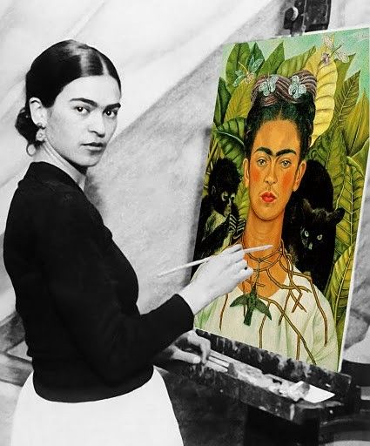
When she was 6 years of age, she caught polio which is a disease that we can now vaccinate against. Frida suffered damage to her leg from it. When she was 18 she was involved in a terrible bus accident. This meant she had to stay in bed for months. She suffered a lot of pain with both illnesses and it also meant that she couldn’t have children. Both her physical pain and emotional pain feature a lot in her artwork, so it is important to know about it and understand a little of what she went through.
Frida was married to another well-known artist Diego Rivera. Frida’s work is influenced by Mexican culture – using bright colours. Frida is often described as a surrealist, though she didn’t like this term herself. She used a mixture or realism and symbols in her art.
If you would like to, we have set you a ‘2Do’ on PurpleMash where you can write some facts about Frida Kahlo. You could also do some of your own research to add to the fact file.

Writing Activity
Read these pages of the book ‘Black Dog’. Complete this table to help us with making a prediction.
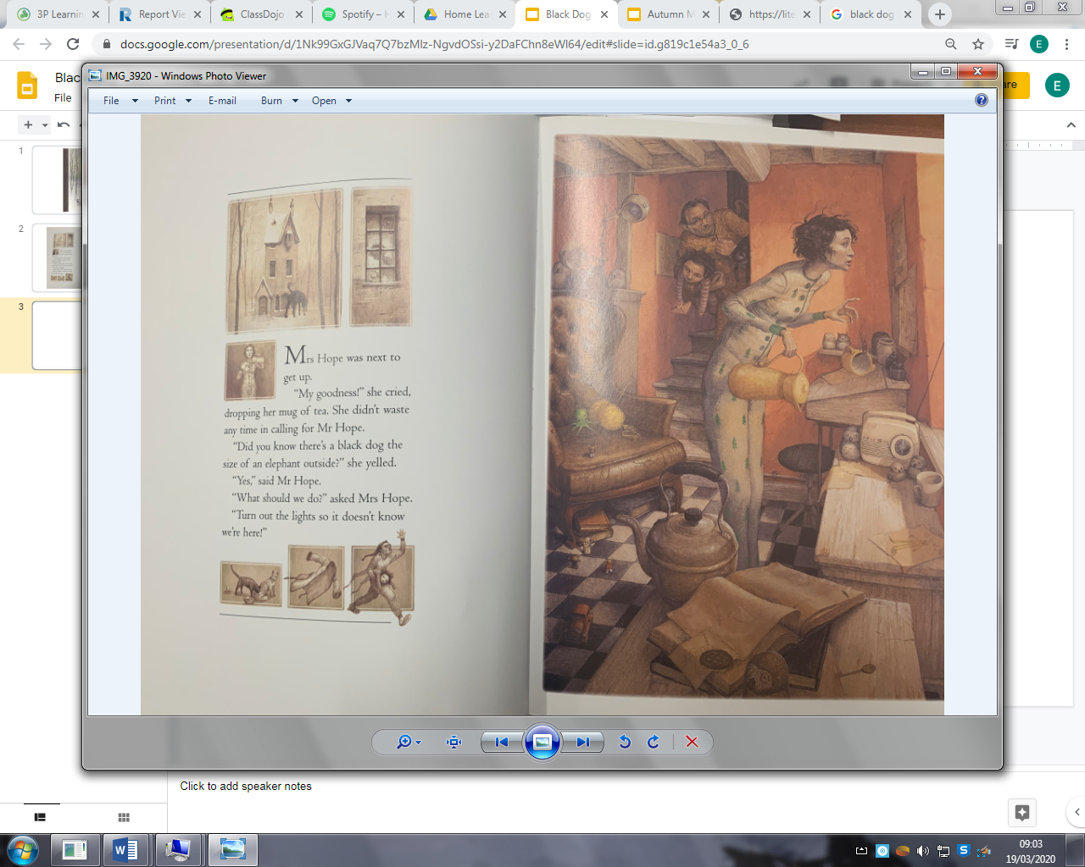
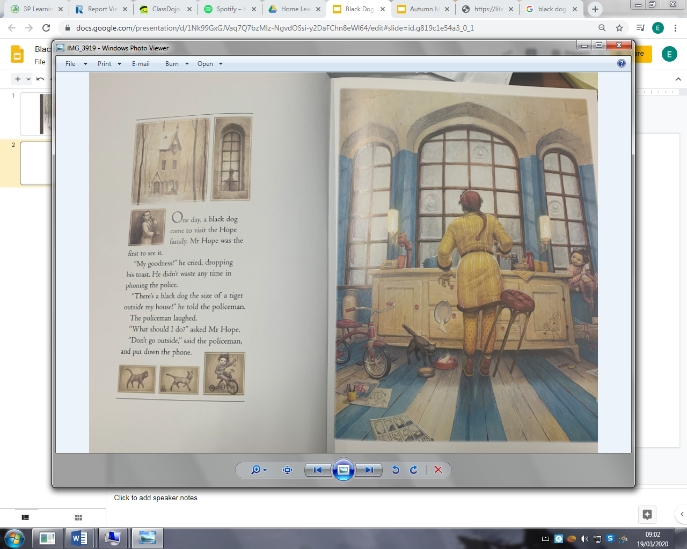

Know | Think | Evidence
Family live in a house | House might be haunted | Looks spooky
Black dog has come to visit

Challenge – Write a prediction of what will happen next in the story.

Maths Activity
Please play TTRockstars or Numbots.

Afternoon Activity
Look at this painting by Frida Kahlo, it is called ‘Still Life’. Can you copy this painting? You could draw it, paint it or even use the paint tool on PurpleMash, it is up to you!
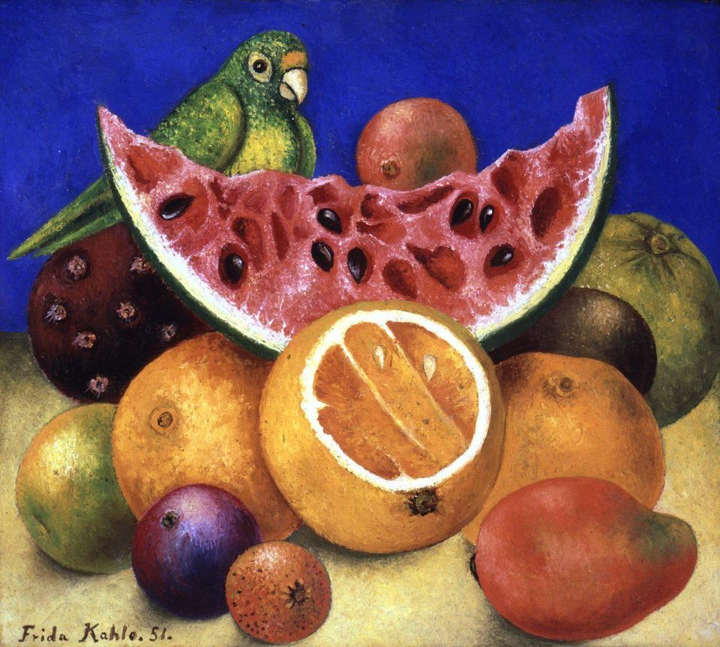

Joke for the day

Why didn’t the orange win the race?

It ran out of juice!


