Thursday 26th March
Remember – Keep playing Spelling Shed!

Reading Activity
Read your own book at home, this might be a story book, magazine, recipe book or even the back of a cereal box!

PE
Today, we would usually have PE. Access this link to complete a Joe Wicks workout. Can you create your own workout too? Think about the different techniques Mr Duffin has taught you to ensure you are using all your muscles, you could even post your workout on Class Dojo.

https://www.youtube.com/watch?v=SbFqQarDM50

Music
We would usually have a music lesson today. Please complete the ‘Monster Grid’ activity which you’ll find in Music on Busy Things.
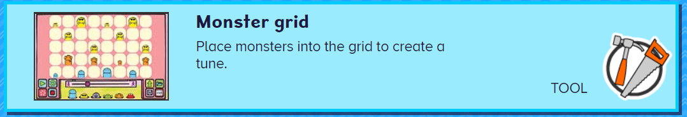
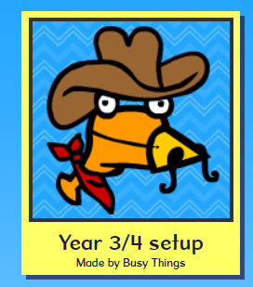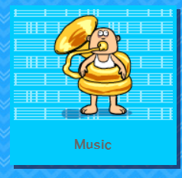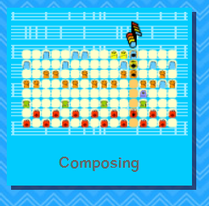
Afternoon Activity
Please complete the Plants and Animals activity, which is set as a 2Do on PurpleMash.


Joke for the day

Which tree fits in your hand?

A palm tree!

