Wednesday 25th March
Remember – Keep playing Spelling Shed!

Reading Activity
Read this short poem.
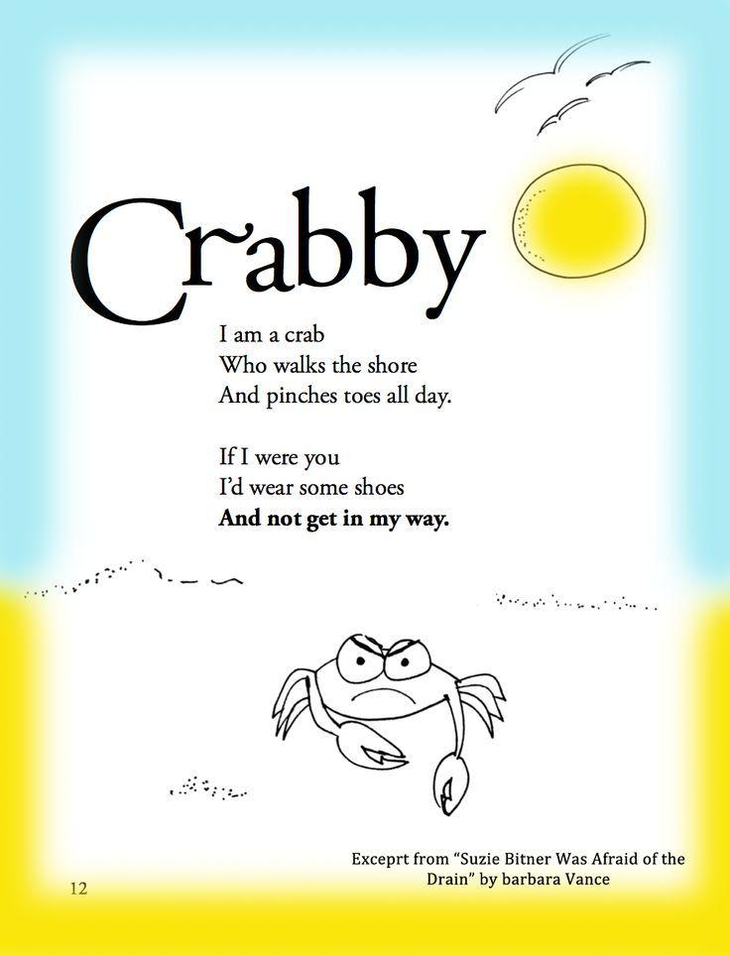

Answer the questions:
- What is the poem about?
- Is he a happy crab?
- Why does the crab tell the reader to wear shoes?
- Have you ever seen a crab at the beach before?

Writing Activity
The title of the book is ‘Black Dog’
Mr Hope spotted a black dog outside his window but it is the size of a tiger!
Mr Hope decides to ring the police as he is afraid, write the conversation between Mr Hope and the policeman.
Remember to use your inverted commas (speech marks “”).
Maths Activity
Complete the addition and subtraction questions. You could try to use column addition and subtraction.
- 121 + 132 =
- 450 + 327 =
- 561 + 321 =
- 466 + 128 =
- 354 + 219 =

- 889 – 231 =
- 569 – 211 =
- 634 – 510 =
- 819 – 357 =
- 990 – 218 =

Afternoon Activity
Go for a walk up the garden/to the park. How many different plants or flowers can you spot?
(If you can’t go for a walk, look out your window)

Joke for the day

Why are fish so smart?

Because they live in schools!


