Tuesday 24th March
Remember – Keep playing Spelling Shed!

Reading Activity
Please log onto Read Theory/Teach your Monster to Read and complete 3 activities.

Writing Activity
For now, we are keeping the title of our book a secret!
This is a photo of a character in our story, he is called Mr Hope.
Mr Hope is looking out the window and he looks afraid! The chair is falling over, he has dropped his washing up and his body tells me that he is shocked!
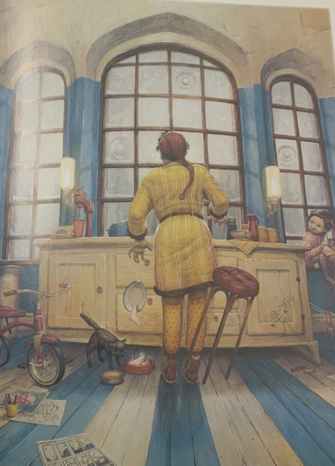

Describe what you think Mr Hope can see out of his window.

Challenge – Improve our adjectives. You could try an online thesaurus.
Eg – scared terrified
- worried
- sad
- small
- quiet
- dirty

Maths Activity
Partition the numbers into hundreds, tens and ones.
Eg – 314 = 300 + 10 + 4
- 96 =
- 55 =
- 14 =
- 731 =
- 940 =
- 803 =
- 156 =
- 7831 =
- 4940 =
- 2018 =

Afternoon Activity
Please complete the Coding 2Do on PurpleMash

Joke for the day

Which day of the week are twins usually born on?

Twos-day!


