Monday 23rd March
Spellings for the Week – On Spelling Shed
- accident
- actual
- address
- answer
- appear
- arrive
- believe
- bicycle
- breath
- build

Reading Activity
Write 3 things you liked about our class book, ‘Cloud Tea Monkeys’ and any questions you may have had about the story.

Writing Activity
We are starting a new class book! But the title is a secret.
Before we begin reading, we are going to explore our fears.
Fears are something we might be afraid or scared of.
Create a list or mind map of your fears.
Eg – the dark

Fears

Challenge – Write 3 sentences beginning with ‘Fear is…’
Eg- Fear is a shadow following me in a lonely street.

Maths Activity
Please play Mathletics for 20 minutes. This might be Mathletics live or an activity of your choice!

Afternoon Activity
How well can you remember your Spanish numbers?
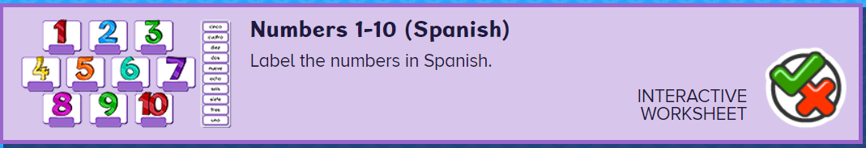
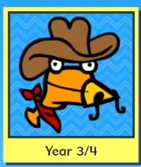
Please complete the ‘Numbers 1 – 10’ on Busy Things.
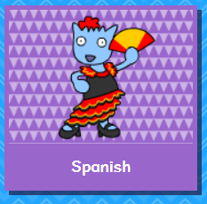
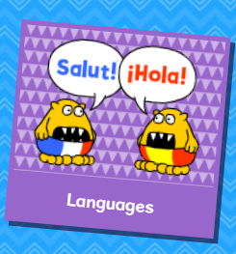
We will begin learning about plants soon and we’d like to see what you know already.
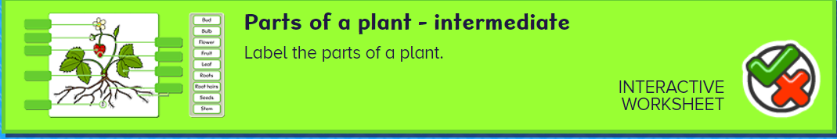
Please complete the ‘Parts of a Plant’ Activity on Busy Things.
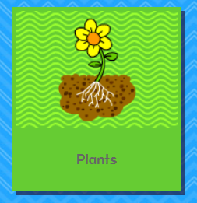
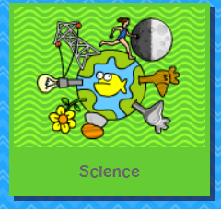
Joke for the day

What did the big flower say to the little flower?

Hi, bud!


