Teaching British Values
At Poverest Primary School we promote the DFE ‘British Values’ to ensure that all pupils are free from bullying and discrimination in the following ways:
Democracy
Democracy is an everyday part of life at Poverest and we promote fairness by ensuring that everyone can share their viewpoints without fear. All pupils regularly vote on various issues and events. They take on the responsibility of being leaders in many different ways including organising their own lunchtime clubs, being digital leaders and auditioning their peers for parts in our ‘Poverest has got talent’ performance. Our Year 6 pupils all have school responsibilities including showing visitors around the school, being house captains, head boy/girl and having monitor jobs which they have to apply for in an interview to prepare them for getting a job in the future.

Democracy is taught discreetly during assemblies, PSHE/Jigsaw lessons and through current events e.g. general elections where the older children find out about the different views of the various parties and then campaign for votes before holding the school election. The children at Poverest recently voted to ‘stay in’ by 10% during the Brexit vote.
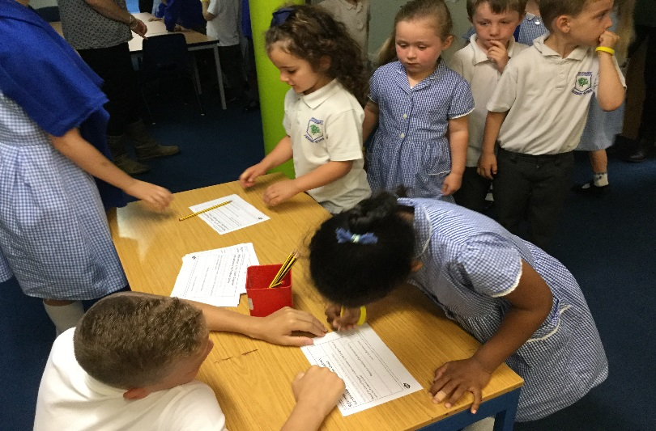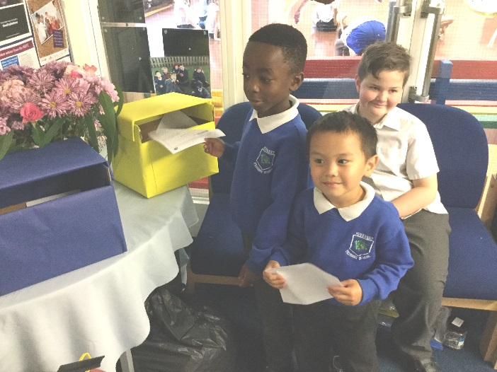
At the beginning of each school year we have a democratically elected School council who are the voice of all of the pupils in the school. The school council have many roles including: fundraising once a term for local charities, sharing their views with SLT, parents &Governors, organising school events and deciding on which nominated children, parents & staff receive the Poverest New Year Honours trophies.

At Poverest we ensure that children have a voice by carrying out pupil questionnaires every term. We show that we values their opinions by acting on the main suggestions or improvements. We ensure that parents have the same voice in the same way alongside parent workshops the most recent being as part of our Equality Review. Our EAL teacher works alongside our children and their families who have English as an additional language to ensure that their voice is heard. Mrs Weeks (Head teacher) also welcomes everyone into school every day to ensure that she is available personally to speak to about any individual issues or suggestions.

The rule of law

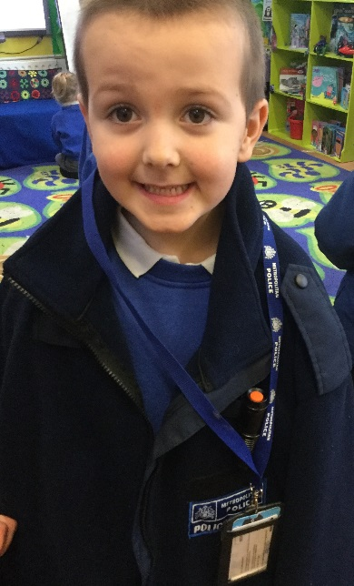
We teach children that rules are there to protect everyone, keep people safe and enable them to learn along with the responsibilities that come with having rights. Each class creates their own class charter of rules which they sign, are displayed near the school office and shared with the parents via class dojo. We have online safety talks every year to help pupils to make the right choices to minimise risk to themselves particularly when using the internet. Through scenario examples older pupils discuss what to do if something does happen to give them the knowledge about who they can turn to for advice.

We use our jigsaw lessons and assemblies to discuss rights including the ‘Pants’ rule to help keep children safe from abuse with parents’ and pupils guides created and shared on the school website. The EYFS children have a visit from parent police officers. This includes talking about their role and helping them to solve an investigation by taking finger prints, following clues, creating posters, acting out news reports and finishing with them solving the investigation by using the evidence that they have collected.

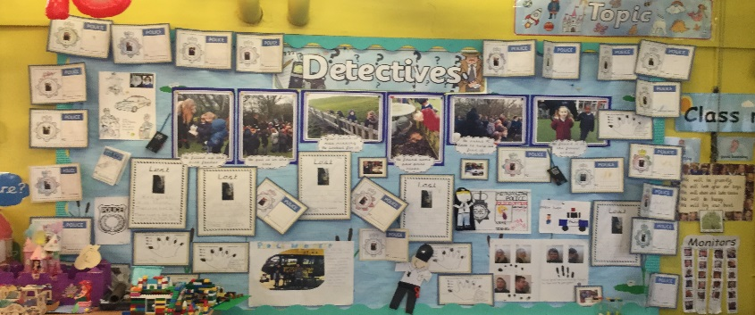
To ensure that children understand that rules are not just for school our year 6 pupils take part in the ‘challenge troop’ programme (http://challengertroop.org). It is underpinned by a very clear set of ‘Values and Standards’ which are adopted by the British Army. These ‘Values and Standards’ support young people, vulnerable to disengagement, in their understanding of both school and society’s expectations of them, providing them with the tools to become positive members of their class, school and local community. It enables pupils to fulfil their potential; by developing each individual’s personal, learning and employability skills to help them become confident individuals, effective contributors in class, successful learners and responsible citizens. The programme is challenging, designed to build resilience, respect, courage, loyalty, discipline, selfless commitment and integrity. It instills self-discipline and raises confidence whilst creating a sense of individual pride, self-worth and fulfilment. It rewards courage, determination, perseverance and achievement whilst helping children to understand and uphold the ‘laws of the land’.

Individual liberty
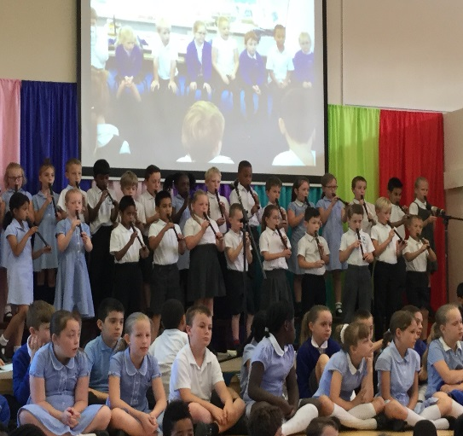
Pupils are encouraged to know, understand and exercise their rights and freedom to make choices whilst in a safe environment. The international primary curriculum that we cover encourages the children to take ownership of their learning through making a variety of choices about where their learning journey will go. At the start of each topic, children evaluate what they already know and want to find out which informs the teachers planning over the next few weeks. The children use feedback marking and next steps to continue to progress throughout the topic. At the end of each topic a class ‘topic book’ is produced and put in the school entrance for all visitors to see along with a ‘celebration of learning’ for the parents to come into the classroom and the children share what they have learnt.

KS2 pupils learn how to make the right choices in different situations by the Young Enterprise scheme https://www.young-enterprise.org.uk. It empowers the children to understand the choices they make have an impact on others and their liberty must not be at the expense of someone else’s well-being. It makes connection between school and the world of work, enabling them to develop the knowledge and attitudes they need to succeed, building on key skills including; communication, confidence, financial capability, initiative, organization, problem-solving, teamwork & resilience.
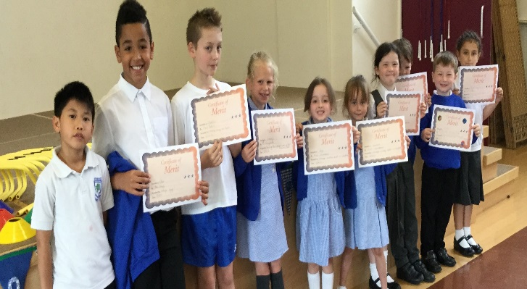

Mutual respect

Respect is a theme which is regularly taught through our jigsaw lessons and class assemblies with the emphasis being that we are all unique and that difference is to be celebrated. We aim to ensure that all pupils treat everyone with respect regardless of their gender, faith, culture, belief or difference. The staff act as role models and praise pupils for showing respect along with good manners and being a good citizen. As part of our promotion of showing respect for disabilities we invite Olympian and Paralympians into school to share their experiences during assemblies and workshops which includes the children competing in events in a similar way e.g. blindfolded to understand what it might be like.

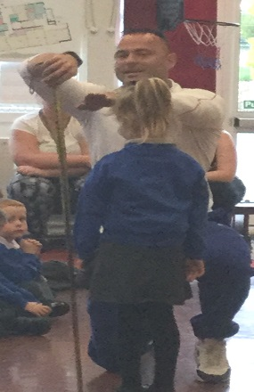
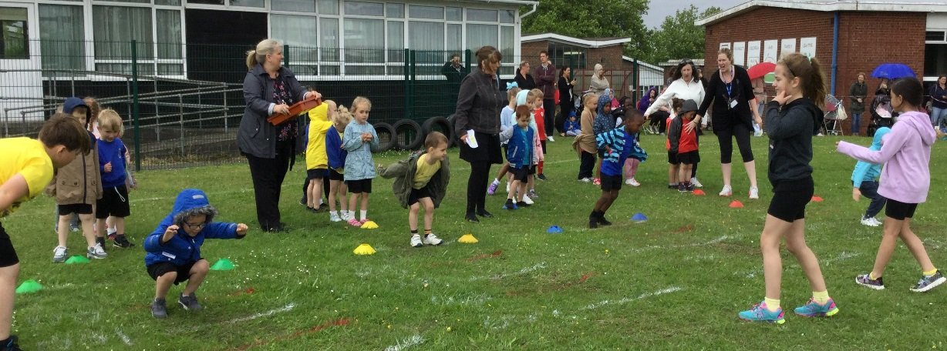

The school council lead the anti-bullying week including, assemblies, creating posters, creating children’s leaflets about what to do if they are being bullied and a parent’s guide about what we do at Poverest and what they can do if they are concerned. This is when our playground ‘buddy benches’ and ‘playground leaders’ are promoted so that children know who to go to if they need a friend or want to talk to someone.

A real strength at Poverest is that our children in the Autistic Provision are included in all aspects of the mainstream school. Through Autism awareness week the whole school learns discretely about what it is like to have autism, however as inclusion is part of day to day life the children understand the needs of these pupils and treat them with respect and kindness.

Our Year 5 and Year 6 pupils take part in the Medway Education Business Partnership in the summer term http://www.mebp.org. This develops respect for each other and the community through enterprise and commercial awareness. They work in teams on a range of skills with mutual respect being the underlining theme. They include management skills, teamwork, taking responsibility, making decisions, and being financially literate, punctual, personable and reliable. We want to ensure that every pupil at Poverest Primary school can achieve their full potential by ensuring that all pupils leave school with the interests, attitudes and skills to make their way in the very fast paced world of work of the future. One of the teams at the summer fair raised over £150 by themselves due to ideas from this programme.

Tolerance of those of different faiths and beliefs

Poverest pupils reflect the diverse culture of the local community. We try to harness cultural links by each year group either visiting a place of worship or having a faith leader come into school to talk to pupils about their faith experiences. Through assemblies and class jigsaw lessons we discuss issues that are happening in the world around us today and try to explore and discuss all points of view with lots of debate and hot seating. This understanding starts in our EYFS with the children becoming pen pals with EYFS children in Thailand. They write letters and make video diaries to find out about similarities and differences between the cultures.

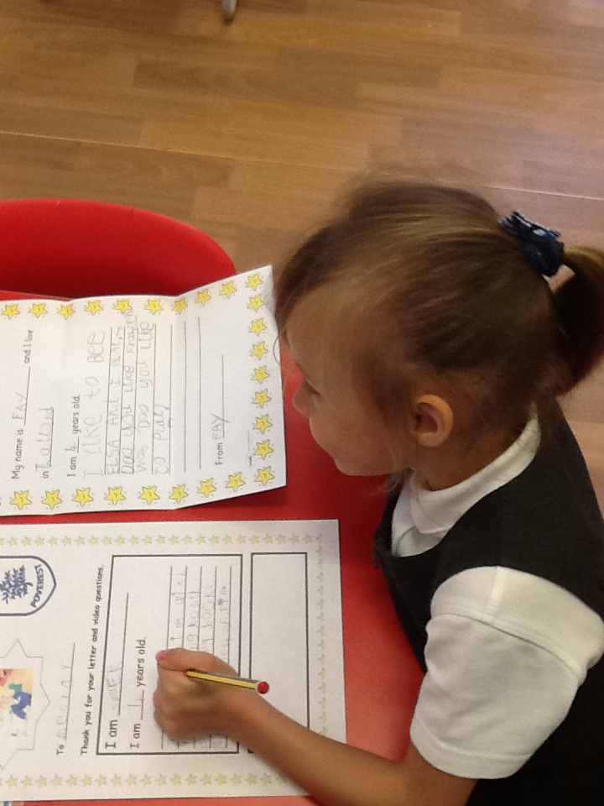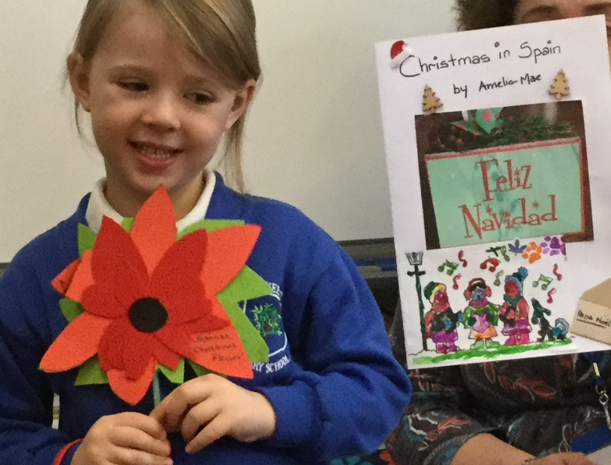

Alongside our RE and PSHE curriculum we have a multicultural week each year where children learn about customs and traditions based on the faiths and beliefs of the children at Poverest and the wider world. We are proud of our traveller community and include learning more about traveller life during this week. The children wanted to find out what it would be like to go into a ‘Vardar’ and so we brought one for the pupils to use at break times. The impact of finding out about the traveller community was evident when more photographs were taken of the horse and carts arriving at the Year 6 prom than the limousines.

Please see our school website for more information and to view our class photo galleries e.g. our Eid celebrations, Bollywood dancing, Nativity etc.

We actively challenge anyone who expresses opinions or extremist views that are contrary to the British values and ethos of our school. If you are concerned about any views or opinions within the school or feel that the school is not promoting British Values please contact the school office and ask to speak to Mrs Weeks, Head Teacher.

